Stations of the Cross WEEK – 9, Thursday 29th March.
4 Drum beats Silence

CHOIR

Introduction: Jay Hill
After the last supper with his friends,
Jesus was arrested by those who didn’t understand who he was.
His enemies took him to court.
They sentenced him to die on a cross.
Jesus gave his life for us so that we could be free.
Today we remember Jesus’ death, but we celebrate with joy, his coming back to life on Easter morning.

Opening Prayer: Safie Matthews
In the name of the Father, and of the Son, and of the Holy Spirit.
Amen.

Heavenly Father,
we pause from the cares and concerns of our daily lives
to spend a few moments reflecting upon the events
surrounding the death and resurrection of our Lord Jesus.
Send your spirit into our hearts.
Increase our faith and deepen our hope in the resurrection.
We ask this in the name of Jesus.
Amen

4 Drum beats –

5P
First Station: The Garden of Gethsemane.
Jesus went into the Garden of Gethsemane to pray. He knew what was going to happen.
When he was alone, he called out “Father let this cup pass me by”
but even in his time of greatest anguish, he accepted God’s will and called out
“I will do what you ask”.
Jesus would give his human life to save us and grant us eternal life.
Jesus knew what was going to happen to him, yet his praying gave him the strength and courage to go on.
When he rose from prayer and returned to his disciples, he found them sleeping from grief. He said to them, "Why are you sleeping? Get up and pray with me. The spirit is willing but the flesh is weak."
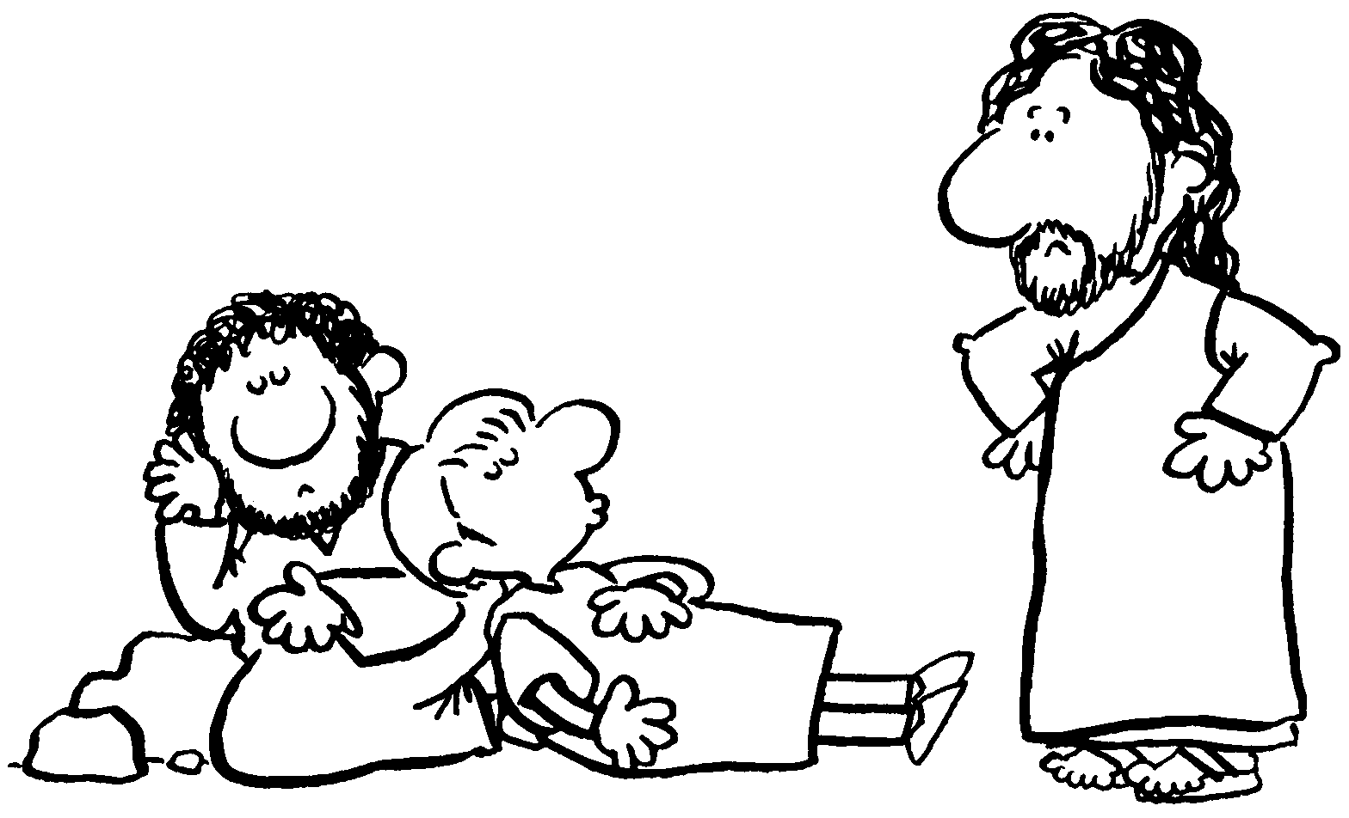
5P Class Prayer:
Lord Jesus,
Even in your time of greatest weakness
you put your faith in God.
Help us to turn to God, when we find it hard to do the right thing.
Give us the courage to follow you
Amen

Whole School: Lord Jesus, teach us how to follow you.

4 Drum beats

5S
Second Station: Jesus is Arrested
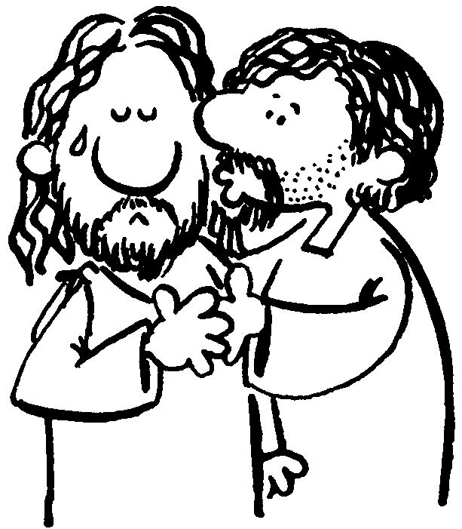
While Jesus was still speaking,
Judas, one of the twelve disciples, arrived,
accompanied by a crowd with swords and clubs,
who had come from the chief priests, the scribes, and the elders.
His betrayer had arranged a signal with them, saying,
"The man I shall kiss is the one; arrest him and lead him away securely."
He came and immediately went over to him and said, "Rabbi."
And he kissed him. At this they laid hands on him and arrested him.

5S Class Prayer:
Lord Jesus,
Grant us the courage of our conviction
that our lives may faithfully reflect
the good news you bring.
Amen

Whole School: Lord Jesus, teach us how to follow you.

4 Drum beats

3N
Third Station: Before the Sanhedrin
Jesus stood before the very people he had come to save.
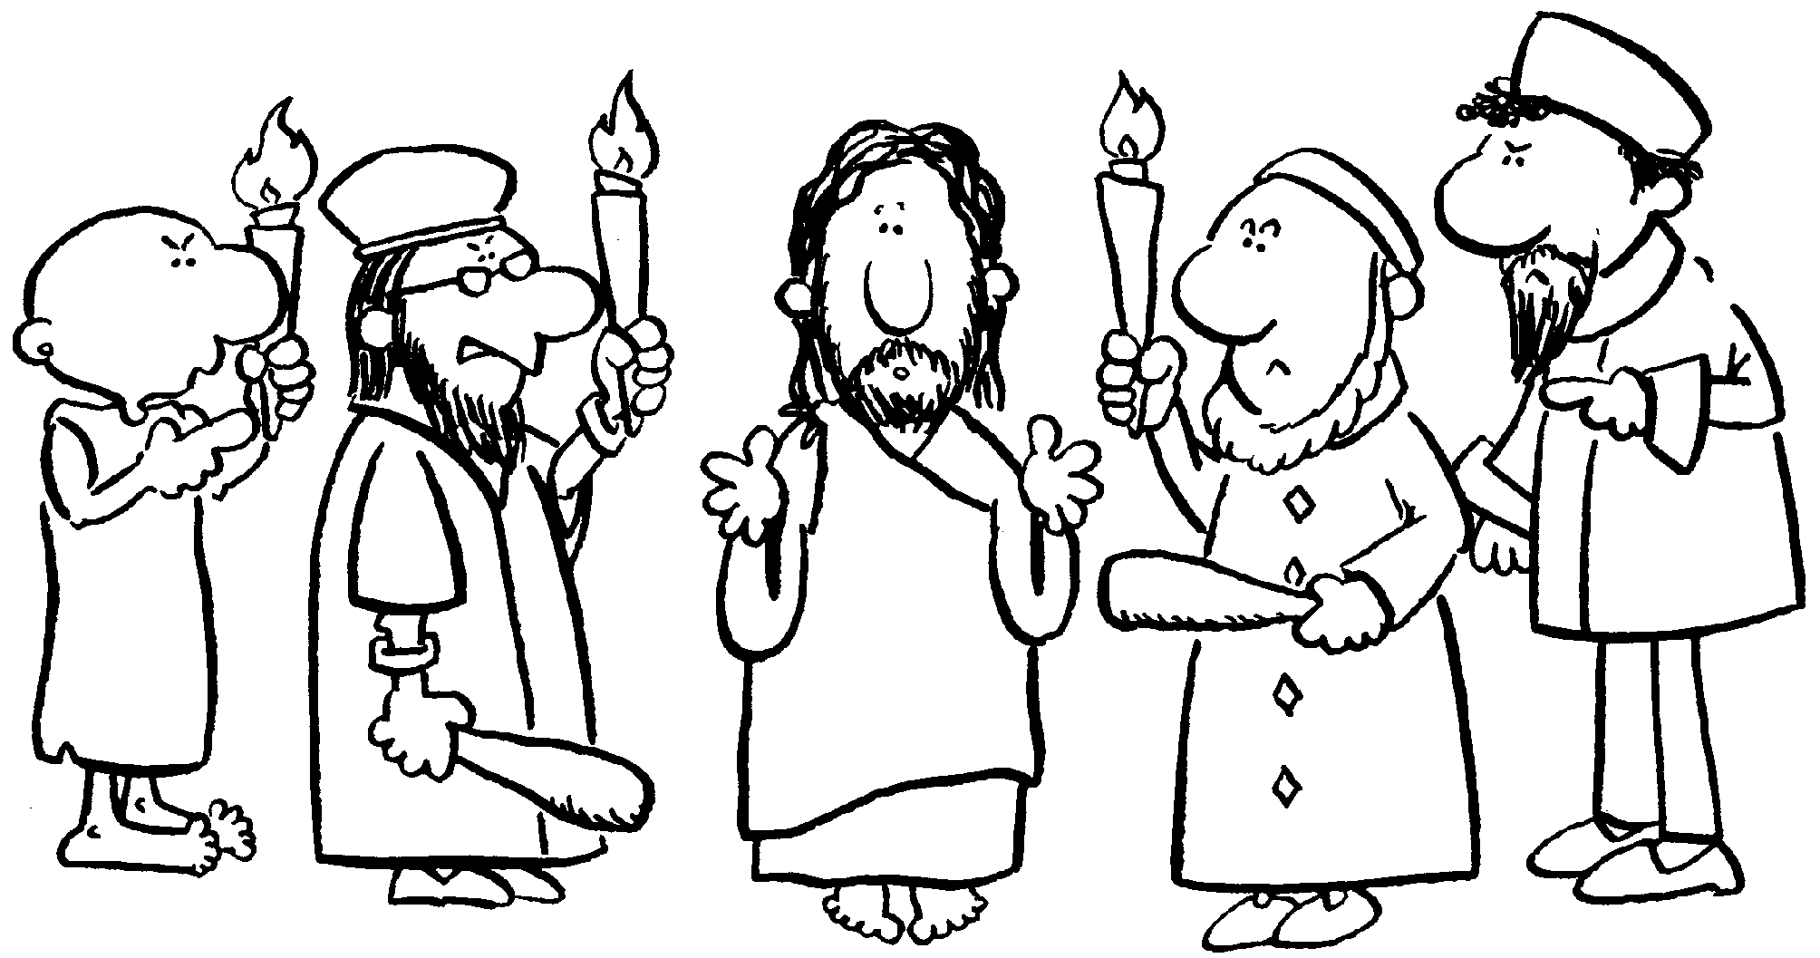
These people taunted and condemned him
because he refused to deny the truth
- that he was the Christ.
They all asked, "Are you the Son of God?"
He replied to them, "You say that I am."
Then they said, "What further need have we for testimony?
We have heard it from his own mouth."
The Sanhedrin thought his death would be the end.
But for us his death would be the beginning of the fulfilment of the Scriptures.
That he would be put to death and rise again as Son of God, Saviour and Messiah.

3N Class Prayer:
Lord Jesus,
Thank you for the strength you give us,
it helps us to speak the truth in times
when it may be difficult.
Amen

Whole School: Lord Jesus, teach us how to follow you.

4 Drum beats

3R
Fourth Station: Jesus is Denied by Peter
Now Peter was sitting outside in the courtyard.
One of the maids came over to him and said,
"You too were with Jesus the Galilean."
But he denied it in front of everyone, saying,
"I do not know what you are talking about!"
As he went out to the gate,
another girl saw him and said to those who were there,
"This man was with Jesus of Nazareth."
Again he denied it with an oath, "I do not know the man!"
A little later the bystanders came over and said to Peter,
"Surely you too are one of them; even your speech gives you away."
At that he began to curse and to swear, "I do not know the man."
And immediately a cock crowed.
Then Peter remembered the word that Jesus had spoken:
"Before the cock crows you will deny me three times."
He went out and began to weep bitterly.

3R Class Prayer:
Lord Jesus,
Grant us the gift of honesty
that we may not fear to speak the truth even when difficult.
Amen

Whole School: Lord Jesus, teach us how to follow you.

4 Drum beats

2P
Fifth Station - Jesus is Condemned by Pilate.
The chief priests with the elders and the scribes,
that is, the whole Sanhedrin, held a council.
They bound Jesus, led him away, and handed him over to Pilate.
Pilate questioned him, "Are you the king of the Jews?"
He said to him in reply, "You say so."
The chief priests accused him of many things.
Again Pilate questioned him,
"Have you no answer? See how many things they accuse you of."
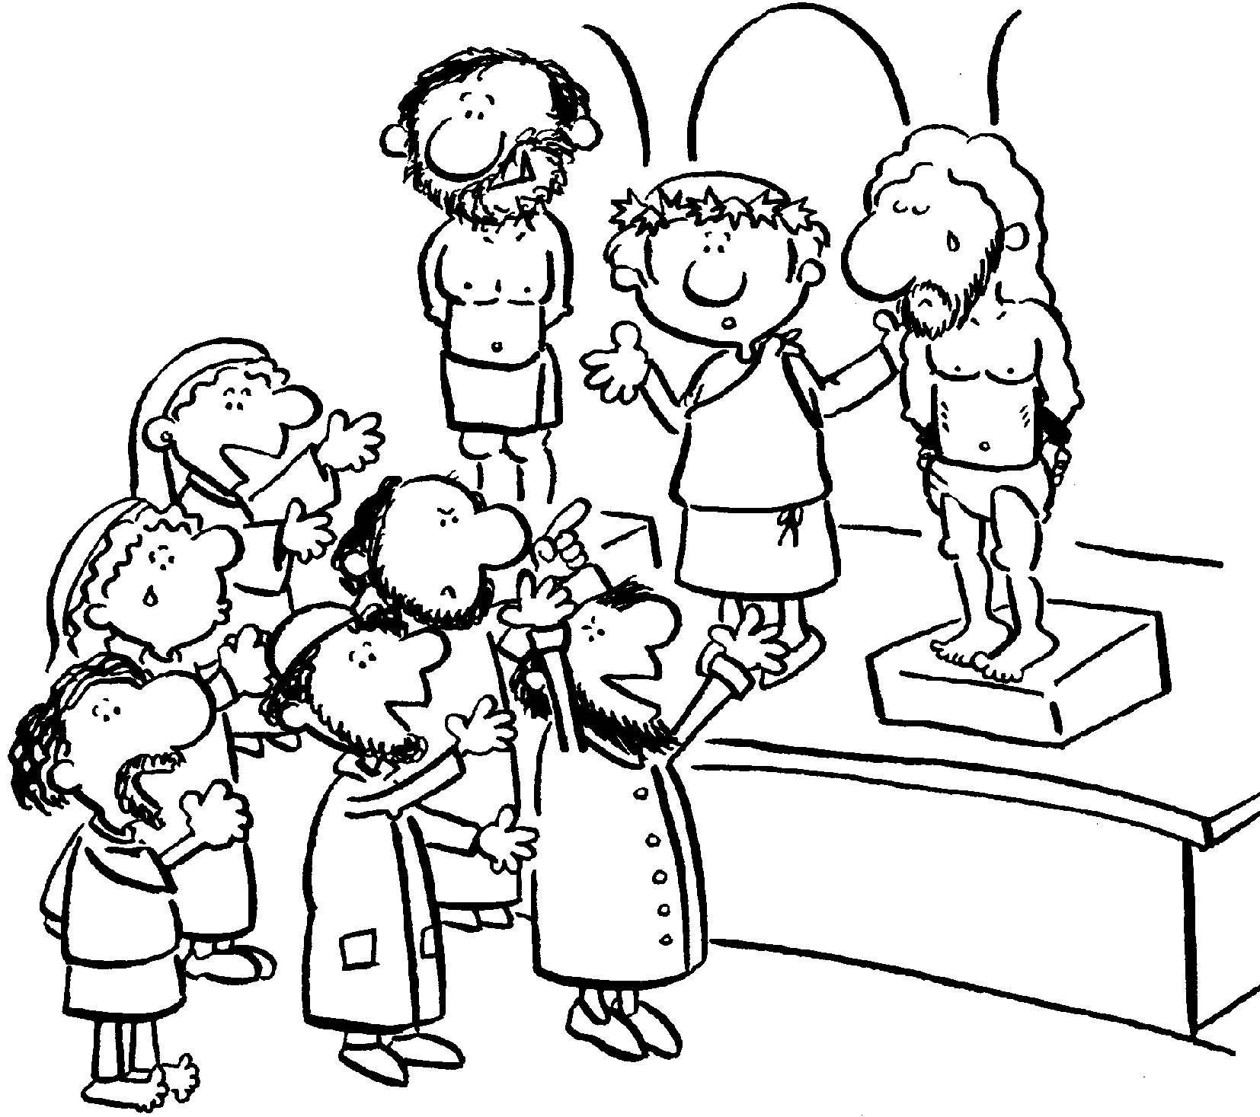
Jesus gave him no further answer, so that Pilate was amazed....
Pilate, wishing to satisfy the crowd, released Barrabas...
and handed Jesus over to be crucified.

2P Class Prayer:
Lord Jesus,
You have been told you must die,
to take away all our wrongs.
This is your Father’s will.
Give us courage in our struggles.
Amen.

Whole School: Lord Jesus, teach us how to follow you.

4 Drum beats
4H
Sixth Station: Jesus is Scourged and Crowned with Thorns

Then Pilate took Jesus and had him scourged.
And the soldiers wove a crown out of thorns and placed it on his head,
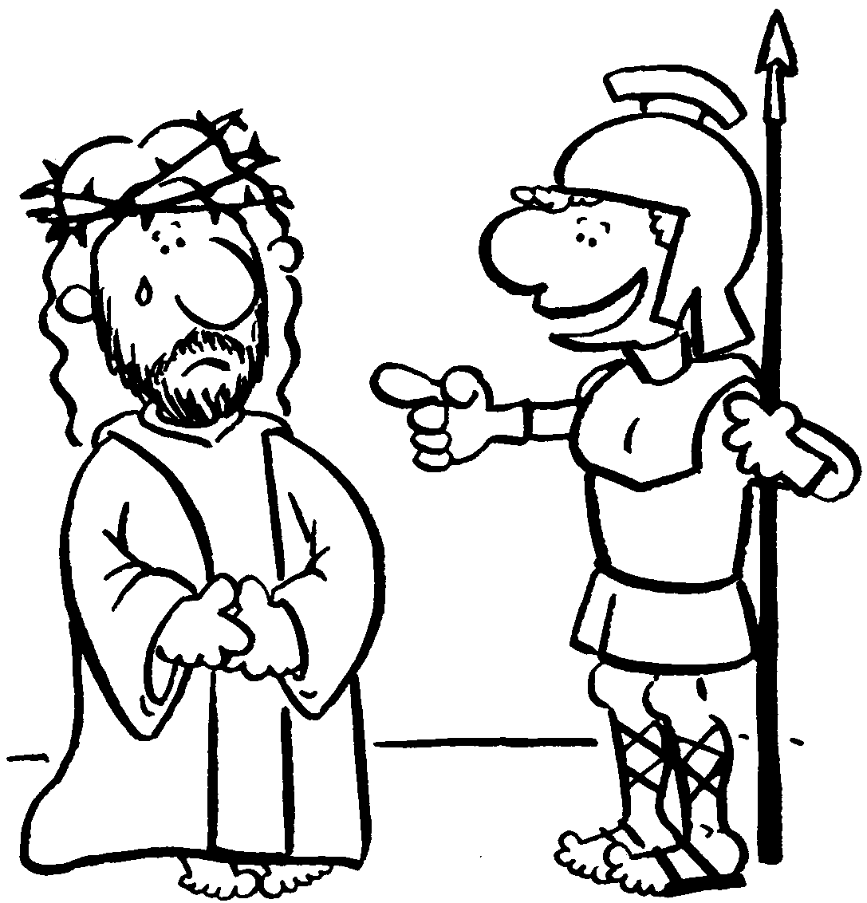
and clothed him in a purple cloak,
and they came to him and said, “Hail, King of the Jews!"
And they struck him repeatedly.
4H Class Prayer:
Lord Jesus,
Pain and suffering are part of our world.
With your help we are able
to do something about it.
We are sorry for the times
we may have caused others pain and suffering.
Amen

Whole School: Lord Jesus, teach us how to follow you.

4 Drum beats

4C
Seventh Station: Jesus Bears the Cross
When the chief priests and the guards saw Jesus they cried out, "Crucify him, crucify him!"
Pilate said to them, "Take him yourselves and crucify him. I find no guilt in him.”...
They cried out, "Take him away, take him away! Crucify him!"
Pilate said to them, "Shall I crucify your king?"
The chief priests answered, "We have no king but Caesar."
Then he handed him over to them to be crucified.
So they took Jesus, and carrying the cross himself
he went out to what is called the Place of the Skull, in Hebrew, Golgotha.
4C Class Prayer:
Lord Jesus,
Grant us strength of purpose
that we may faithfully bear
our crosses each day.
Amen

Whole School: Lord Jesus, teach us how to follow you.

4 Drum beats

PPS
Eighth Station: – Simon of Cyrene helps Jesus carry the cross

Simon, a stranger to Jerusalem
saw Jesus walking weighed down with the cross
and even though he did not even know who Jesus was
he stopped and helped him to carry the cross

PPS Class Prayer:
Lord Jesus,
Thank you for the people who step out
and help us when we are in need.
Help us to be the caring hand,
for friends and strangers
who need your help.
Amen

Whole School: Lord Jesus, teach us how to follow you.

Drum Beat

PPL
Ninth Station: Jesus Meets the Women of Jerusalem

Jesus only spoke once
on the journey to the crucifixion.
This was to offer comfort and advice to a group of women
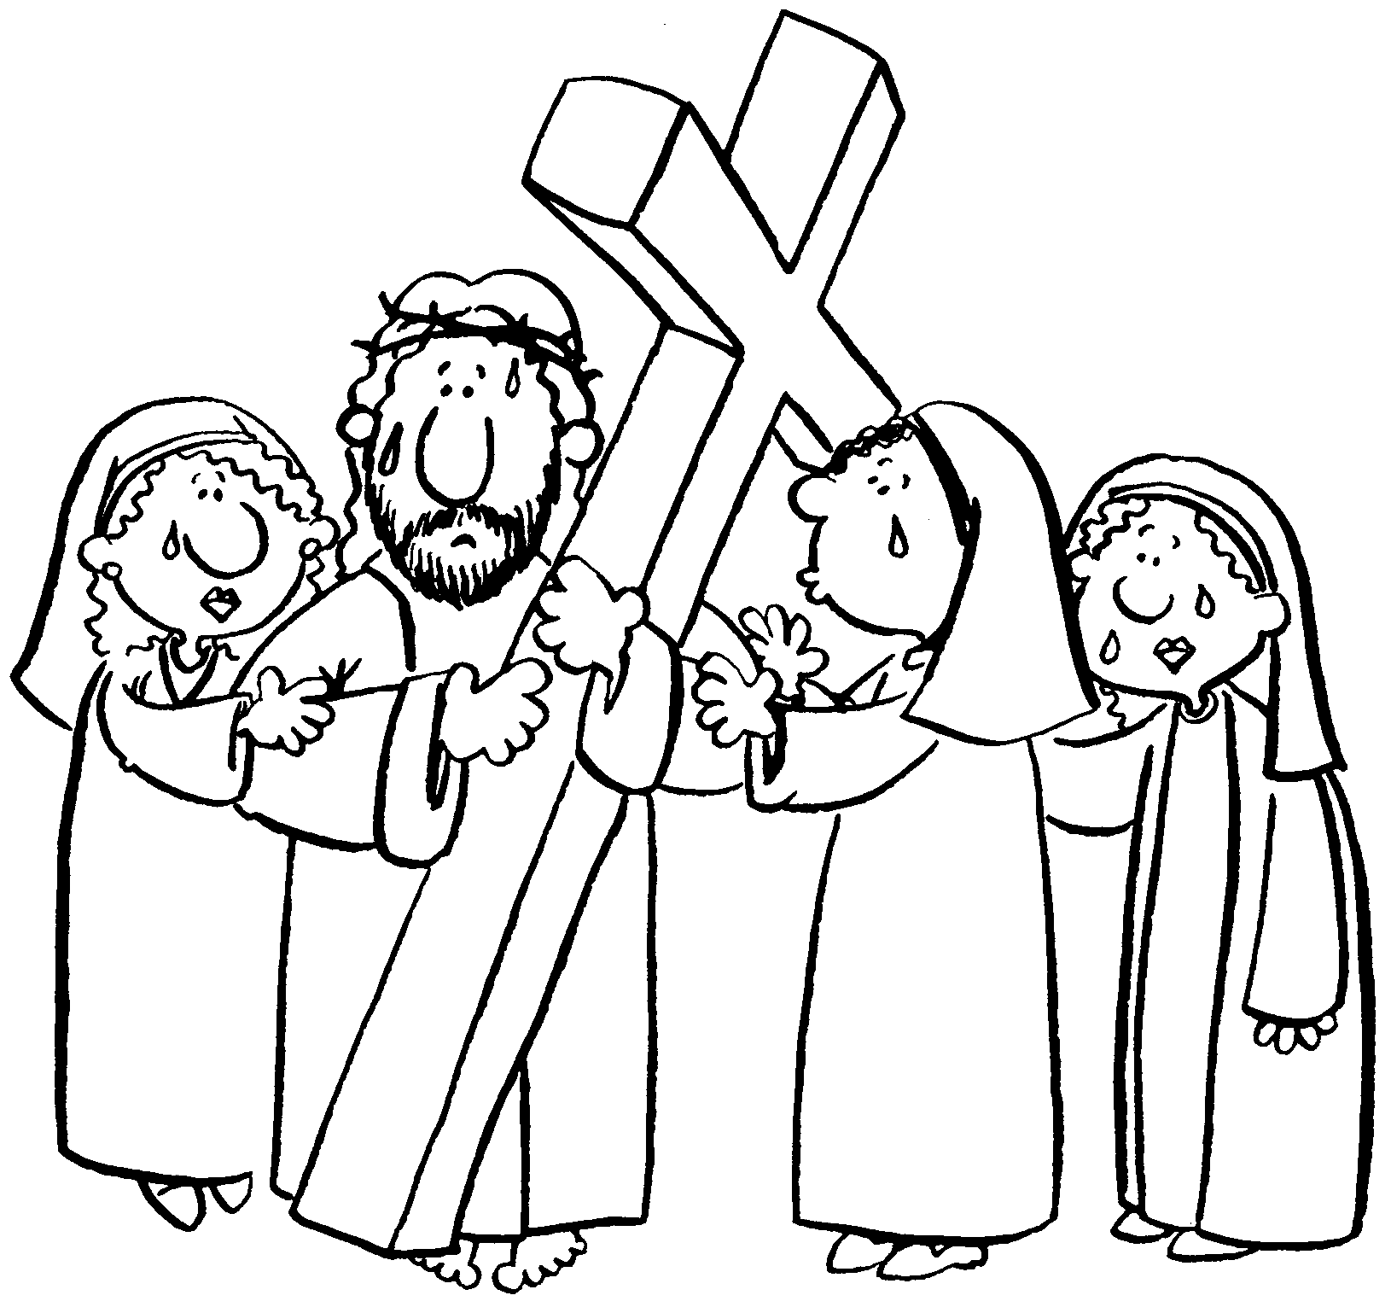
who grieved over his suffering.
He told them to stop crying for him
and to weep instead for the evil being done.
He was asking them to follow their own hearts
– not those of the crowd.

PPL Class Prayer:
Lord Jesus,
forgive us, when we are weak
and follow along with the crowd.
Give us the courage to do what is right.
Amen

Whole School: Lord Jesus, teach us how to follow you.

4 Drum beats

1Z
Tenth Station: Jesus is Crucified
Arriving at the hill of execution,
Jesus was stripped of his clothes
and nailed to the cross.
He was raised in front of the crowd
to endure the hours of dying.

1Z Class Prayer:
Lord Jesus,
Forgive us for the times,
we have nailed others to the cross,
because they were different.
Show us how to love and value people
as you did.
Amen.

Whole School: Lord Jesus, teach us how to follow you.

4 Drum beats

6L
Eleventh Station: Jesus Promises His Kingdom to the Good Thief

One of the criminals hanging there abused him
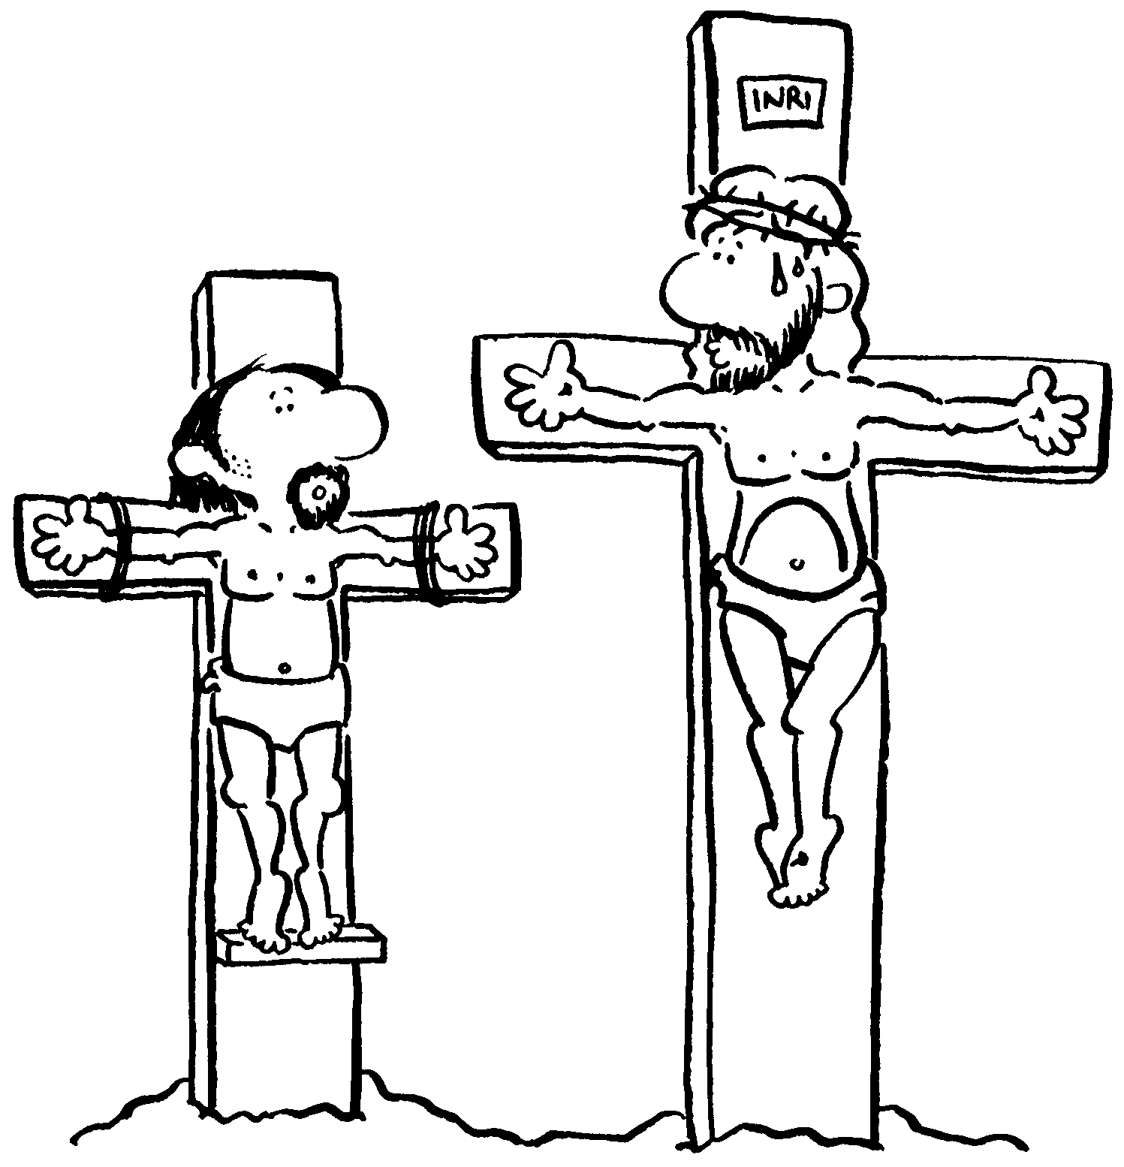
“Are you not the Christ?”
“Save yourself and us as well.”
But the other criminal spoke up
“Have you no fear of God at all?
We got the same sentence as he did,
but in our case we deserved it,
we are paying for what we did.
But this man has done nothing.”
Even through his dying
Then he said, “Jesus, remember me when you come into your kingdom.”
He replied to him, “Amen, I say to you, today you will be with me in Paradise.”

6L Class Prayer:
Lord Jesus,
our saviour, you came to call us all
so that we may repent and live a new life.
May we heed your call and
turn away from sin
and enjoy the life that you have won for us.
Amen.

Whole School: Lord Jesus, teach us how to follow you.

4 Drum beats

1M
Twelfth Station: Jesus Speaks to His Mother and the Disciple

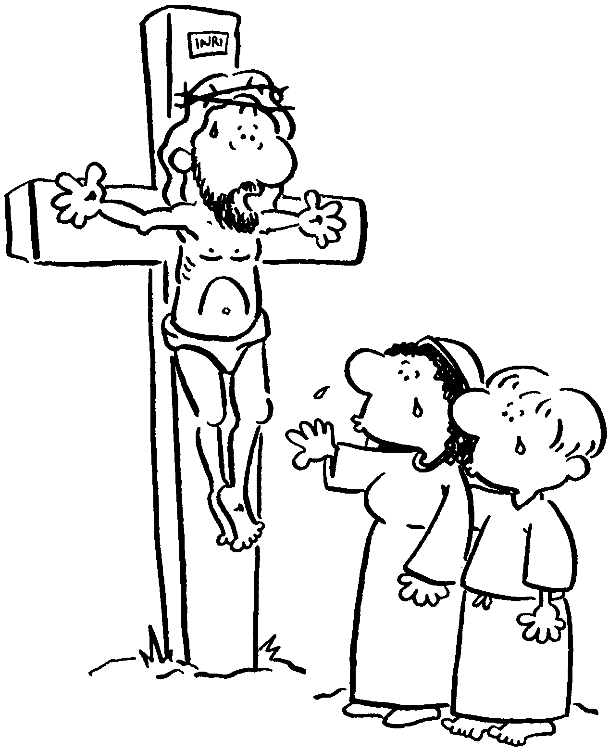
In his final moments
Christ’s thoughts turned to his mother.
he confided in her to the care of his disciple, John.
‘John can you take care of Mary?’
At the same time he called Mary to be a mother to his disciple.
‘Mary can you take care of John?’
Just as the disciples represented us at the last supper,
here John represents us.
We are called to honour Mary as our mother.

1M Class Prayer:
Dear Lord
Thank you for the gift of Mary our Mother.
Help us to recognise her in good times
And times of need.
May we model ourselves on her devotion and love.
Amen.

Whole School: Lord Jesus, teach us how to follow you.

4 Drum beats

2E
Thirteenth Station: Jesus Dies on the Cross
It was now about noon
and darkness came over the whole land until three in the afternoon
because of an eclipse of the sun.
Then the veil of the temple was torn down the middle.
Jesus cried out in a loud voice, "Father, into your hands I commend my spirit";
and when he had said this he breathed his last.
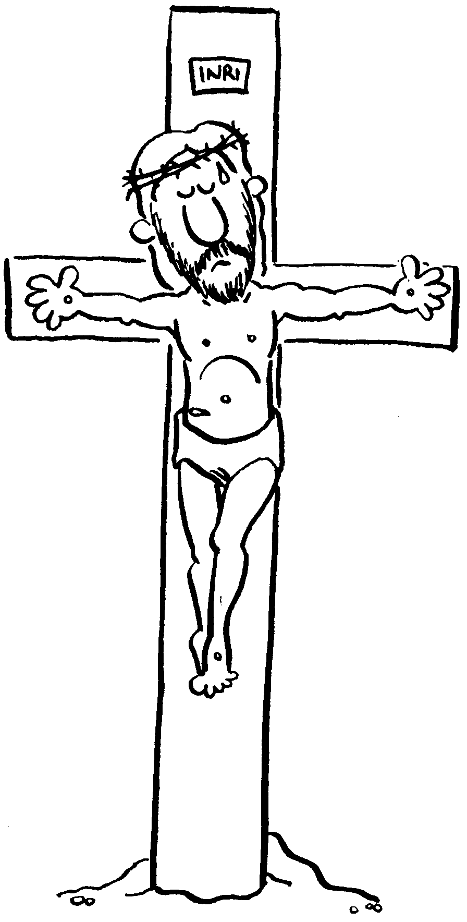
2E Class Prayer:
Lord Jesus,
Thank you for your sacrifice,
you died so we might live.
May we be ever conscious of your love for us
and draw closer to you,
the way, the truth and the life.
Amen

Whole School: Lord Jesus, teach us how to follow you.
4 Drum beats

6J
Fourteenth Station: Jesus is Placed in the Tomb

When it was evening, there came a rich man from Arimathea named Joseph, who was himself a disciple of Jesus. He went to Pilate and asked for the body of Jesus; then Pilate ordered it to be handed over. Taking the body, Joseph wrapped it [in] clean linen and laid it in his new tomb that he had hewn in the rock. Then he rolled a huge stone across the entrance to the tomb and departed.
6J Class Prayer:
Lord Jesus,
Forgive us for the times,
we have done wrong,
and not believed in you.
Thank you for your sacrifice.
Amen

Whole School: Lord Jesus, teach us how to follow you.

4 Drum beats

Concluding Prayer: Tamaya Pigram
Lord Jesus Christ,
your passion and death is the sacrifice that unites earth and heaven
and reconciles all people to you.
May we who have faithfully reflected on these mysteries
follow in your steps and so come to share your glory in heaven
where you live and reign with the Father and the Holy Spirit
one God, for ever and ever.
All: Amen

4 Drum beats

Wyatt Smith: Could everyone please bow YOUR heads and TAKE TIME TO REFLECT ON THE person of JESUS.
While this is happening we ask that the choir students QUIETLY MOVE TO THE STAGE.
THANKYOU

4 Drum beats

Choir on Stage

4 Drum beats

Final Song: quiet music – classes to be dismissed in an orderly fashion.
Teachers encouraged to ask students to remain quiet as they walk back to their classrooms. Jesus to remain lying under the cross while everyone exits.

