BEGINNING OF YEAR PRAYER
~ 2018
OPENING PRAYER
Let us pray…
Loving God, we ask you to deepen our understanding of what it means to serve with compassion. Guide our feet to walk in the ways of Jesus. Help our hands to create a welcoming and inclusive world. May Your love inspire us and Your light sustain us, as we strive to serve in the Love of Christ.
We ask this through this same Jesus Christ, Your Son.
All: Amen.

READING: Colossians 3: 12-17
The Word of the Lord
All: Thanks be to God.

REFLECTION ON OUR SERVICE OF OTHERS
Response: Please hear and answer us, God our friend.
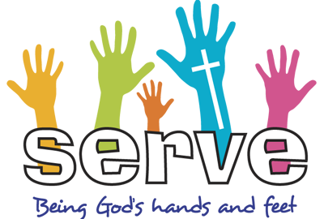

COMMISSIONING OF CEWA BROOME STAFF
In Catholic Education we are called to promote the vision and values of Catholic Education based on the values of the Gospel.
All: We commit to diligently fulfilling this role by witnessing to the teachings of the Gospel.

In Catholic Education we are called to develop our own faith through both our work and our personal lives.
All: We will commit to strive for a deeper, personal relationship with Jesus through prayer and seeking the face of God in all those we meet.

In Catholic Education we are called to embrace and live out a life following in the teachings and modelling of Christ in every action we do and every word we speak.
All: We will commit to live a life infused by Gospel values by embracing the Code of Ethical Conduct and ensuring that we always act in a professional manner.

In Catholic Education in Broome we are called to advocate for our students, communities and school staff, with particular focus on the issues that affect education in remote Aboriginal communities.
All: We will commit to serving the needs of the communities we serve.
CLOSING PRAYER:
Father,
Allow me to serve others with a joyful heart;
Never keeping score;
Always giving;
Never expecting to receive.
Allow me to give of myself,
To give of my talents and of my goods,
To give of my time and of my energy,
To give of my heart and of my soul.
Help me understand the needs of others,
Always Loving,
Always forgiving,
Always restoring;
Allow me to serve others as You serve,
With gentleness, compassion, and tenderness.
I ask all of this through Christ, my model.
Amen.

Grant us:
A passion for LEARNING:
so we may help create environments that educate the whole person

A heart for ENGAGEMENT:
so that respectful relationships and loving communities may be formed, where all may reach their God-given potential.

The wisdom of ACCOUNTABILITY:
to use gifts and resources generously and responsibly according to the model of divine stewardship.

A commitment to Christian DISCIPLESHIP:
that we may grow in building the kingdom and inspire others to live as Jesus lived.

