Saint Mary’s College

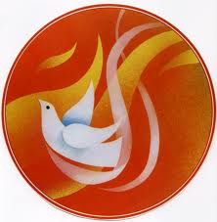
Teacher Handbook

Confirmation Retreat Program
24th October, 2014

Welcome to your Confirmation Retreat, during this time together we hope you will participate fully in all of the activities and be open to everyone who is here.
Remember that at all times you must obey the following rules:
1. Follow the instructions given by all adults here today.
2. Give everyone the chance to participate and appreciate their contributions.
3. Observe signals that mean stop and listen.
4. Be silent during reflection and journaling times.
5. Use courtesy and respect at all times.
8:00am - Gather together at the Holy Place.
8:10am - Prayer with Father and briefing for the day.
8:15am - Pilgrimage to Church.
9:00am - Gathering activity – The Journey of Life
9:30am - Morning tea at St John of God heritage building.
9:50am - Workshop starts, including activities on the story of Pentecost, candle making, and the gifts and fruits of the Holy Spirit.
11:15am – Journal entry and creation of Prayer
12:15pm - Reconciliation.
12:45pm - Lunch.
1:15pm - Confirmation rehearsal.
1:45pm – Gifts of the Holy Spirit Activity
2:00pm - Return back to school (troopy)
Gathering Activity - The Journey of Life Activity

Create a pattern of stepping stones as set out below. Divide the students into teams. The aim of the game is for students to cross their entire team from one side to the other. There is a pathway created and known by the teachers that sit at the top of the area. Students attempt to cross the stepping stones one at a time. If they step on the right stone the teacher says yes and they can keep stepping until they get a no for stepping on the wrong stone. That student then leaves the stones and returns to the back of the line and the next student begins the crossing. As the team members cross to the other side their task is to guide fellow team members across the stones. The team wins when everyone has crossed to the other side.

Reflection Activity
How is crossing the stream like life?
It’s about finding the right way to go …
Sometimes it’s easy…
Sometimes you might take a wrong step
but you can always begin again.
Once you find the way, you have the knowledge and wisdom
and you can use what you have learned
to help and lead others.
Working together makes getting through easier.
The Holy Spirit will help and guide you through life,
give you the courage to begin again
and help you to discover new knowledge and understanding
as you go through life.
Your team is like the Church,
there to help you through and guide you.

The story of Pentecost
After viewing the power point on the Holy Spirit of Pentecost students complete these questions:
What book of the Bible is today’s verse?
What was the Holy Spirit like? Blowing of a violent…
Where did the Holy Spirit come from?
How do we know if the Holy Spirit is in us?

How can you share what you learned today?

Why is the learning about the Pentecost a special part of the Sacrament of Confirmation?
Pentecost is a Christian holy day that celebrates the coming of the Holy Spirit 40 days after Easter. Before Jesus was crucified, he told his disciples that the Holy Spirit would come after him:
And I will ask the Father, and he will give you another Counselor to be with you forever — the Spirit of truth. The world cannot accept him, because it neither sees him nor knows him. But you know him, for he lives with you and will be in you. I will not leave you as orphans; I will come to you. John 14:16–18
And 40 days after Jesus was resurrected (10 days after he ascended into heaven), that promise was fulfilled when Peter and the early Church were in Jerusalem for Pentecost:
When the day of Pentecost came, they were all together in one place. Suddenly a sound like the blowing of a violent wind came from heaven and filled the whole house where they were sitting. They saw what seemed to be tongues of fire that separated and came to rest on each of them. All of them were filled with the Holy Spirit and began to speak in other tongues as the Spirit enabled them. Acts 2:1–4
Although many North American Christians hardly notice Pentecost today, traditional European churches consider it a major feast day. Pentecost, also called Whitsuntide in parts of Europe, is just behind Easter in overall importance. For example, in Germany today, on only three occasions does the observance of a national holiday span two days: Christmas (December 25 and 26), Easter (Sunday and Monday), and Pentecost (Sunday and Monday)
Gifts of the Holy Spirit Questions
Go through the power point presentation as a group and discuss each of the Gifts of the Holy Spirit. Students then answer the following questions.

The Spirit of Wisdom helps us to sense what is true and right, and discover answers to personal questions and difficulties.
What are the questions I have about life? How can Jesus help me?
The Spirit of Understanding is the ability to understand what God has revealed through Jesus about living a Christian life.
What does God want of me? How does God want me to live my life?
The Spirit of Knowledge is the ability to know Jesus’ teachings and to put them into practice when making choices in life.
What do I know about Jesus and his teachings?
The Spirit of Right Judgement is the ability to make decisions that are consistent with the teachings of Jesus.
When have I chosen to do something because I knew it was what Jesus teaches is right?
The Spirit of Courage is the ability to resist temptations and pressures from others and follow the teachings of Jesus.
What has been a difficult teaching of Jesus to follow?
The Spirit of Reverence is the desire to do God’s will as Jesus did by showing respect and honour to God.
How do I show respect to God?
The Spirit of Wonder and Awe is the ability to sense God’s presence within creation and oneself.
What do I wonder about? What is my favourite thing in creation? Where do I feel/sense God?
Fruits of the Spirit
Go through the power point presentation as a group and discuss each of the Fruits of the Spirit. Students then answer the following questions.
What fruits of the Spirit and qualities would you like to develop in your life…

What would you like people to say about you?

What does he mean? How can you be a light for the world?

What type of person would you like to be in the future?

How would you like the world to be?

What will you do to help the world be the place you want it to be?

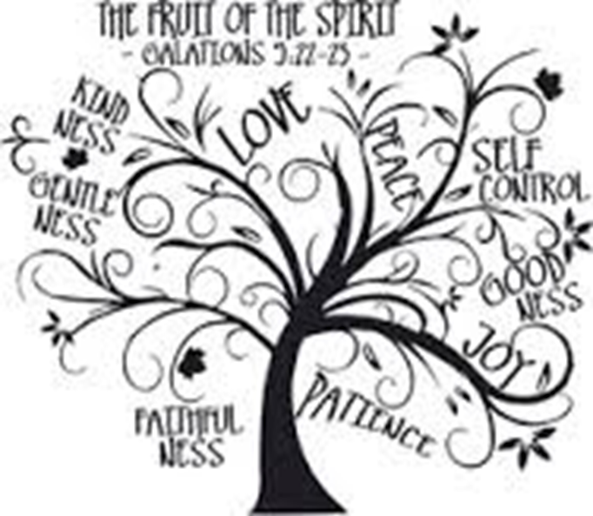

When admiring good qualities in others, we are experiencing God calling us from within to develop these qualities or ideals ourselves. This call grows stronger within us as we try to develop these qualities ourselves, and regret times when we
Candle Activity

Design your candle so that it reflects your personal expression of faith and the Holy Spirit.

Once you have come up with your design of your candle please use the selection of craft to decorate your candle You may include your name and the date of your Confirmation on the candle by using the labels provided.

Journal Entry Questions
Write down the names of these people.
Who do you most look up to and admire… What about that person that you really respect and like? What qualities do they have?
What have you taken from today’s journey? How has it helped you to feel ready to receive the Sacrament of Confirmation? How do you feel about accepting responsibility for your own faith and destiny?

Flame and Dove Activity

Once you have come up with your prayer, take this time to decorate your dove using the crayons and textas provided and write your prayer on the flame.

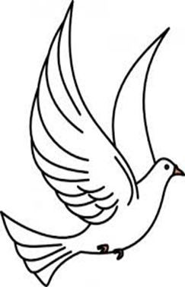

Gifts of the Holy Spirit Activity

