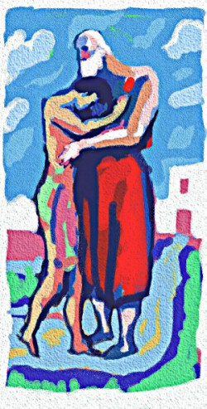“His father forgave him and welcomed him home” (Luke 15:11-31)

St Mary’s Parish
Leederville
First Reconciliation
This is to certify that:

Celebrated the Sacrament of Reconciliation for the first time on:
Thursday 1st September 2011.

Parish Priest: Father Joseph Angelo

