First Reconciliation Is A Family Celebration
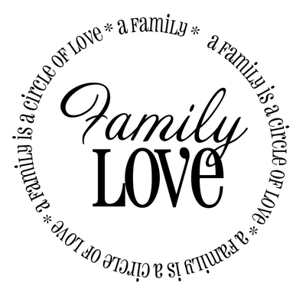
The context of our first understanding of the Sacrament of Reconciliation is in the life of the family.

It is in the family that we learn of the major themes of this wonderful and healing sacrament.
In the family we learn that our selfishness has a bad effect on those with whom we live.
In the family we learn that our actions, both good and bad have consequences.
In the family we learn that we need to ask forgiveness and that we need to give it when it is requested.
In the family, we also learn that there are rules for living in society that must not be broken, but that when they are broken, we need to view one another with compassion and love, even though there is some reparation needed.
Sacraments are not isolated events intended for individuals. Sacraments are by their nature communal, that is, they belong to and must be celebrated in the context of God’s People. So, Reconciliation reinforces our responsibility not only to ourselves, but to God and His family. It is the expression of our common need for grace and forgiveness, not only from God, but from the Church which is the Body of Christ.
.
Here are a few guidelines to help you in preparing your child:
1. A child needs love and security.
Forming a child's conscious begins (and continues) with a parent's love. Your affection, firmness and encouragement can teach your children that they are good. If a child grows up with the impression that their parents (or God) will stop loving them when they misbehave, their conscious development will be crippled. They learn to love and trust when they are loved.

2. A child needs to experience forgiveness.
If a child is to believe in God's forgiveness and mercy, he/she must experience the forgiveness of parents. Your child needs to feel pardoned by you.

3. A child needs to experience the fact that God is a loving Father.
Be careful not to present an image of God as a "law enforcer" in order to pressure the child to obey. Rather, let us teach our children that God loves us always - His love never changes regardless of what we do.

4. A child needs to understand the reason for Rules and Laws.
Does your child realize that there is love behind your rules at home? Does he/she see that the commandments are rooted in love of God and of our neighbour?

5. A child needs a true understanding of sin.
Sin is failing obey God on purpose. It is very important for us to help the child recognize the difference between sins (deliberate acts done on purpose) and temptations, accidents, or making mistakes. Sin is doing wrong on purpose and choosing not to love.

6. A child needs to learn to make choices.
In this area of moral development, the parent can help his/her child learn how to make good choices by discussing some of the simple choices he/she makes each day. This will lead the child to see what the results might have been if different choices had been made. It is important that the child recognize his/her responsibility for words and actions.

