Knowledge
Knowledge is the gift that helps us to know ourselves and the world around us. It helps us to know where our faith is leading us and what our church is about. “Knowledge” is the gift that makes us smart about ourselves. [smarties]
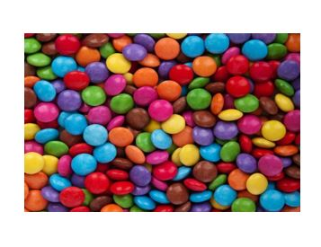
Understanding
In Confirmation we receive the gift of Understanding. This helps us to untie the knots, to straighten out our lives, to deal with our problems. “Understanding” is letting the Word of God have room in our lives. [pretzels]
Wisdom
Wisdom is the gift of the Holy Spirit that helps us to see and understand God’s plan in our lives and in the world. It helps us to say, “Aha, I finally understand.” [glow sticks or mini torches]
Fortitude
Fortitude (or Courage) is the gift of the Holy Spirit that helps us walk out into the world and feel prepared. It gives us the stick-ability to stand up for what we believe. [gum]
Piety
Piety (or Reverence) is the gift of the Holy Spirit that helps us to see God in everything around us. It teaches us to treat our fragile world gently. [flower petals]
Fear of the Lord
Fear of the Lord (Awe and Wonder) is the gift of the Holy Spirit that keeps us awestruck by the power and beauty of God in our lives. When we let the Holy Spirit into our lives, “Fear of the Lord” helps lead us into the mystery of God’s infinite mercy so that we will be constantly amazed at the greatness of our God. (sparklers or party poppers)
Counsel
Counsel (or Right Judgement) is the gift of the Holy Spirit that encourages us to talk things over so that we can make choices that let us feel comfortable with ourselves afterwards. “Counsel” keeps us from feeling like ‘suckers’. [lollipops]

