THE HAIL MARY
When telling a story in this way you seat the students around you in a semi-circle and sit on the floor (or at a low table) to tell the story. The wonder questions at the end of the telling are to get students thinking about the meaning and the meaning of the presentation to them, so there are no right or wrong answers.
(all photos are from the storyteller’s perspective)
YOU WILL NEED:
- a white or gold rectangular cloth, about 60cm long
- a picture of Mary
- a picture with Mary with Jesus (I used one with Mary with Jesus as a baby and Mary at the foot of Jesus’ cross to indicate she was with him throughout his life)
- a stone

Children are seated in a semi-circle ready to listen to the story. Have the white or gold cloth rolled up by your side with the stone and the pictures face down next to it
Place the rolled up cloth in front of you.
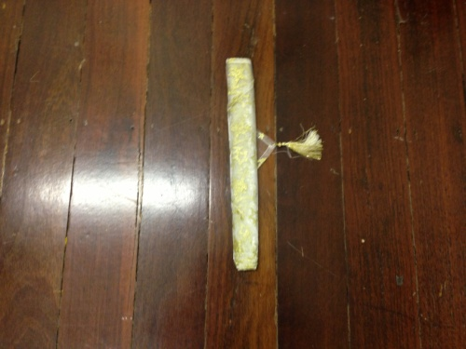

Today we are going to look at a prayer may know, but we are going to learn what the prayer is saying to us.
Unroll a portion of the white/gold cloth, enough to fit the picture of Mary, in front of you. Place the picture of Mary facing the students, on the part of the cloth that has been unrolled.
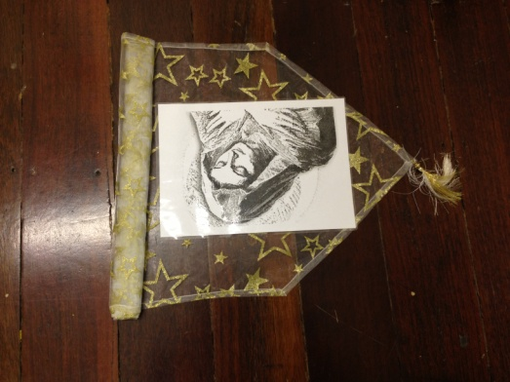

When we start the Hail Mary we say, “Hail Mary, full of grace, the Lord is with you; blessed are you among women…”. When we say this we remember how special Mary was. She was chosen from every woman to be the special person to care for Jesus while he was here on earth.
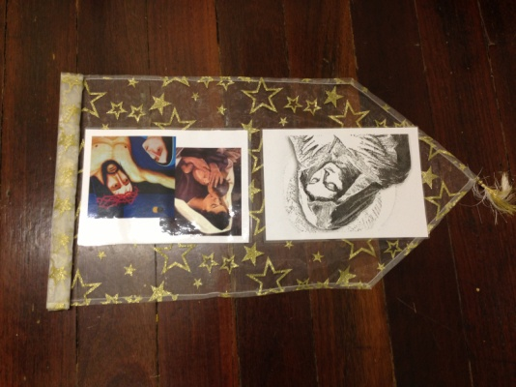
Unroll another portion of the white/gold cloth, enough to fit the picture of Mary with Jesus. Place the picture on the cloth, facing the students.

We then say, “…and blessed is the fruit of your womb, Jesus.” When we say this part of the prayer we remember that Jesus was Mary’s son and that she helped him to grow up to be the wonderful person we hear about in all our stories. She was with him right through his life, helping him, teaching him, protecting him…
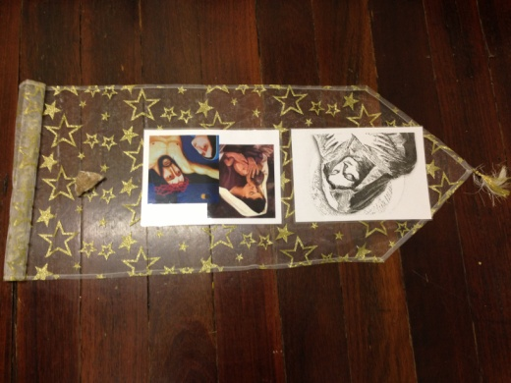
Unroll the rest of the cloth and place the stone in the centre of the material.

We then say, “Holy Mary, Mother of God, pray for us sinners, now and at the hour of our death. “ When we say this part of the prayer we are asking Mary to pray for us, who sometimes make the wrong choices as we try to live like Jesus, so we can be strong and live as Jesus taught us to.
At the end of the Hail Mary, and all prayers, we say, “Amen”, which means that we believe in everything we have said in the prayer.
Spend a moment silently contemplating the presentation before you and then ask some wonder questions.
I wonder which part of the Hail Mary tells you the most about Mary?
I wonder which part of the Hail Mary you think is the most important part?

