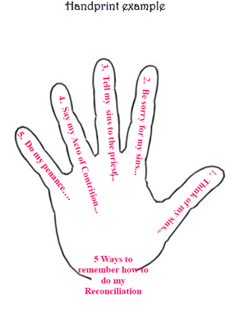
HANDPRINT ACTIVITY

Materials:
White or flesh coloured construction paper
Pencils
Some type of board (we use portable lap boards)
Scissors

1. Bring the children into the confessional and ask them to sit around in a circle on the floor or chairs. We then discuss where the priest will sit and where the child will sit. In our confessional the child has the option to sit in a chair or kneel.
2. We review the Reconciliation procedures that we have given the children and their families prior to this retreat.
3. Pass out the construction paper, pencils, lapboards and scissors. Ask the children to trace ONE of their handprints onto the paper, and cut out.
4. On the handprint have them write the following….

Thumb - Think of my sins
Pointer - Be sorry for my sins (“Bless me Father for I have sinned This is my first confes-sion.”)
Middle - Tell my sins to the priest (“I am sorry for…..we discuss about how many sins to confess)
Ring - Say my Act of Contrition (we call it Act of Sorrow)
Baby - Do my penance (back at my pew)

