Our History
The history of the Catholic Church in the Kimberley began in the late 1800’s when the spread of cattle and the growth of the pearling industry in the Kimberley region drew an influx of Europeans and Asians into the region. In the 1870’s, the Bishop of Perth, Martin Griver, campaigned for a missionary foundation in the north. It was not until 1884, at the invitation of Bishop Griver, that Father Duncan McNab finally arrived in the Kimberley to serve the Catholics in the region and to establish contact with the local Aboriginal people.
Keen to build on the work of his predecessor, Bishop Gibney negotiated for the establishment of an Aboriginal mission in the Dampierland area. A mission site was selected a few kilometres inland from Beagle Bay (Nyul Nyul country) which was a popular lay-up base for the pearling luggers. In 1890, Trappist (Cistercian) monks from Sept Fons in France founded a mission at Beagle Bay. Their activities extended into the growing metropolis of Broome in 1895. In 1901, the Pallottine Fathers from Germany took over Beagle Bay Mission with two priests and four brothers and, in 1907, they were joined by the Sisters of St. John of God from Ireland. The Sisters assisted the priests and brothers in evangelising the coastal and desert areas of the vast Kimberley.
In 1895 Father Nicholas Emo was placed in charge of the mission station in the town of Broome which was developing at a steady pace. The population of approximately 500 consisted of about 50 ‘white’ residents with the remainder being Japanese, Chinese, Malays and Filipinos.
In 1897, the Parish of Broome was established. A small church and a small school for native children were built. The church became known as ‘Our Lady Queen of Peace’.
During the First World War, the German Pallottine missionaries were interned and Father John Creagh, a Redemptorist Priest, took charge of the newly established Vicariate.
Bishop Ernest Coppo of the Salesian order, administered the Vicariate between 1922 and 1928. In 1929 Father Otto Raible SAC, took over and was consecrated Bishop in 1935.
During World War II, the German Pallottine Fathers and Brothers were jailed and interned in Melbourne. Most of the population of Broome was evacuated to Beagle Bay and the Lombadina Missions. Bishop Raible, Vicar Apostolic of the Kimberley, resigned in August 1958 and was succeeded by Bishop John Jobst, the first residential Bishop of Broome.
The post war era saw extensive expansion of missionary activities, influx of religious orders and establishment of the Kimberley Lay Missionary Association. Priests and religious Brothers and Sisters starting moving into the east Kimberley, at the invitation of the Bishop, and a network of parishes and schools spread throughout. There are now eight parishes and 13 Catholic schools within the diocese.
In 1966 the Vicariate was raised to the status of a Diocese. The first Diocesan priest was ordained in 1976.
The present Bishop of Broome, the Most Rev Christopher Saunders, was ordained Bishop on 8th February 1996.
Today, the Diocese of Broome covers over 773,000 Sq Km of the greater Kimberley region and serves a population of over 33,500.

http://www.broomediocese.org/history.html

From KCP Magazine
Church of The Kimberley – Heroes in Faith
Father Duncan McNab
By: Bill Worth
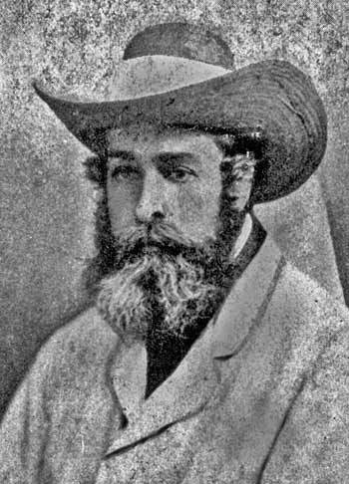
Father Duncan McNab was a Scot, born in the highlands, 11 May 1820. As a cousin to St Mary MacKillop, he heard stories from letters of life in Australia and, even during the early years of his studies for the priesthood, he expressed his desire to one day work in the Great Southern Land among the Aboriginal people.
Ordained on 8 March 1845, it was not until 1867 that Father McNab finally received permission from his Bishop in Argyllshire Scotland to migrate to Australia. He worked initially in Victoria, in Geelong, Portland and Bendigo before moving north to Queensland where he appears to have been given some sort of mandate by Church authorities to minister among Indigenous people, as a type of personal mission that ranged far and wide.
Readily aware of the plight of poor Catholics back in Scotland, particularly those who were land-less, he worked zealously to better the welfare of Aboriginal people in the northern colony. His efforts, as strenuous and forthright as they were, gave rise to a growing number of enemies among the landed gentry and the leading citizens of the day and eventually he welcomed an invitation from Bishop Griver to move to Western Australia in March 1883.
After spending some time as Chaplain to Rottnest Island penitentiary, the missionary call inspired Father NcNab once more when, at the encouragement of the then Perth Vicar General, Father Matthew Gibney, he accepted the challenge to begin a Mission to Aboriginal people in the Kimberley. Eventually, in June 1885, after some time in Derby while forlornly waiting for the arrival of an assistant priest, Father McNab set off on an exploratory journey to the Dampier Peninsula, landing at Swan Point, north-west of Derby, in Bardi country. He had just turned 65 years of age. He had no formal training for this mission, no understanding of the local languages, and no real plan for what came next. But the experience of his work in Queensland assisted him to appreciate the enormity of what lay before him and diminished the culture shock that inevitably accompanied such an apostolate in a remote location. He steadfastly held on to the hope that others would come after him to rescue his work among the peninsula inhabitants and thereafter improve upon it.
He travelled extensively in the area, observing and mixing with local people. When he met a young Aboriginal man called ‘Knife’, who had been working on the pearling luggers and could speak English, and who was willing to act as an interpreter, the first resident priest in the Kimberley was suddenly able to communicate with the people of his vast parish. To this end he began to write a dictionary of the Bardi language. In December 1885, together with Knife, he established himself at Goodenough Bay, among the Nimanboor people, seventy kilometres south of Swan Point. This site was closer to Derby and a more central location for the work of his apostolate.
In April 1886, his long awaited assistant arrived, Father William Treacy. Together the three man team built a bush-timber Church, a rough hewn residence, a bower shelter out of spinifex and they established a garden to grow whatever they could. The Mass, their daily prayers and devotions, and their determination to be faithful to their vocations sustained them in a harsh wet-season environment. Local Aboriginal family groups visited and brought gifts of fish and bush foods, and listened to the missionaries speak of this son of God, Jesus, whose word is “Spirit and life.” The seeds of faith were thus first scattered on Kimberley soil.
Five months later, while in Derby collecting supplies, Father McNab heard stories of the gold rush in Halls Creek and reports that many miners were dying in the harsh conditions without the benefit of the Sacraments.
Accompanied by Knife, he immediately set off on the eight hundred kilometre journey determined to assist however he could. He prayed for the sick, said Mass for the faithful, gave the Last Rites to the dying and presided over their burials. He baptised and counseled and in many instances consoled a vast number of those desperate men who had lost companions during their quest for riches.
On his return to the mission, and suffering fatigue and a grave illness himself, Father McNab discovered that Father Treacy had been taken south to Perth after a bout of severe malarial fever. Bush fires had destroyed the buildings and the garden was in ruins. Feeling the effects of his debilitating sickness and overcome with tribulation Father McNab left the Kimberley by ship for the Northern Territory where he rested and recuperated.
Eventually, this most generous crusader for the rights of Aboriginal people, whose very life personified the idea of dogged determination, found his way back to Melbourne Victoria and stayed with the Jesuits in Richmond. He died in 1896.
For some, his mission in the Kimberley was a failure. He converted no-one, baptised some on their death- bed and left a mission in ruins. Yet stories of him remained; stories of kindness, sincerity and trust. He had sown the seeds of certainty that the word that he proclaimed was Good News in difficult times. It was upon this foundation that others were able to build.

http://www.broomediocese.org/kcp1302/1302-church-of-kimberley.html

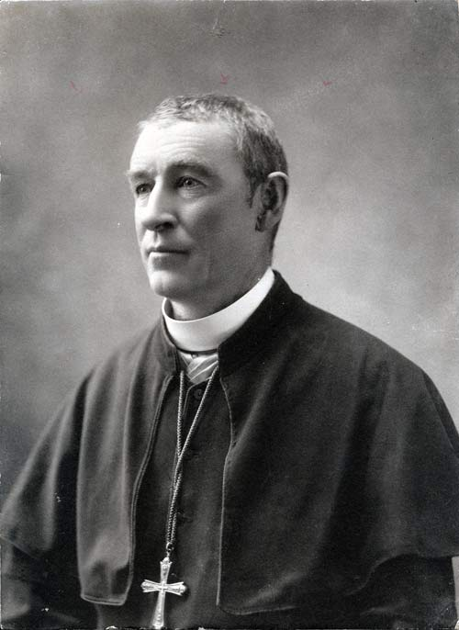
From KCP Magazine
Faithful Heroes of the Church
Bishop Matthew Gibney - Pioneer Bishop for the Kimberley
By Margaret Zucker
An unlikely link between the Catholic Church in the Kimberley and the notorious Ned Kelly was formed one June afternoon in 1880 at the bloody siege of Glenrowan, in Victoria, which marked the end of the feared Kelly gang.
Father Matthew Gibney, of the Diocese of Perth, was in the eastern states to raise money for a boys’ orphanage when his train stopped at Glenrowan, a small country town in Victoria. Learning that the Kelly gang had been surrounded at Jones Inn and were shooting it out with police, Father Gibney walked from the train to the hotel. He found Kelly bleeding from serious wounds to his arms and legs, which had not been protected by his famous armour, heard his confession and anointed him. Then, against advice from Kelly who thought he might be shot as a policeman, Father Gibney entered the burning hotel to search for the other members of the gang, but found three of them dead from their wounds and one, whom he anointed, at the point of death. It was Father Gibney who was able to inform the police of the gang’s deaths and of Kelly’s serious wounds. The he got back on the train and travelled to Albury.
Such was the calibre of the man who was responsible for the foundation of the Church in the Kimberley.
Matthew Gibney was born into an Irish farming family in 1835 and was ordained priest in 1863. He arrived in Perth later that year and became the right-hand man of the Spanish Benedictine Bishop Griver, whose command of English was limited and who appreciated the ability and loyalty of the young priest.
Gibney was consecrated Bishop of Perth by Cardinal Moran on 1 January 1887 and quickly found himself involved in controversy about the position of Aboriginal people in Western Australia’s white colonial society.
Interests of the white pastoralists, who had settled on land traditionally held by Aborigines for tens of thousands of years, were paramount and the first peoples were regarded mainly as a nuisance to be dealt with. Bishop Gibney displayed a very different attitude, writing in a letter to the Trappist Abbey in Lyons, France that his goal was to achieve a work that will be lastingly effective for the welfare of the natives.
The Kimberley was always close to the Bishop’s heart and when two French Trappist missionary priests arrived in Perth the Bishop decided to accompany them on their first expedition to the north, where he had secured land from the government. The little group sailed to Derby on 17 May 1890 and the Bishop helped them to establish the mission at Beagle Bay, where they found a tribe of Aborigines living in the fertile country.
Preferring exploration of the vast Kimberley to administrative duties in Perth, he made a number of other trips to the Kimberley, one with Daisy Bates after the Trappists had suddenly withdrawn from the mission in 1900. At that time in his mid-sixties, he helped clear gardens and paddocks and baptised, confirmed and married a number of the resident people.
Always battling for the Aboriginal people in a hostile political climate, Bishop Gibney was at the same time coping with serious financial problems in Perth. The Pallottine Fathers, who had taken over the Beagle Bay Mission in 1901, also suffered chronic shortages of men and money.
After his retirement in 1910 the great pioneer priest and missionary of the Kimberley lived quietly in Perth until his death in 1925. http://www.broomediocese.org/kcp1301/kcp1301heroes.html
KCP Magazine
Church of the Kimberley - Heroes of Faith
Father Nicholas D’emo: 6 July 1849 – 8 March 1915 (Part 1)
By Bill Worth
The story of Father Nicholas D’Emo is a story of great faith and remarkable courage. This diminutive priest from Emo in Spain stands tall in the annals of fame in the Kimberley Mission. His fascinating life so clearly reflected a deep determination to serve devotedly those people to whom he was sent in mission, the Aboriginal people.
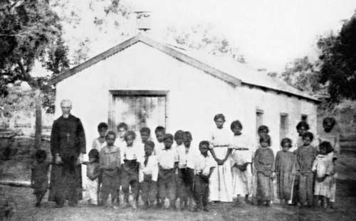
This humble clergy-man had volunteered to join the Cistercians in their Mission at Beagle Bay, arriving in 1895. He was born in Ville Flores, Castellon, Spain but was working as a priest in Patagonia, South America when he heard of the Cistercian Mission in the far north of West Australia. He was determined to join them with the express intention of spending the remainder of his life caring pastorally to Aboriginal people. Such was his determination to succeed in his quest to work with the local people, that he steadfastly remained in the Kimberley as a Diocesan Priest, without the support of a Religious community, when the Cistercians were suddenly ordered by their superiors to leave the Mission in 1899 and take up another assignment.
Soon after his arrival in the region Father Nicholas became the founding priest at Broome and was well remembered for his apostolic work there among local families. He acted in an official capacity at one time as President of the Broome Filipino Association, then a most influential body in the town. He began the first school in Broome for native children and constructed a hostel for half-caste girls alongside his corrugated iron Church on a small sand-hill behind Streeter’s store. Sometimes full-blood children, rescued from the filthy camps located on the fringe of the then ramshackle hamlet, were also taken to the hostel if a good home among the town families could be not found for them. He employed a teacher, a part- Aboriginal woman married to a devout Filipino who, along with her husband, shared Father Nicholas’ vision that the children had every right to a good education and a safe upbringing.
Father Nicholas deplored the exploitation of the helpless women who lived in the town’s fringe camps and did his best to assist them. Eventually he built premises to house the aged, the infirm, the sick and the abandoned peoples of Broome, providing medical assistance himself, tending their wounds and treating their infectious diseases.
In a very short period of time Father Nicholas became well known as a capable pastor and his counsel was sought by all manner of people. Possessing a joyous and extravert personality he moved freely about the tightly structured regime of Broome society drawing support from wherever he could find it. He was not without his critics but chose to answer them with a resolute dedication to preaching the Gospel and a continuing care of the poor and the most marginalized in the emerging port of pearls.
As the first Parish Priest of Broome this dedicated monk never resiled from his hope that one day he would be able to work in the more remote areas of the Kimberley with tribal people. Nonetheless, in obedience he worked tirelessly for those in his care in the pearling settlement. Little did he suspect in 1899 that the Trappist monks were about to be recalled from Beagle Bay, leaving him in charge and opening the way for him to take on the work of the apostolate of his dreams.
Father Nicholas D’Emo
6 July 1849 – 8 March 1915 (Part 2)
By Bill Worth
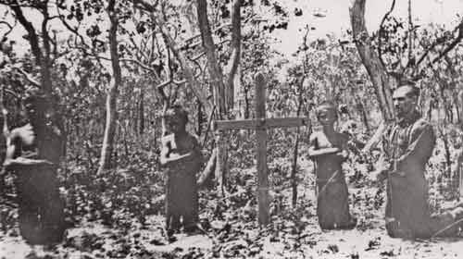
The sudden announcement in 1899 of the proposed departure of the French Cistercians from Beagle Bay and the Peninsula was an alarming development that threw the infant Kimberley mission into turmoil. As Father Nicholas had no desire to retire to other monasteries overseas as the French monks in Beagle Bay were commanded to do, he was soon installed as caretaker Cistercian Superior of the Kimberley Mission.
Finally, in his capacity as temporary Superior, Father Nicholas oversaw the handover of Beagle Bay to the incoming, mainly German Pallottine Missionaries, but by 1906 he had been dispensed from his vows as a Cistercian. With the help of a benefactor, and the blessings of the Bishop in Perth, he purchased a lugger, the San Salvador. Thus began another extraordinary chapter in a vocation of service in the life of this humble priest as he sailed the waters of the Kimberley with renewed vigour and apostolic zeal.
The intention of the Benedictines of New Norcia to begin a Mission in the North-West Kimberley necessitated a scouting visit to the region by the Abbot, Fulgentius Torres, who was met in Broome by Father Nicholas in April 1906. The priest was preparing to establish his mission at Cygnet Bay on the northern part of the Peninsula some distance from the Pallottines in Beagle Bay, among a different tribe, the Bardi. As usual, Father Nicholas was generously accommodating to the needs of others, and upon request he postponed his proposed pastoral work at
ygnet Bay to travel in the San Salvador with the Abbot into the uncharted waters of the far north in search of a suitable location for a Benedictine Mission. The voyage continued up the coast as far as Wyndham and the experience of it all appealed to Father Nicholas’ sense of adventure. He saw a vast area yet untouched by any exploitative European settlement and ready for the Proclamation of the Word that he felt promised hope in difficult times. Eventually, it was agreed that the Drysdale River area was most suitable for the Abbot’s Mission. Upon return Father Nicholas turned his attention to his earlier project at Cygnet Bay.
Father Nicholas lost no time settling into life in his new mission. With the help of his loyal Manilamen and Aboriginal friends he set about building a stone-lined well, constructing a residence and Church out of local timber and paper-bark, setting up a garden and contacting the various pearling camps in the region to offer pastoral care. Aboriginal people from as far south as Disaster Bay visited him, as did the local Bardi. Father Nicholas’ ability as a medic and ‘healer’ was as much sought after as was his welcoming and warm personality that spoke clearly of his care for the people. His decision to call the new Church ‘Our Lady of the Aborigines’ was a result of thoughtfulness much before its time, and indicative of this priest’s complete immersion in his work with his beloved people. Quite typically of this man, the Church was inscribed with the biblical quotation: ‘Nigra Sum Sed Formosa –I am black but beautiful.’
Caption: Father Nicholas D’Emo with East Kimberley children at the grave of Big Charlie, Drysdale River Mission. (Photo: Courtesy of the Benedictine Community of New Norcia WA)
In June 1908 Father Nicholas with the San Salvador helped Abbot Torres and the Benedictine monks found the Drysdale River Mission. The young Filipino and Aboriginal lads who were his crew provided invaluable help with their labour and their willingness to assist with new buildings, the sinking of wells and the provision of useful foods such as turtle, dugong and fish. There can be no doubt that the successful development of the young Mission can be attributed in no small part to the significant contribution made by Father Nicholas who left there for Dampierland in May 1910.
Thomas Puertollano, a Manilaman man who was married to a part Aboriginal woman, Agnes Bryan from Beagle Bay, had purchased a pastoral property at Lombadina. At his invitation Father D’Emo moved into Lombadina to help attend the spiritual needs of the many local people. Catholic Filipinos and their Aboriginal families in nearby pearling camps often made their way into the Mission. There they attended Mass on Sundays and had their children baptized, while augmenting their food supplies from the stores of the enterprising Thomas Puertollano. With the help of a hard-working young lay helper, Joseph Martin Sibosado, the settlement thrived.
The coming of the war in 1914 meant that the German Pallottines were impeded in their travel and pastoral work. Father Nicholas therefore spent more time at sea travelling around the Peninsula area and down to Broome to offer Mass and pastoral services wherever needed. But the passage of time and a restless determination to toil endlessly for the Lord took its toll on the little Spaniard from Castellon.
On the 8 March 1915 at 3:40am, after having suffered a severe stroke, and with the benefit of the sacraments administered by Father Droste from Beagle Bay, this dedicated priest, died in his much loved mission at Lombadina. Characteristically, he was buried simply without any splendour or trimmings, among the people he had ministered to so faithfully. His life was a testimony to a living faith in a loving God and his life’s work was poured out for the Aboriginal people he had served with unwavering determination. Truly this man was a hero in Faith.

http://www.broomediocese.org/kcp1303/1303-Kimberley-church.html and http://www.broomediocese.org/kcp1304/Church-of-Kimberley.html

From KCP Magazine
Church of the Kimberley - Heroes in Faith
Sister Antonio - Leader Into the Unknown - Part 1
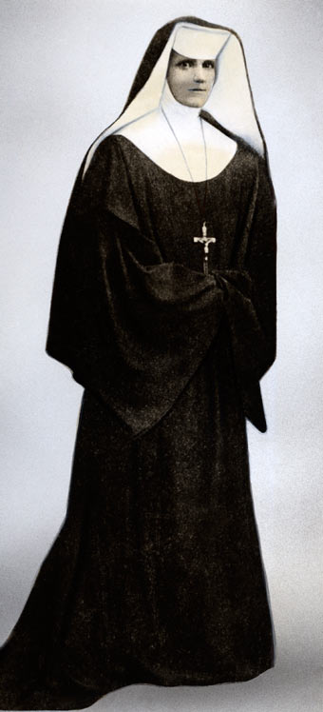
In 1907 Sr Antonio led a small band of Sisters of St John of God to an uncertain future in the North West, which at that time was a practically unknown country to most people in the South of the State. These women struggled against harsh conditions, illness, and exile to stay in the Kimberley and work with Aboriginal and mixed-race people. Antonio had started something that would outlast the pearling industry, the blatant racial discrimination, the hostility of the State Government, the White Australia Policy and the scourge of leprosy, which was about to sweep through the Kimberley in a terrible wave of new suffering that would last for decades.
Born Bridget Mary O’Brien in Ennistymon, County Clare Ireland in 1859, Sr Antonio witnessed the wretchedness of the poor, the deprived and the down-trodden in post-famine Ireland.
As a young woman of nineteen she joined the recently-formed Congregation of Infirmarians (Sisters of St John of God). In those early years Antonio experienced the value of discipline, endurance, limitations of obedience and the dynamics of inter-personal relationships.
In 1895 she volunteered for mission work in Australia and in 1896 began nursing in the goldfields of Coolgardie and Kalgoorlie where she remained for nine years. It followed that, in 1906 when she heard the request from Bishop Matthew Gibney for a female religious order to establish work in Beagle Bay Mission with Aboriginal women and children, she felt obliged to respond.
Antonio faced two major obstacles even before she set off. Firstly, public opinion was against the project which would see female religious go to the Kimberley. Secondly, her colleagues in the Subiaco community were deeply opposed to the establishment of a major commitment in the north-west.
Undaunted, Antonio took the opportunity to accompany a sick sister back to Ireland and while there personally recruited five young Irish women who were joined later by a young woman from Perth. The group rose to nine when Srs Bernardine Green and Benedict Courtney, who had both worked with Antonio in the Goldfields, volunteered from the Subiaco community.
The Mother Superior at Wexford had given the missionary branch her formal blessing but insisted it must be completely self-supporting and separate from the main body of the Order. Antonio’s deep faith and apostolic zeal made up for the lack of experienced religious women and the usual formal Church structure.
The group set sail on board the Bullara on Trinity Sunday June 1907 with the Gospel reading for the day being Go, teach all nations. After calling in to all ports along the coast, they arrived at the entrance to Beagle Bay. To reach the Mission, Sisters transferred first to the Mission lugger, then into a small dinghy before they landed on the beach where Antonio knelt down and fervently kissed the soil of her new home. Paddy Djiagween described this as an act of dedication to his country and its people. (Durack p. 191)
The sisters, relieved to see an end to their long journey, hurried to put their luggage onto the wagon only to be told ‘stores first — hand luggage only this trip.’ After a rough ride to the Mission they were welcomed by the whole population in full regalia; several priests and ten brothers in habits and burettas, boys in cassocks and surplices, warriors flourishing spears (terrifying one sister) and women with screaming babies. Later came a community dinner where beer and wine were served but the tea they longed for did not appear. Exhausted they spent the first night fighting off mosquitoes and frogs.
The very next day, Antonio led the group to begin making relationships with the people of Beagle Bay. Sisters’ memoirs tell us that not only did they provide all the teaching, nursing, sewing, cooking, doing the laundry for the entire community but they also looked after the girls dormitory and a range of pastoral duties. Sr Antonio visited the camp each day, getting to know the people and learning their ways.
Within the first year at Beagle Bay, Antonio took up the cause of the women when she challenged the official policy on marriages. She wrote to the Chief Protector of Aborigines (51986):
Another matter to which I wish to draw your attention is the fact that our half caste girls, will be forced into lives of immorality if the Government Officials persist in not allowing them to be married to the Aboriginals. The ‘Law’ as far as I know does not forbid it; then why should Officials? The ‘Law’ I believe prohibits their Marriage with Asiatics, then what resource is left to them, but a life of frightful immorality. In consideration of this fact, will you, sir, in the cause of justice and humanity, send your permission for the marriage of two parties in this Mission (names given).
Antonio was aware of the huge responsibility that had been placed on her when she led her little band into the unknown at Beagle Bay Mission. After almost twelve months she had no independent means to care for the personal needs of her Sisters, to provide for those who were sick and to train new recruits. She could not fulfil her leadership obligations to provide for the Sisters. Action was needed so she obtained free passage on Captain Owen’s schooner and set off with Sr Benedict Courtney to the nearest commercial town of Broome.
KCP Magazine
Church of the Kimberley - Heroes in Faith
Sr Antonio - Leader Into the Unknown
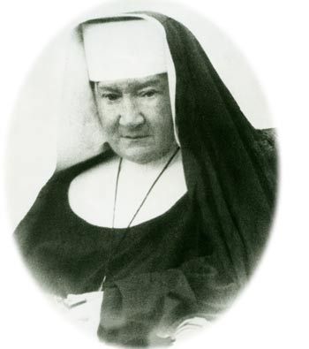
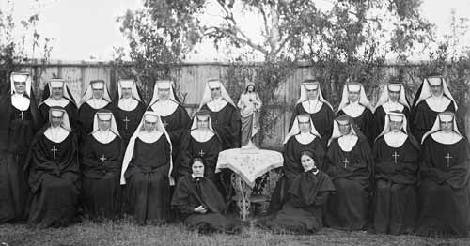
In June 1908, after 12 months at the Mission in Beagle Bay, Antonio, accompanied by Sr Benedict Courtney obtained free passage on Captain Owen’s schooner and set off for Broome to establish a base for the Sisters. By the end of their first day in Broome, she had met and made friends with an Irish woman Rose Gonzales, Japanese and Chinese merchants, and a Phillipino carpenter Leandro Loredo who gave them use of his one room hut where they set up their home.
In the years that followed, under Antonio's leadership, the Sisters ministered to the people of Broome in the areas of nursing, health, education and pastoral care covering all sections of the multicultural population of this pearling town. She was a master at fundraising which can be seen by the way she obtained land and built a convent. Now it was possible to attract new recruits.
Many tributes have been paid to Antonio's ability to undertake the almost impossible, her efficiency and the practical way she dealt with issues. By her actions as a woman, nurse, religious and teacher, she demonstrated a love of God and humanity in all its guises, and responded effectively to the needs of the socially oppressed and unfortunate. It has been said that she forged a survival path and instituted humane care for Aborigines and the mixed race people of the Kimberley.
The Sisters’ memoirs record that she was capable of gentleness and generosity yether determined, independent manner and blunt speech didn’t make friends easily but friends she had in Broome — stalwart ones — and faithful.
Mother Antonio was no killjoy. She dearly loved a good joke, even against herself. … An excellent mimic, Antonio would often entertain the community with amusing stories or by reciting poetry and reading from the classics. She encouraged her sisters to see the funny side of difficult situations and to perform their tasks gaily. She liked to see them enjoying themselves. (Durack p.192)
She never talked of the missionaries goodness to the Aborigines, only of the people’s kindness to them and of the gratitude owed them on that account. Remember, she told her sisters, the natives did not ask us to come. We are here of our own choice and we can remain only by their goodwill and the grace of God.
Durack (p191) states that Antonio was a woman of uncompromising values, she set an example of iron self-discipline. The stiffly starched coif, deep collar, cuffs, pleated bodice and other bulky features of a habit designed for a cold climate were worn with stoical compliance with tradition in temperatures often rising to over 110 degrees.
As Mother Superior, Antonio carried a heavy burden and years of hardship and uncertainty finally took their toll. Sometimes she fainted because of the intense heat. She suffered from Bright’s disease and anaemia and died in 1923 sitting fully attired, in starched head-dress and the heavy serge habit, on the verandah of the then Broome Convent.
One of her oldest friends in Broome, Captain Ancel Gregory master pearler, took charge of all funeral arrangements – Sisters have nothing to do but attend the funeral in the cars I will provide. He was an Englishman and a Freemason. He was one of the two who enabled Mother to build the first convent and he laid her to rest with whatever profusion Broome could offer in those days.
The Sisters who knew her best remembered her spirit of prayer, her apostolic zeal, and simple faith. Antonio was well suited for the tasks she undertook and the significant achievements she and her sisters made possible. She gave a sense of meaning and purpose, and articulated the spirit of the Sisters of St John of God.
The example set by Sister Antonio during her 16 years laid the foundation for the next 100 years of the Sisters of St John of God ministry in the Kimberley.
Photo Captions:
Top: Mother Antonio shortly before her death.
Bottom: Mother Antonio with all her Sisters, a Novice and 2 postulatnts gathered in Broome, 1920. Click on photo for larger version

http://www.broomediocese.org/kcp1305/church-of-kimberley.html and http://www.broomediocese.org/kcp1306/kimberley-church.html

from KCP Magazine
Church of the Kimberley – Heroes in Faith
The Trappists of Beagle Bay
Father Duncan McNab, at sixty-three years of age, never saw himself as remaining in the Kimberley Mission indefinitely. He was, by his own estimation, merely building a crude foundation while eagerly awaiting others to arrive so that the works of the apostolate might continue. One priest who was sent by Bishop Gibney to Disaster Bay Mission fell sick from the ravages of fever and had to return to Perth. Father McNab too was ailing and even his unbridled enthusiasm for the apostolate could not sustain the physical capacity needed in such a challenging environment.
Bishop Gibney’s dream that the Diocese of Perth should establish a Mission in a setting far from the settlement of the southern regions of Western Australia at this stage looked most unlikely to succeed. There, in the south, the Aboriginal people continued to suffer oppression and severe trauma as their lands and traditional livelihood disappeared under the farmers plough and livestock. There was little that could be done to stem the forces of colonization and while Gibney railed against the injustices suffered by Indigenous people his words fell on deaf and hostile ears.
Bishop Gibney continued in his quest to find suitable missionaries and appealed in 1888 to the Holy Father, Pope Leo XIII, who was able to encourage the services of the Cistercian (Trappists) monks of Sept-Fons, France, to go to the remote Kimberley. It was a task taken up reluctantly by Abbot Dom Sebastian Wyart as Mary Durack noted in her history of the Church in the Kimberley, The Rock and The Sand:
“But two years later (May 1890) there was... Dom Ambrose Janny, tall, ascetic and bearded, with little Alphonse Tachon, swarthy and volatile, bouncing at his side, their white, cowled habits drawing curious glances from the crowds on Fremantle wharf as they disembarked.” (page 8)
Their arrival with Bishop Gibney in attendance at the then dismal northern Port of Derby with its ramshackle huts and small population was most certainly a disappointment to them. Father Alphonse Tachon almost immediately went down with a bout of malaria while the heat proved a distinct challenge for Dom Ambrose.
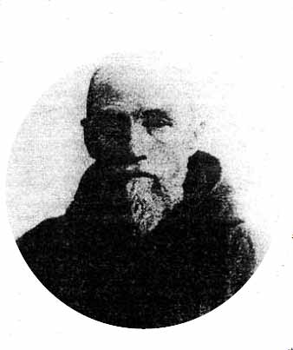
A moment of encouragement for the Monks was the appearance of John Cornelius Daley, a policeman in Derby, who presented himself to the Cistercian Superior as a companion for the journey soon to be taken overland to Beagle Bay, the rospective site of the new Mission. Further, he offered himself as a Novice and was to become thereafter the first vocation to Religious Life in the Kimberley, and from then on was called Brother Xavier Daly.
This faith filled young man was born in 1858 at McCullum’s Creek, a goldfield in the vicinity of Ballarat, Victoria. He was the first of nine children, of Irish parents who had married in Australia in 1857. The family moved several times within Victoria as his father engaged in a variety of commercial undertakings including some time spent in Collingwood, where he had a shop, before finally settling in Dunolly near Ballarat.
John Cornelius Daley had taken up a lease to do farming outside of Derby in 1883 but financial issues forced him to abandon it four years later and to sign on with the police for a period until
the monks arrived in 1890. Evidently his heart was not in policing as he wasted no
time at all joining the Bishop and the Cistercians. Further, there is every reason to suggest that the odious system of awarding bonuses to policemen for the incarceration of ‘suspected’ criminals among the indigenous population, stock spearers included, had led to many instances of injustice and cruelty, and was not in conscience acceptable to the pious young Daly.
With an Aboriginal guide, Dom Ambrose and the Bishop and John Daly set off on horseback across the Yeeda Station plains and through the endless arduous scrub for the spring country of Beagle Bay. Meanwhile, Dom Alphonse, was too ill to travel and remained in Derby to convalesce from his attack of fever.
The diary of Bishop Gibney, written with a casual hand in purple pencil in a small lined notebook, spells out clearly the burdens of each days travel. The presence of the new recruit, John Daly, is an important addition to the team as he applied his well honed bushman’s skills and his ability to work with stock. This alone must have given much encouragement to the bishop regarding the future of the mission yet to be carved out of untamed territory by French Monks - novices themselves to the rigours of a harsh and demanding land. But something wonderful is recorded in the diary too. The engagement with Aboriginal people along the way brought immense happiness to the missionaries. Through their guide the missionaries made it clear that they came in friendship and were in fact the brothers of the much loved Father McNab. This stated relationship ensured a hearty welcome from those clan groups they met and joyful news of their arrival traveled before them.
The Trappists of Beagle Bay - Part Two
By: Bill Worth
By 24 June 1890 Bishop Gibney, Dom Ambrose and John Xavier Daly were satisfied that they had found a site near Beagle Bay for a mission. They then returned to Derby to organize transport for their stores and equipment.
The Bishop was now close to founding his long dreamed of mission to Aborigines in the north while the Trappists, apprehensive but committed, faced the challenge ahead with hope and faith.
The Bishop and the now recovered Fr Alphonse sailed for Goodenough Bay in a police vessel and awaited there for John Daly and Abbot Ambrose who came overland. Once in Beagle Bay the hard physical work began. Gardens were established as a matter of necessity and shelter became a priority for the ensuing wet season with its squalls, incessant heat and destructive winds. Insects and particularly mosquitoes were an added challenge in the Beagle Bay spring country and their level of activity became only fiercer as 'the Wet' grew closer. Happily, the support and assistance of the local people was a welcome respite and their friendly disposition made some things easier to bear. When Bishop Gibney made preparations to return to Perth in September he bid the Trappists farewell and left them with a reassuring thought: "God will provide and I will not see you hungry".
When Abbot Ambrose went back to France, in February 1891, to attend the General Chapter of the Order, and to recruit more monks, he left Fr Alphonse in charge of the fledgling mission.
Dom Alphonse struggled at first to master the local languages and found it hard to grasp the depths and nuances of the culture. Before becoming competent in the Indigenous languages Fr Alphonse usually spoke French with Aboriginal people and was critical himself of his own skills in English. The local Aboriginal people, used to dealing in languages other than their own, soon became accomplished in French and were able to help Fr Alphonse improve his ability to speak the native tongues. Eventually Fr Alphonse translated hymns and scriptural passages into Nyul Nyul and Djabba Djabba. He produced Catechisms in the local language and became well versed in local cultural and ritual matters. He saw some cultural practices as obstacles to growing the faith and identified ways of communicating ideas and principles while building relationships despite the obstacles. Steadfast in his missionary endeavour, Fr Alphonse remained a leading light in the area of the religious work of the mission and was well regarded by the local people as a friend and protector.
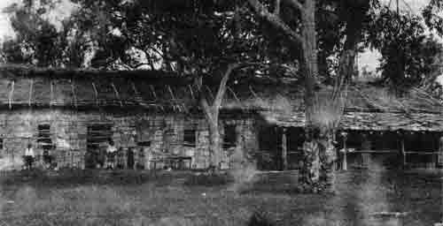
Chapel and Living Quarters at Beagle Bay during the Trappist Years. Photo: From the Pallotine Archives. Courtesy of Tarrawarra Abbey.
The visit of Abbot Ambrose to the Mother House of Sept Fons in France had given rise to some new worries regarding the struggling mission. In Europe he discovered that the proposed reunion of the two Cistercian traditions had forged a greater emphasis on the contemplative over the missionary aspects of monastic living. He doubted that these two aspects were reconcilable in the Kimberley. It would seem, the seeds were sewn for the suppression of the monastery some years later. Nonetheless the Abbot must have felt somewhat buoyed with ten new recruits from Sept Fons chosen for the Australian Mission in 1895. They in turn were mostly enthusiastic for their task although surely some of them found the crude bush dwellings, the continual assault of insects, and the accompanying fevers a challenge to their enthusiasm at times. The division of the day into hours equally spent in sleep, work and prayer was not always manageable. Fr Nicholas de Emo, one of the new recruits, was sent to Broome where he undertook heroic work among the poor and marginalized. Dom Jean Marie Janny, the Abbot's brother, likewise earned a reputation for loving service among the people of the Peninsula and was satisfied that the Trappists had not only a duty but an obligation to work in this area among people whom he felt especially called to serve.
Despite the contemplative hard working efforts of the warm Dom Jean Marie Janny, the teaching and linguistic abilities of Fr Alphonse Tachon, the quiet dedication of Brother John Xavier Daly, and the apostolic zeal of the selfless Fr Nicholas de Emo, the Mission was suppressed in 1899. On-going financial hardships, a lack of support from the Church in Australia at large, a lack of practical interest from Government authorities, the negative argumentation in Sept Fons of the retired Abbot Ambrose against the mission continuing and the support for his position of perhaps three monks from Beagle Bay eventually led to the Mission's demise.
One cannot help but wonder at what might have been had the French monks persevered. If the conflict, in the minds of some, between the contemplative life and the demands of mission living in such a pastorally demanding setting had been reconciled what might Beagle Bay have looked like today? Physically and spiritually, under French influence and Monastic guidance what might the Mission, under the protection of Notre Dame de Sacré Coeur, as it was then called, have later resembled? Somewhere in the DNA of the Church on the Peninsula lies the remnant of a French motif representing a moment in time that was at once unique and so promising.

http://www.broomediocese.org/kcp1401/kcp1401-heroes.html and http://www.broomediocese.org/kcp1402/1402heroes.html
KCP Magazine
Church of the Kimberley
The Pallotines come to the Kimberley Mission 1901 - Part 1
By Bill Worth
When the Diocese of Geraldton was formed in 1898 it encompassed most of Western Australia, including the Vicariate of the Kimberley. With the official resignation of the French Trappists in 1899 from the northern Mission, Bishop William B Kelly was left with the task of finding a replacement Congregation. While in Rome he met some German priests who were followers of the inspiring Roman clergyman, Vincent Pallotti.
After quite some negotiations, the Bishop departed Europe on the ship Fredrich der Grosse in March 1901 with the new Mission Superior, Father George Walter, and three other chosen members of the Pious Society of Missions, as the Pallottines were then known. The group included an English Pallottine priest, Father White, and two German Lay Brothers – Brother Kasparek and Brother Sixt.
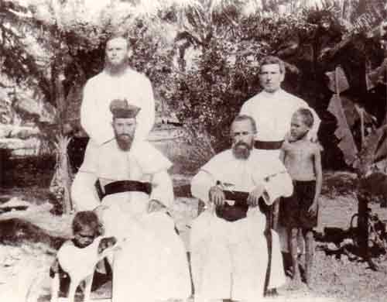
Photo Caption: The first Pallottine Missionaries in Beagle Bay. Fr White, Fr Walter, Br Kasparek and Br Sixt. Photo: Diocese of Broome Archives
They found the Mission in the capable hands of Father Jean Marie, the Trappist priest who had returned from France to oversee the handover, and Father Nicholas de Emo, together with Brother John and Brother Xavier who had remained to manage the stock while assisting the Pallottines settle in. The ramshackle collection of buildings, with their rudimentary bush timber frames, their earthern floors and paperbark lining, proved a shock to the new missionaries who were used to facilities that were kept in better order and were more substantial in construction.
The Pallottines wasted no time, however, gathering people together, inviting them in from the bush to attend devotions and Mass once more, and to work to restore the dilapidated buildings and those recently destroyed by fire. They opened the school and Father White was soon busy conducting lessons for an enthusiastic group of youngsters. While lessons were in English there was, understandably, a smattering of German introduced into general communications around the Mission which the locals took to as easily as they had to French. The continuation of the use of Latin in the Liturgy and devotions was an obvious connection between the French and German missionaries, and the willingness of the new arrivals, particularly Fathers Walter and White, to learn Nyul Nyul and Djabba Djabba was appreciated by the Indigenous tribes people.
Understandably, there was some apprehension by the locals regarding the Pallottine Missionaries since the French Trappists were the only missionaries they had known and they suspected the new ones would be different. Indeed, their fears had some foundation as the newcomers soon exhibited a different type of authority, more strident, and in the personality of the Superior – more severe. In addition, these hard working Priests and Brothers were better organized and more efficient than their French counter-parts, in keeping with the predominantly German character of the Pallottines.
A constant problem the Missionaries faced was the matter of adequate finances, something that was never properly addressed by the Australian Church authorities, nor by government authorities in Perth. While The Church in Australia had been quick to establish a Vicariate of the Kimberley dedicated to work among Indigenous peoples, but it was in a sense a tokenism that left the isolated Missionaries even more alone and unsupported. The State, meanwhile, abandoned its responsibilities to this and other isolated missions, hoping that the missionaries would provide a cheap solution to what was for it an unfathomable problem: How to care for the needs of Aboriginal people and balance these needs against the tireless colonization of pastoral areas? Both Church authorities and State constantly let the Missionaries down. While promises of help with transport, food, building materials, educational facilities were forthcoming from the State, they seldom materialized and constant reviews, enquiries and reports by government bodies were more evident than any meaningful action.
Father Walter was not one to give in easily to the massive challenges he faced and in 1902 he set off to Europe for a general Chapter of the Pallottines, where he presented a strong case for the new Pallottine Australian Mission. He returned with a sizeable sum of money and an important group of six Pallottine Brothers, all hard-working and all steeped in a deep faith. Work and prayer were for these men inseparable components of life, especially that life poured out in the service of the Church. Each aspect complemented the other and with this as the foundation of their spirituality the Brothers shouldered the burden of sustaining the Mission in a practical manner through the continuing difficult times.
“Superintendents and assistant priests would come and go, but these obscure and dedicated men, as others to follow, were to remain year in and out, stamping the missions with the imprint of their toil, passing on to the natives all they could of their ancient crafts and their enduring faith”.
The Brothers learnt how to rotate crops in the soils of the spring country and introduced foods that readily sustained life: sweet potatoes, corn, cassava, plantains, vegetables in season, peanuts, mangoes and rice. Goats for milk and meat, shorthorn cattle, Timor ponies, mules and donkeys, hens, ducks, and guinea fowls and useful catches of fish and turtle from the sea were all part of a very significant effort to survive the harshness of the country to enable the apostolic work to continue.
KCP Magazine
Church of the Kimberley
The Pallottines and the Kimberley Mission 1902-1914 - Part 2
By: Bill Worth
The Mission at Beagle Bay continued to grow in significance as the hard working German Missionaries under the leadership of Fr Walter adapted to their new environment with its challenges and difficulties. The idea that the mission was a protectorate for Aboriginal people, saving them from exploitation by crews of Pearlers, was not always recognized by the Pearl fishers and certainly never appreciated by them. Songs of lamentation prominent among the Bardi people told stories of young men being ‘black-birded’, enticed upon boats and forced to dive for Pearl shell, and then disappearing for ever. For many in the Pearling industry, the local native population was merely a factor of production to increase their wealth by the use of free labour. Tensions over this matter of rampant exploitation between these men of the sea and the missionaries continued for a long time to come. In 1903 the Government became so concerned with this problem that a policeman was stationed at the Mission. The police presence gave rise to a little success in protection of the local Aboriginal population although with shore-based camps dotted all over the peninsula, on every large creek and inlet, there was still considerable abuse of women and girls by idle Pearling crews during lay-up times. Meanwhile, the practice of ‘black-birding’ continued to a lesser degree sometimes cleverly disguised as employment.
The inter-action between the growing population of Pearlers, Graziers and miners and the Aboriginal people of the Kimberley extended beyond economic matters. All over the region there was emerging a growing number of half-caste children, some of whom were treated well by their families and cared for, and some of whom who were not. Stories of the exploitation of these children found their way to Perth and their welfare became a cause for justice with little distinction made between those who were treated harshly and those who were not. A 1904 Act of Parliament gave rise to an attempt to address what some saw as a scandal and what others saw as a sad state of affairs that needed to be urgently rectified. What later became known as the ‘Stolen Generation’ or the ‘Separated Children’ began with Orders from Magistrates authorizing police to remove children “from their perilous existence” and place them in institutions of care. Under Fr George Walter’s leadership, and then later in 1908 under a reluctant Fr Joseph Bischofs, and with political and financial encouragement from the Government, Beagle Bay became one such place – now not merely a protectorate and a mission for Peninsula Aboriginal people but also a refuge for those of mixed race from elsewhere who were deemed by authorities to be in need of such care.
By the time Fr Walter left for retirement in Germany in 1908, major changes had occurred at the Dampier Peninsula mission. The St John of God Sisters had arrived led by Mother Antonio O’Brien and had set up house in the seriously sub-standard accommodation offered to them. The Irish Sisters could not have found anything less like Ireland when they arrived at this distant ‘Vineyard of the Lord’. There was much to be done and to the Sisters goes the credit for providing a warm presence in such a demanding and austere environment. They cared for the children who had arrived from distant parts of the Kimberley, as well as the locals, and they taught in the rudimentary school house providing knowledge and skills as best they were able. English became the common language as a means to deal with the competing various languages that came to Beagle Bay with the children from the East Kimberley, a factor that found approval from the authorities who saw education as a means to ‘civilize’ those removed from their homes for care in places like Beagle Bay.
Fr Thomas Bachmair quickly succeeded Fr Bischofs as Superior of the Mission. Fr Bischofs was more content to work on his anthropology and language studies and he translated the catechism into Nyul Nyul and Djabba Djabba. He felt most at home in this role. Fr Bachmair meanwhile was quiet and reluctant to accept the post but dutiful just the same and therefore took on the position of leadership during what was to be a most challenging period for the Church of the Sacred Heart at Beagle Bay. In 1914 the British Empire declared war on Germany and the German Pallottines at Beagle Bay found themselves in awkward times.
KCP Magazine
Church of the Kimberley
Title: The Pallottines in the Kimberley Mission 1914-18 Part 3
By Bill Worth
When War broke out in Europe, young Australians responded to the call to join the armed forces ‘For King and Empire’ with remarkable enthusiasm. The cost of this Great War to human life and well- being for our nation was simply enormous, as it was for those on the other side of the hostilities. Consequently, and with the assistance of war-time propaganda, feelings of anger and hatred towards Germans were running high.
In Beagle Bay, the German priests and brothers were fingerprinted and warned against pursuing any adverse activities. As aliens, they were regarded with suspicion and the white people in Broome had to be assured that ‘these enemies on home soil’ were well supervised. In the ensuing hysteria the resident policeman at Beagle Bay was put on full alert and the navy one time did a search of the Mission premises looking for signs of enemy activity. Naturally, nothing suspicious was found. However, Fr Bischoffs, always a little pugnacious and lacking due discretion in his opinions, was sent away to New South Wales where he found a home with the Bishop of Armidale for the duration of the War. Later he was posted to South Africa and his anthropological and linguistic gifts were forever lost to the Peninsula Missions.
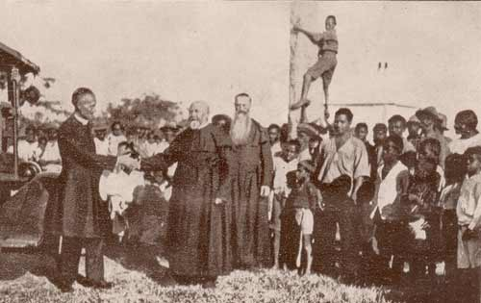
Photo Caption: Fr Droste, Fr Puseken and the Beagle Bay community welcome the Apostolic delegation including Bishop Coppo circa 1922. Photo: Diocese of Broome Archives
The German Missionaries were now cut off from any support from ‘home’ and together with the Sisters of St John of God they suffered severe deprivation. The Government authorities in their usual inept and hostile way were unable to maintain the necessary regular stores and subsidies to the Missions, citing the difficulties of war-time shortages. The emergence of A.O.Neville as The Protector of Aborigines was no help to the Missionaries since he had always adopted an adversarial position with the Catholic Missions and saw in their alien status the opportunity to remove the Church as a provider of services to Aboriginal people. He failed in his attempt to side-line the missionaries when senior Church personnel such as the Archbishop of Perth and the now retired Bishop Gibney intervened. The thought that the Government could somehow provide such services in a competent and humane manner was accepted by many, but not by Neville who continued in his prejudiced ways against the Church, to no avail, for many years to come.
Neville even tried to seize Lombadina in 1915, upon the death of Fr Nicholas de Emo, on the grounds that the land was being held illegally by an Asiatic, Thomas Puertollano, who had by law no right to own land or employ Aborigines, For a while the future of that Mission looked extremely grim. However, the new Pro-Vicar Apostolic Administrator of the Vicariate of the Kimberley, Fr John Creagh CSSR, with the help of his brother Monckton, purchased the land with the intention of transferring it to the Pallottines after the war when such a move would be politically more palatable. Fortunately, once more, Mr. Neville was thwarted in his attempt at domination of Missionary efforts on the Peninsula.
Fr Creagh CSSR, who hailed from Ireland, was appointed to his position as Pro-Vicar Apostolic in the Kimberley Mission with the help of the Irish Redemptorist, Archbishop Patrick Joseph Clune, of Perth. The kindly priest came with a reputation of care for the poor and was immediately regarded as a friend of Aboriginal people. He was appalled at the living conditions of the missionaries and in particular, of the St John of God Sisters. He set about rectifying their accommodation needs in Broome and further, he allowed the sixteen St John of God Sisters in the Kimberley to abandon their dark European religious habits, made of climatically unsuitable serge material, in favor of cooler white cloth. This action alone came as a welcome relief to the nuns who labored so tirelessly in the tropical climate.
The new Pro-Vicar was, according to them, also immensely kind to the German missionaries now effectively held captive on the Mission reserve. He did his best to gather assistance from down south and from other bishops in Australia to assist the Pallottines and the Mission - something that, as usual, never resulted in great success. He regularly left his simple residence in Broome to visit the forlorn Missionaries and eventually appointed the quiet and sensitive Fr Bachmair to Lombadina to succeed Fr De Emo.
However, before he took his appointment in Lombadina, Fr Bachmair had convinced the Pallottine community in Beagle Bay to begin work on a new Church, of monumental proportions in contrast to the previous simple temporary buildings. It was an breathtaking task that involved the entire community at the Mission. Furnaces were built to burn the sea shells to make the lime. The monks and the people collected everything from firewood to mother of pearl, clay for bricks and seeds for decoration, tonnes of sand for rendering walls, wild berry juices for the artists’ paint and native timbers for the windows, the pews and the altar rails and the doors. It was an imposing work with its significant bell tower and flying buttresses. It was most of all a labour of love and faith undertaken at a time when morale was low as the result of a protracted war. An inspiration was needed to lift peoples’ spirits and according to the journals of the day never before had the local people and the missionaries worked together with so much unity and with so much enthusiasm as they did on this project.
The Church was officially opened in 1918 and named in honour of the Sacred Heart of Jesus. To this day it stands as an amazing monument to human endeavour in the face of punitive adversity. It signifies faith as a powerful force enabling humanity to achieve what so many had never imagined nor thought possible. This German Church in the Australian bush was Fr Bachmair’s idea, but it was the towering symbol of inspiration for so many others at the time and for generations to come.

http://www.broomediocese.org/kcp1403/1403-church-kimberley.html, http://www.broomediocese.org/kcp1404/1404-church-of-kimberley.html and http://www.broomediocese.org/kcp1405/1405-church-of-kimberley.html

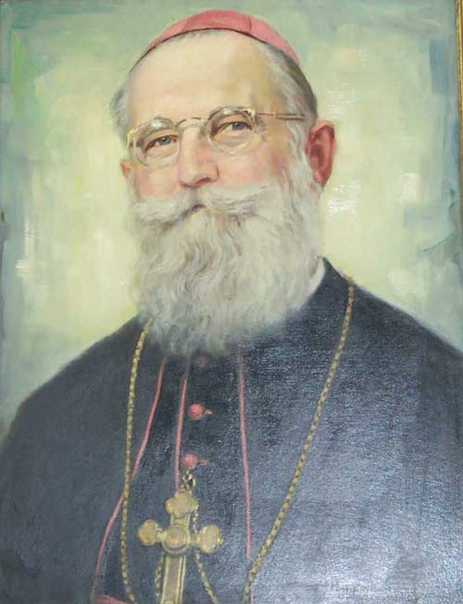
KCP Magazine
Church of the Kimberley - Heroes in Faith
Bishop Otto Raible SAC - Part 1
By Bill Worth
Father Otto Raible was assigned, after ordination to the priesthood in 1911, as a Pallottine Missionary to the Cameroons, in Africa. However, a serious bout of fever forced him home to Germany just before the First World War. After serving as a chaplain in the German Army, Father Raible spent some time as a professor of History at the Pallottine Seminary at Limburg before being sent to replace the ailing Father Droste at Beagle Bay. Arriving in Australia in May of 1928, at the age of forty-one, Father Raible was in fact appointed Apostolic Administrator of the Kimberley.
His first reaction on arriving at Beagle Bay was that of shock as his eyes set on the isolated mission which appeared primitive and underdeveloped compared with the Cameroons. He stood in awe of his confreres who so obviously suffered numerous deprivations regarding shelter, good health, clothing, diet and recreation. Some of the Brothers working there had not had a break from the Mission for twenty years. The Sisters, too, struggled with the demands made on their services in education and health, nonetheless generously denying themselves much to remain faithful to their commitment.
Newspapers described the Bishop as “a picturesque person”, “striking” and “jolly”. His talent as a musician was appreciated by all he met and the long flowing black beard meant he stood out as someone who took your eye. Stories of his congenial nature still survive in the Kimberley among those who knew him personally.
The opposition to the work of the Catholic Church in the Kimberley by A.O. Neville, the Chief Protector of Aborigines, continued unabated. More and more Government control and an increase in the regulations hampered the work of the Missionaries. The demand of authorities that English be the only language used among children at school was one such regulation. Another was that the production, in the Mission’s tailor shop, of fine quality shirts might be made but not sold outside of the mission, no matter how high the demand for them. At one time Aboriginal Lay Missionaries from the Peninsula assisted the expansion of the Church into the East Kimberley - George Dan, Paddy Paddy and Philip Cox in the first group - a noble and generous effort, only to be met with a staunch rebuke from A.O. Neville, who railed that the natives had left their Reserve without his permission.
It is obvious that the preferred methodology of the Vicar Apostolic of the Kimberley, Bishop Otto Raible, ordained a Bishop in 1935, was to do something and see what happened. Hence it was that the Bishop brought from Germany two Pallottine priests who were anthropologists and linguists, Father Ernest Worms and Father Hemann Nekes, to study Aboriginal society and to enable some professional appraisal of Indigenous culture and language. At the same time a husband and wife team of doctors enabled the Bishop to look to provide medical services in the East of the region where they had never been before. He purchased a cattle station, “Rockhole”, not far from Halls Creek with the intention of building a major hospital with a school attached. A.O. Neville did his best to see to it that no such hospital was ever built and no German doctors were authorised to practise their profession in the East Kimberley. One cannot but imagine what such a project might have achieved in the realm of Aboriginal health had Mr Neville been more receptive to ideas outside that of his own narrow framework.
This setback did not prevent Bishop Raible from exploring further the possibility of an Eastern Desert Mission. The intrepid Father Ernest Worms, armed with little more than a notebook, a billycan and a light swag, explored the area on the Canning Stock Route and around Lake Gregory, meeting with local Aboriginal people, studying their language, eating their food and recording their major travel routes throughout the area. This primary work would result eventually in the removal of all mission livestock and personnel from Rockhole to Comet Well and Tjalawan, to the far south of Halls Creek. After three years of living under canvas and in rough shelters, a mission was later established at Old Balgo Mission under the leadership of Father Alphonse Bleischwitz. The Bishop regarded the establishment of Balgo as his work, one “close to his heart”, and told Father Alphonse as much. Now, decisively, the Church in its endeavours and under the leadership of the Bishop, moved away from the coast to begin a new era in furthering the Faith in the Kimberley.
http://www.broomediocese.org/kcp1502/1502church-of-kimberley.html

