LECTIO DIVINA
Choose a piece of scripture and use the Lectio Divina way of praying the scripture as outlined below.
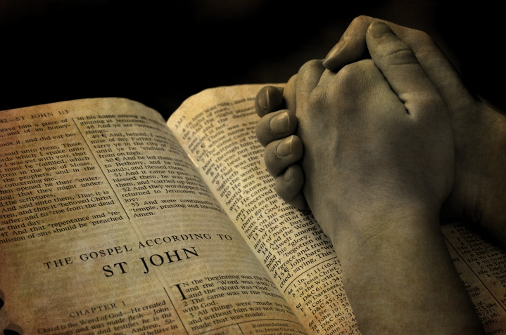
Lectio Divina (‘holy reading’) is a way of praying with the Scriptures that allows the words you read to flow into every part of you; thoughts, words and actions; body, mind and soul. Lectio Divina begins with developing the ability to listen deeply, to hear with the ear of your heart. It is a time to slow down, a time to quieten, a time for silence.

Understanding Lectio Divina :
There are 5 steps in this form of prayer
- Readiness: This first part is a time to still the body and to enter into silence. Breathing and awareness exercises may help students to come to this readiness to listen and pray. It is a time for relaxing and letting go of thoughts or worries. Reflective music may be used to help with stilling and calming.

- Reading (Lectio): This is time to read or listen to someone read a short passage of scripture slowly and reflectively. Participants are invited to allow these words to sink into one’s mind and heart. There needs to be an age or stage appropriate time of silence after this first reading.

- Reflecting (Meditatio): This is a time to read or listen to someone read the passage once more. It is a time to pause wherever a word or phrase stands out or speaks to the listener. Participants are invited to stay with this word or phrase repeating it gently in one’s mind. They are invited to take time to listen to this word or phrase. There needs to be a suitable period of silence.

- Responding (Oratorio): This is a time to read or listen and to let one’s heart speak to God and respond in prayer. It may be a time to thank God, praise God, ask for forgiveness or pray for others. This can be a time for silent or verbal response.

- Resting (Contemplatio): This is a time to rest quietly and peacefully in God’s loving presence.

