Looking for a special way to pray the Rosary? Try bringing a Living Rosary to your school or religious education community. This beautiful prayer service takes some preparation and practice, but many teachers have found it makes for a powerful and prayerful annual tradition.
The Rosary, in this case, is made of students, with each representing a bead. Select a group of students (61 in all) to embody the Rosary in the church. Pass a wireless microphone, if available, around the human rosary, with each student leading the prayer associated with his or her position in the Rosary.
- Form the decades by arranging 50 students in segments of ten around the perimeter of the church. This can be a good way for younger students to participate, as they need only lead one Hail Mary each.
- Between the decades, place five individual students. This can be a good way for older students to take a leadership role in your community’s prayer, as each will lead the Glory Be, the Fatima Prayer, announce the next mystery, and lead the Our Father before passing the microphone to the next student.
- If your church has stairs leading up to the altar, this is a great place to form the “tail” of the rosary or you can bring the tail back into the middle of the church (see the diagram below). Have six additional students form a line from the main part of the “rosary” up toward the altar, bending the line slightly so students sitting in the pews can see. The student on the end should hold a crucifix, perhaps the one used during the opening and closing processions at Mass. As with the other groups, select students of an appropriate age to lead their corresponding prayers.
- Be sure to select a strong leader to offer the “Hail, Holy Queen” and “Sign of the Cross” at the conclusion of the Rosary. This will likely be the same leader who announces the first mystery and leads the first Our Father.
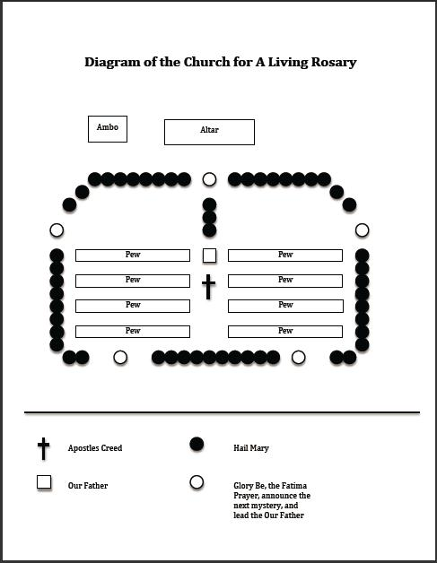
Select your group well ahead of time to allow for at least one rehearsal. You’ll want your “beads” to feel confident in their role as prayer leaders, and practice will help relieve the anxiety about where to stand, when to start speaking, and what to say.
On the day of the Living Rosary, gather your “beads” in the church and then bring in the rest of your students and have them sit in the pews. They may wish to bring regular rosary beads or may prefer to watch the microphone as it moves around the Living Rosary. Either way, this unique prayer service brings your whole community together around the Rosary.
Living Rosary Variations:
- If you plan to do a Living Rosary with a smaller number of children—a single class—then divide the students up into the different decades and “tail” of the rosary or have a Rosary procession very much like the Stations of the Cross only each “station” is a Mystery of the Rosary.
- If a cordless microphone is not available, you may want to select a small group of prayer leaders – perhaps one per decade and a sixth to begin and end the Rosary – and have them lead prayers from the ambo. In this case, you might give each “bead” a taper candle. As the prayer for their bead is said, the previous student can light that taper candle from his or her own. (This variation may be especially meaningful when praying the Luminous Mysteries!)
- Rather than simply announcing the Mysteries, you might have a group of older students prepare reflections on the mysteries to offer at the appropriate times.
- Invite guests from the community—parents, representatives of local social justice organizations, your pastor or resident sisters, etc.—to introduce the mysteries with reflections of their own. This can be a meaningful way to incorporate a focus on vocations into the Living Rosary.
You can download a PDF of the Diagram of the Living Rosary to use as a reference tool.
This was a guest post by Jennifer Dees and Meghann Robinson who work for the Alliance for Catholic Education. They also wrote a popular collection of Catholic Schools Week Ideas that thousands of visitors found helpful in 2010.

