Our Lent Prayer Place
Unit 3.2

YOU WILL NEED:
* small table
* box or basket, containing a purple cloth, ashes, outline of feet, Cards: prayer, fasting, giving to poor; Bible, bookstand, crucifix and purple candle (white candle tied with purple ribbon) next to your chair
Invite children to sit reverently in a circle in the part of the classroom where you intend to set up a prayer place. Begin by saying…
As Lent begins we’re going to change our prayer place. During Lent we’ll have different symbols and objects on our prayer place.

Cover the prayer table with a purple cloth.
At this time of the Church’s year we place a purple cloth on the table. Purple is the Church’s colour for getting ready or preparing. During Lent we prepare ourselves to celebrate the great season of Easter.

Place ashes on the prayer place.
The season of Lent begins on Ash Wednesday. Today, a cross is drawn on our foreheads with ashes.

Place feet on the prayer place. Place word cards on the feet.
Lent is a time to think of ways we can change and follow Jesus more closely through prayer, fasting and giving to the poor.

Hold the Bible up for all children to see. Be conscious of handling the Bible in a reverent manner.
Our Bible - At this time in the Church’s year we remember and tell the stories of what Jesus said and did towards the end of his life.
Place the Bible on the bookstand.

Hold the crucifix.
This is a crucifix. It’s different to a cross because it has Jesus on it. The crucifix reminds us of the way Jesus died on Good Friday.
Place the crucifix on the prayer place.

Hold the candle.
The candle reminds us that Jesus, the light of the world is always with us. We’ll light the candle each time we pray or when we’re listening to the stories from the Bible.
Place the candle on the prayer place.
This is our prayer place for the season of Lent.
Point to the symbols and objects as you name them again.
It has a purple cloth, a bowl of ashes, ‘feet’ to remind us that we follow Jesus, the Bible, a crucifix and a candle.
[During Holy Week symbols for Palm Sunday and Holy Thursday could also be added to the prayer place.]

Resource Sheet 2

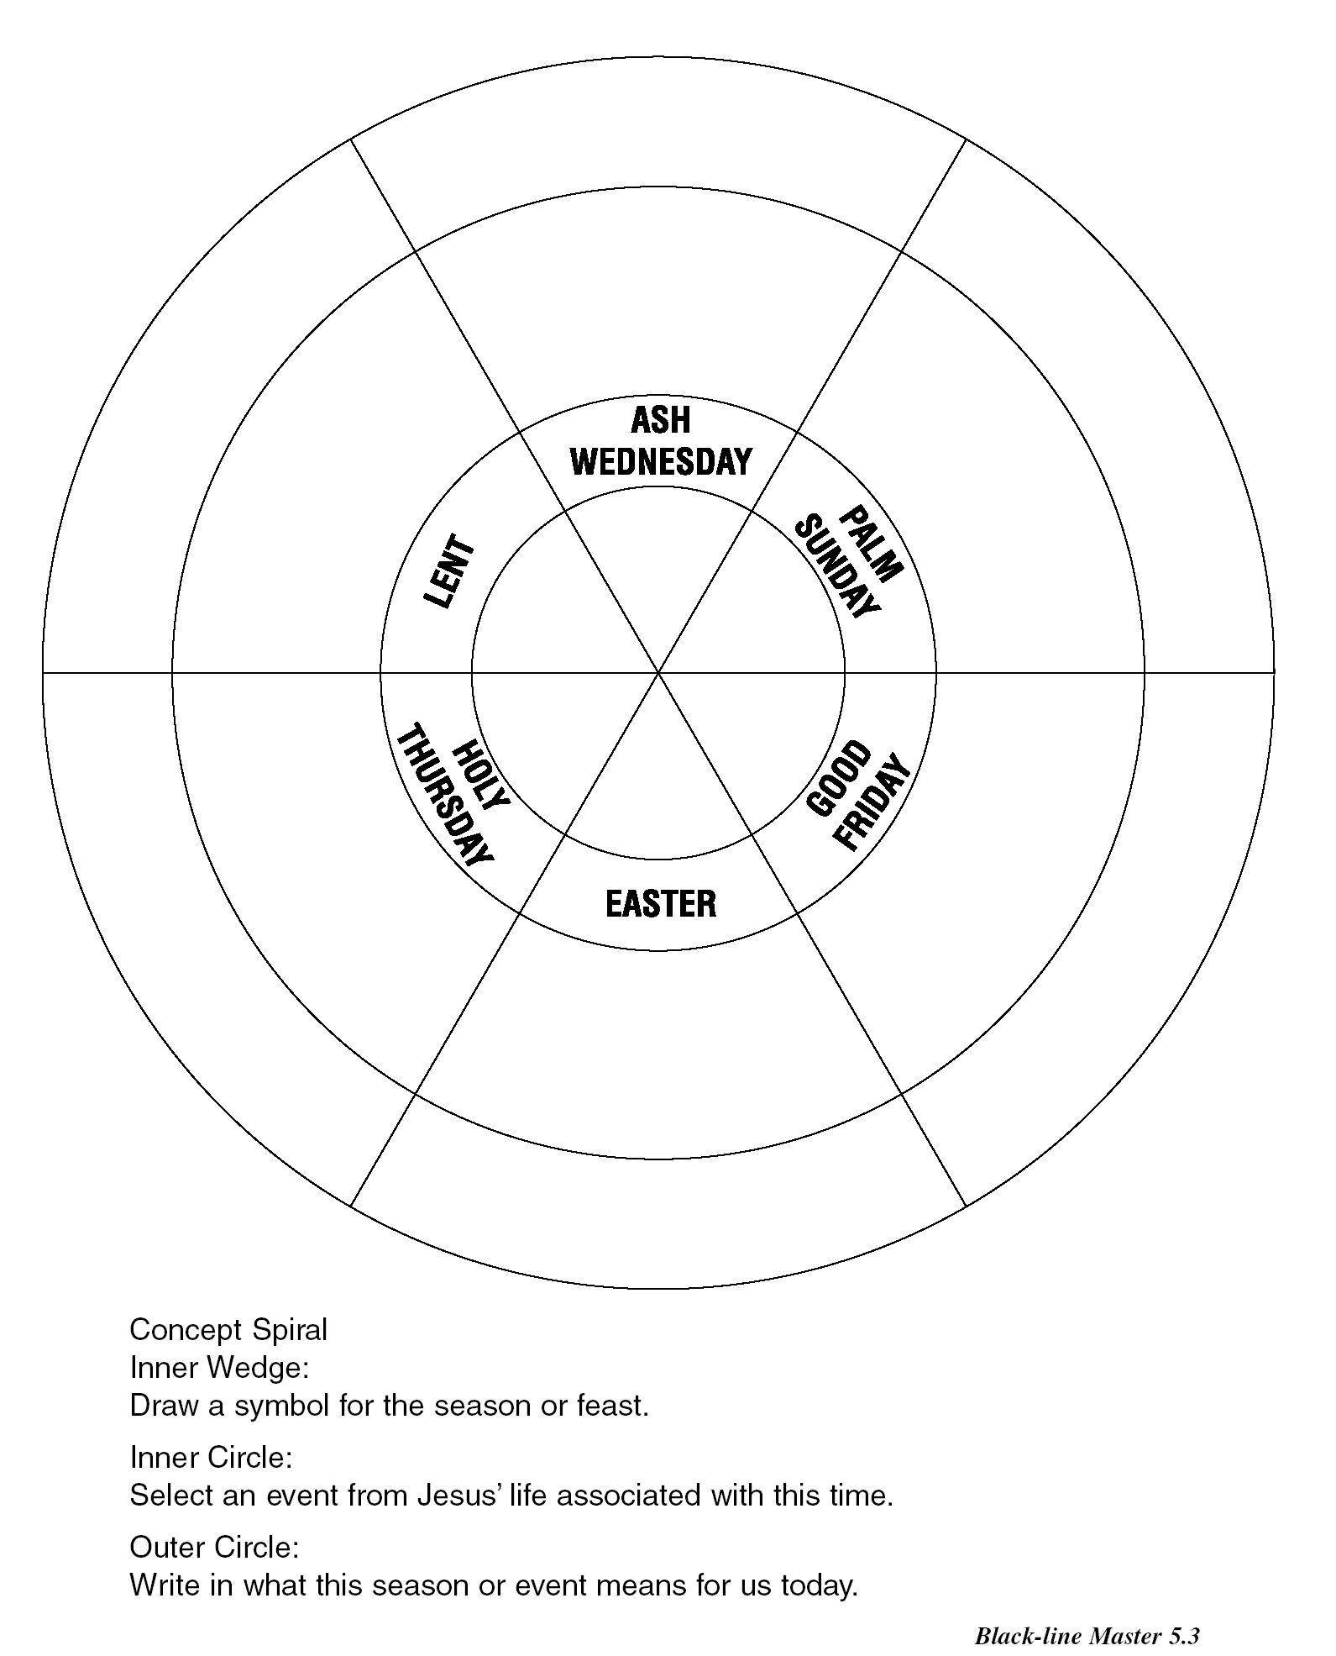

Most Eastern Catholic Churches begin the season of Lent on the Monday before Ash Wednesday. For Maronite and Armenian Catholics this day is called Ash Monday and for Byzantine Catholics it is called Clean Monday. For more information on Eastern Catholic Churches see http://resource.fraynework.com.au/object.cfm?o=205&pid=1472&showrm=true&uptam=false

