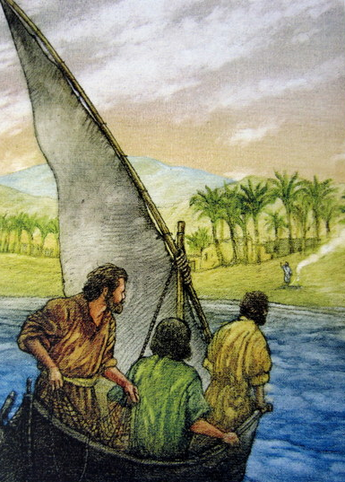
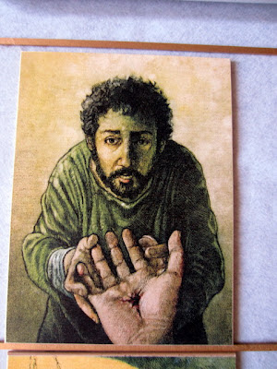
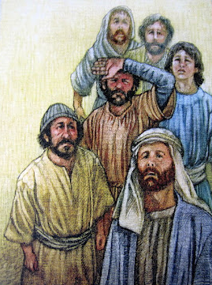
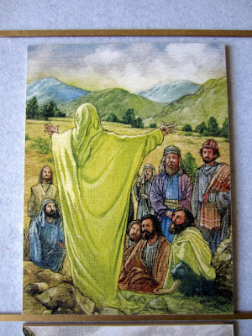
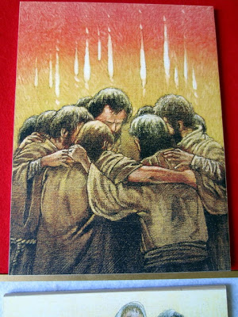

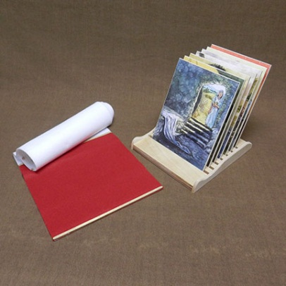
This script is done on a long white cloth, rolling out some more to put the next picture. It is completed on a red cloth with Pentecost.

Knowing Jesus in a New Way 1: Known in Absence
This week’s story always gives me goosebumps-especially the moment when Jesus calls Mary’s name and she recognizes him. It’s hard to think of a story that would be more full of suspense and fear and joy, and the script for this Godly Play lesson does such a great job of sharing all of that with the children. I’m so glad that we don’t have to cram all of the after-Easter stories into Easter Sunday! It’s a luxury to be able to enjoy them and study them over several weeks.
The script is shared in the book that comes in the basket with your story tiles. This series is told much like the Easter series, with each lesson shared in a weekly tile, presented in sequence. The book suggests that after the story is shared, that you give the children time to find something among your Godly Play materials that helps further tell/illustrate the story. I hope that if you have the materials out in your room that you’ll do that. I’ll also include wondering questions for you for each week.
Here are the wondering questions for this week. Thank you so much for taking time to jot down responses so that we can share them with the parents.They have shared that they find it meaningful and enjoy feeling connected to what happens in class.
Wondering Questions:
1. I wonder what your favorite part of today’s story is.
2. I wonder what the three women named Mary first felt when they saw that the tomb was empty.
3. I wonder what Mary thought when the person she thought was the gardener called her name and she realized it was Jesus.
4. I wonder what John and Peter hoped to find as they ran to the tomb, and what they said to the others when they found it empty. I wonder what they thought would happen next.
5. I wonder if there are ways we can learn about Jesus even though he’s not here with us. I wonder what those ways are.
6. I wonder what God is trying to teach us with this story about loving Jesus even when we’re not with him.
Knowing Jesus in a New Way 2: Known in the Breaking of the Bread

What a remarkable story from Luke 24:13-35. Two followers of Jesus (Cleopas and another unnamed) are walking from Jerusalem to Emmaus, talking about what had just happened to Jesus, and they meet a stranger on the road who asks them what they are discussing. The stranger is Jesus, but they don't recognize him. The two are speechless until Cleopas says, "Are you the only person who doesn't know?" Jesus then asks him to explain, and Cleopas says that they are talking about Jesus of Nazareth, "He was a prophet, powerful in word and deed before God and all the people. The chief priests and our rulers handed him over to be sentenced to death, and they crucified him; but we had hoped that he was the one who was going to redeem Israel." Then he adds that some women went to the tomb and couldn't find his body and came back with stories of seeing angels who told them that he was alive.
Then the stranger calls them foolish and slow and says, "Did not the Messiah have to suffer these things before entering his glory?" He explains what was said by Moses and the prophets about Jesus in all the scriptures.
As they near the village, the men ask the stranger (Jesus) to stay with them. As they settle down to eat together, Jesus takes the bread, says the blessing, breaks the bread and hands it to them, and suddenly they recognize who he is. At that moment, Jesus disappears from their sight. They say to each other, "Wasn't it like a fire burning in us when he talked to us on the road and explained the scriptures to us?"
Of course they rush back to Jerusalem to tell the 11 disciples.
How moving! The children are sure to be amazed with this scripture.
Be sure to check out how the Godly Play script shares these verses. It's beautiful.
So, how do we help the children process the story?
If you are in a classroom where all the materials are near available to the children (if you aren't, I'd love to help change that--there's money for shelves for your circle) I hope you'll consider going along with the Godly Play script and letting the children gather items that help tell the story. It will be interesting to see the connections they make.
Here are some wondering questions for this lesson:
1. I wonder what your favorite part of today's story is.
2. I wonder how the two followers felt as they first started walking and talking, before they found the stranger.
3. The stranger talked to them about how the Jewish people had been trapped in so many ways and that prophets said a little child would lead the people out of being trapped. I wonder how Jesus helped the people from being trapped.
4. Jesus said that someone would come to suffer and die so we might be really alive. I wonder what he meant by being really alive.
5. I wonder why Jesus' followers finally recognized him when he broke the bread and blessed it.
6. I wonder what the followers might have said to each other after realizing it was Jesus, and then seeing Jesus disappear.
7. I wonder how Jesus helps us today from being trapped by our own mistakes.

Knowing Jesus in a New Way 3: Known in Doubt

Are you as captured as I am by the expression of Thomas on the story tile for this week? He looks so worn and ashamed of his doubt, wanting to believe, yet in such need of seeing the wounds for himself.
I love the way the story script tells the story from Luke 24:36-43 and John 20:19-29. It describes the mood of the group of disciples gathered-with the doors shut, afraid for their lives. And then suddenly from within the group someone says, “Peace be with you,” and they realize it is Jesus.
They think he’s a ghost but then he eats a piece of fish. He wishes them peace again and he’s gone. Thomas comes to the group and hears the story of what happened but can’t believe. I like that the script does not find fault with this. “And why wouldn’t he doubt? Their minds were stretching, stretching to be big enough to know Jesus in this new way.”
Then eight days later the disciples are again in a locked room and Jesus appears, this time with Thomas present. Thomas doesn’t have to ask. Jesus approaches him and shows him the scars, inviting him, “Touch me.” Of course he falls on his knees. When Jesus says, “Blessed are those who have not seen and yet believe,” goosebumps rise on my arm. Yours too?
I bet children will identify with Thomas, particularly the older ones. They’ve been told so many things and have been disappointed to find they were duped. Proof makes belief so much easier. Older children might like to talk about belief and doubt. We shouldn’t be afraid to share our own experiences and hear theirs.
For younger children, this is a great story to have in their back pocket, so that when times of doubt and questions do arise when they’re older, they remember one who loved Jesus and whom Jesus loved who experienced the same feelings.
So, how do we help the children process the story?
If you are in a classroom where all the materials are near available to the children (if you aren’t, I’d love to help change that–there’s money for shelves for your circle) I hope you’ll consider going along with the Godly Play script and letting the children gather items that help tell the story. It will be interesting to see the connections they make.
Here are our wondering questions for the lesson:
1. I wonder what is your favorite part of the story.
2. I wonder what the disciples thought when Jesus appeared to them in the locked room.
3. I wonder why Thomas needed to touch Jesus’ wounds.
4. I wonder what Thomas thought when Jesus appeared and came up to Thomas and said, “Touch me.”
5. I wonder if you’ve ever had doubts about anything. I wonder how that feels.
6. I wonder what we can do when we have doubts about believing.

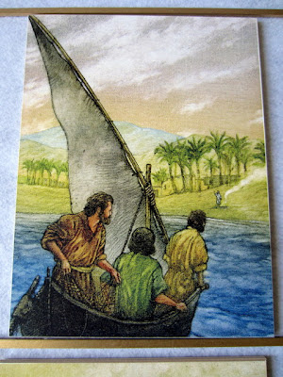
Knowing Jesus in a New Way 4: Known in the Morning

This week we enjoy yet another goose-bump raising story, that of Jesus' appearance to seven disciples at the sea of Galilee, told in John 21:1-24.
There are several different things you may choose to emphasize to the children:
1. The miracle in the boat. The men had caught nothing on their own. But when Jesus was in charge, "they could feel all the fish moving into the nets." They were shocked to find that the man on the shore was Jesus, sitting by a campfire, cooking fish for their breakfast. With Jesus' direction, there were fish. Without it, no fish. What does this say to us?
2. Jesus' words of direction to Peter when Peter said he loved Jesus: "Feed my lambs." If we do love Jesus, we have our work cut out for us. Our job is to take care of each other. How would Jesus have us do that?
3. All through this story, Peter hasn't taken his eyes off of Jesus. But as he walks with Jesus, he turns around, sees John following them, and says, "Lord, what about him?" Jesus answers with,"If I want him to live until I come, what is that to you? Follow me!" To me, this is Jesus saying,"Keep your eyes on your own paper!" or don't worry about others and their relationships to me. Instead, think about your relationship to me.
4. Another thing that strikes me in this story is that Peter so often messes up, right after discovering some profound truth! He promises that he will never deny his Lord, and then denies him three times. He says, Yes I'll do your will, I'll feed your sheep...and then gets concerned about what John is doing. Yet Jesus loves and accepts him and even sees him as a leader, as fault-filled as he is. This gives me hope!
Wondering Questions:
. 1.I wonder what your favorite part of this story is.
2. Jesus tells the men what to do in the boat and they listen and suddenly they start catching fish. I wonder what we can learn from that.
3. I wonder how it felt to sit down for breakfast with Jesus. I wonder what you would have said to Jesus if you were sitting there.
J 4. Jesus tells Peter if he loves him to feed his lambs. I wonder what this means.
I wonder who are the lambs.
I wonder what we do to take care of them.
5. When Jesus and Peter are walking together, Peter notices that John is following them. When Peter asks Jesus about what will happen with John, Jesus tells him not to worry about John or others , but to concentrate on following Him. I wonder what we can learn from that.

Knowing Jesus in a New Way 5: Known in Making Him Known

What an important lesson this is, the scripture from Matthew 28:16-20 in which Jesus tells his disciples to go everywhere and tell His story, teach people to be disciples, and baptize them. As the story script says, the disciples had been followers and now they had to be leaders, they had been sheep and now it was time to be shepherds. But they didn't need to be afraid, because Jesus says he will be with them always, "to the end of the age."
There are several different aspects of the story that you may choose to emphasize:
1. The meeting itself of Jesus with the disciples on the mountain.
2. Jesus' command to go to people everywhere and make them disciples, baptize them, and teach them to obey his commands.
3. Jesus' assurance that He will always be with us.
In the past few weeks a couple classes have tried letting the children gather items from the materials that helped to tell the story, and it sounds like it went really well. You may want to try that this week.
Here are some wondering questions to also use:
1. I wonder what was your favorite part of today's story is.
2. I wonder how the disciples felt about Jesus telling them to go everywhere and tell Jesus' story.
3. I wonder how you would feel if Jesus asked you to go to a new place and tell Jesus' story.
4. I wonder where we are in Jesus' story. I wonder how we become part of it.
5. Jesus said he would be with disciples forever. I wonder how he was with them. I wonder how we find him with us.
6. I wonder how you and I can share Jesus' story with others.

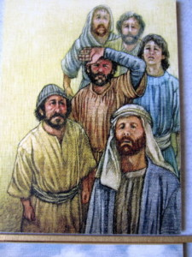
Knowing Jesus in a New Way 6: Known in Waiting
Welcome to Knowing Jesus in a New Way 6: Known in Waiting, our lesson for May 28.
This week we get to share with the children the story of Jesus’ ascension as told in Luke 24:50-53 and chapter 1 of Acts.
What a wonderful opportunity to again talk about the disciples’ experience with having Jesus right beside them and then having to learn to live with him in a completely different way. The children have not witnessed this event of course, but most know what it feels like to be left or abandoned-even temporarily-by someone they love- or to feel afraid of what that might be like. For modern Christians whom have never had the joy of having Jesus physically with us, it takes some thinking to imagine what that must have been like, and then to have it taken away.
In addition to discussing the story itself, this Sunday is a good time to talk about the idea that feelings are not always the truth of what is really happening. When bad things happen we may feel abandoned by God, but that is not the truth. God never abandons. So what do we do when we have these feelings and fears? What did the disciples do? They did what Jesus told them to do.They waited and prayed and obeyed Jesus’ commands until they would be with Jesus again in heaven. As in the sermon last Sunday, they did the ordinary things of living as they waited on God. They chose a replacement for Judas. They went on with life, holding onto each other and to prayer.
I hope that if you’re in a room where the children have access to Godly Play materials, that after the story is shared, you’ll try letting the children select something to bring to the circle that helps tell the story. Those connections can be so meaningful.
Here are the wondering questions for Sunday.
1. I wonder what is your favorite part of today’s story.
2. I wonder if you’ve ever been left behind. I wonder how that feels.
3. Before Jesus disappeared he told the disciples that they would be baptized in the Holy Spirit. I wonder what they thought would happen. I wonder what they thought the Holy Spirit was. I wonder what you think the Holy Spirit is.
4. When Jesus vanished, I wonder if he was really gone. I wonder how he was still with the disciples.
5. I wonder where you are in this story. I wonder what part of this story is about you?

Knowing Jesus in a New Way 7: Known by the Holy Spirit

This week we get to share with the children the story of the coming of the Holy Spirit on the first Pentecost as told in Acts 2:1-21
What a perfect time to not only share the story of the events of Acts 2:1-21, but to lead the children DURING the Godly Play lesson into an exploration of what the Holy Spirit is, what it did for the disciples and what it does for us today. A good time in the script to insert this is after you relay what Peter said, quoting Joel.
Here's the part of the script as I would amend it:
(original script)
Peter stepped into this chaos with a confidence
and calm that the disciples had never seen before.
"These people are not drunk, like you think. After
all, it is only morning. What has happened is what
the prophet Joel wrote about. He said that God will
pour out God's spirit on us so that our sons and
daughters will prophesy, the young will see visions,
and the old will dream dreams.
(section you might add to help children get the concept of the Holy Spirit)
The pouring out of God's spirit was God's gift of the
Holy Spirit. But was the Holy Spirit? Jesus had talked
about the Holy Spirit and when he did, he called it the
Comforter. He had told the disciples that it would come
after He left them. And now it was here! But what would
it do? Jesus had talked about that too and we can find it in the
book of John. Jesus had said that the Holy Spirit ...
1. helps people see what they've done wrong and points
them to God
2. helps people do what is right
3. helps us understand the Bible
4. prays for us-the Bible says that He prays to God when
we sometimes don't know how or what to pray. Helps us
through our hard times
5. helps us find out what our special gifts are so we can use
them to help others
The Holy Spirit had come! It had happened!
(the original script picks back up here)
Many passed on by to keep their great traditions and live
good lives. Others listened and became baptized.....
(Continue with rest of the script.)
You can see that I've included questions about the Holy Spirit in my wondering questions.
Wondering Questions

1. I wonder what your favorite part of this story is.
2. We know now that the mighty wind signaled that something special was happening, the arrival of the Holy Spirit. I wonder how it felt to have God's spirit poured out on you.
3. I wonder what you would have thought if you were on the streets when the disciples ran out, overjoyed, telling everyone what happened in different languages.
4. Before Pentecost the disciples felt the love from Jesus. At Pentecost the Holy Spirit helped the disciples feel the love inside them. I wonder how the love helped the disciples do their work.
5. I wonder how the Holy Spirit can help you.

