Basic Outline for Reconciliation of Several Penitents (children)
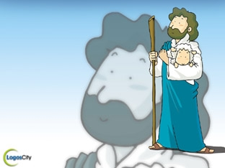
Introductory Rite
Entrance Procession
Greeting
Introduction
Opening Prayer

Celebration of the Word of God
The celebration of the word follows. If there are several readings a psalm or other appropriate song or even a period of silence should intervene between them, so that everyone may understand the word of God more deeply and give it his heartfelt assent. If there is only one reading, it is preferable that it be from the gospel.

OT Reading (optional)
Responsorial Psalm
NT Reading
Gospel Acclamation
Gospel
When the individual confessions have been completed, the other priests stand near the one who is presiding over the celebration. The Presider invites all present to offer thanks and encourages them to do good works which will proclaim the grace of repentance in the life of the entire community and each of its members. It is fitting for all to sing a psalm or hymn or to say a litany in acknowledgement of God's power and mercy, for example, the canticle of Mary (Luke 1:46-55), or Psalm 135:1-9, 13-14, 16, 25-26.
Other texts may be chosen

Homily
Examination of Conscience

Rite of Reconciliation
General Confession of Sins
Invitation to Confession
Confession
Intercessions
Lord's Prayer
Individual Confession and Absolution
Proclamation of Praise
Concluding Prayer

Concluding Rite
Blessing and Dismissal
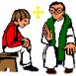

INDIVIDUAL CONFESSION AND ABSOLUTION

1. I go to the priest and Father greets me with a prayer.

2. I respond, “Bless me Father I have sinned it’s been
( ___ however long) since my last confession.”

3. I tell Father about a good choice I have made.

4. I talk to Father about the times I have sinned
(the times I have made wrong choices)

5. Father talks to me and asks me to pray a Prayer of Sorrow.

Prayer of Sorrow
O My God, I am very sorry
that I have sinned against you,
because you are so good
and with the help of your grace
I will not sin again.

6. Father prays the Prayer of Absolution and forgives me.

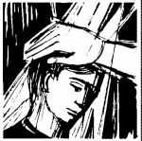
7. Father gives me Penance and says
“Your sins are forgiven, go in peace.”

8. I make the sign of the cross as he
blesses me and says
“Thanks be to God.”
FIRST INDIVIDUAL CONFESSION

1. I go to the Priest …
He greets me and says a prayer for me.

2. I say ‘Hello Father, my name is ______________________________ and this is my first Reconciliation.’

3. I tell Father about a time when I made a good choice.

4. I talk to Father about the times I have sinned when I made a wrong choice.

5. Father talks to me and asks me to say a Prayer of Sorrow.

Prayer of Sorrow
O my God,
I am very sorry that I have sinned against you
because you are so good
and with the help of your grace
I will not to sin again.

6. Through the Priest I receive God’s forgiveness in the Prayer of Absolution.
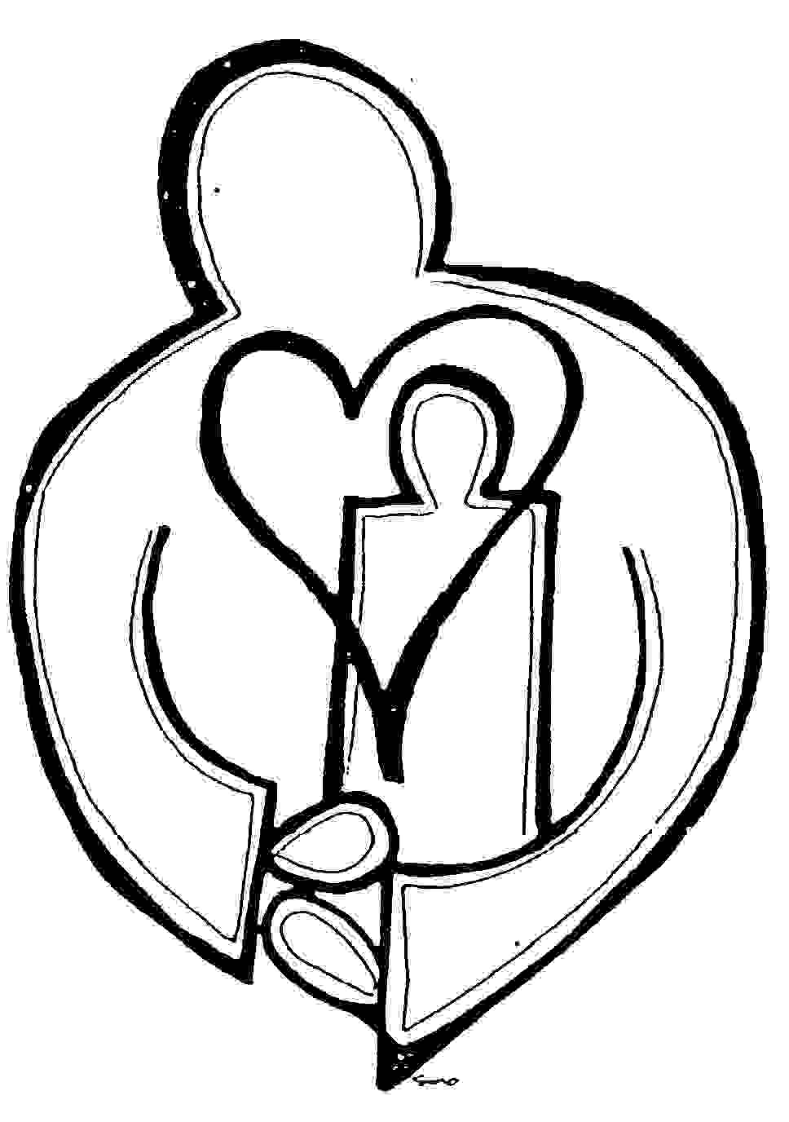
7. Father gives me a Penance.

8. Father says ‘God loves you,
Go in peace, your sins are forgiven.’

9. I say ‘Thanks be to God.’

An Examination of Conscience
Jesus wants to help me become a loving and good person.
When have I not let Jesus do this by acting in ways that are selfish or wrong?

You must love the Lord your God with all your heart,
with all your soul, with all your strength and with all your mind …
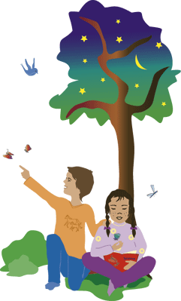
[Luke 10:27]
(1) Have there been days when I have not prayed or made time for God in my life?
You must love your neighbour as you love yourself.
[Matthew 22:39]
(2) Instead of letting God help me to love my parents, other family members and teachers, have I disobeyed or not shown respect for my parents or for those who help them care for me? Have I hurt, fought or not cooperated with family members?
(4) Instead of letting God help me care for my health or the health of others, have I not cared properly for my health? Have hurt others when feeling angry?
(5) Instead of letting God help me to be friendly and kind to
everyone, have I fought others? Have I called others names?
Have I not let them join in games? Have I made fun of
someone who is new to the school, or who looks different ?

(6) Instead of letting God help me to care for creation; have I deliberately destroyed plants, trees, animals and other creatures?
(7) Instead of letting God help me to be truthful, have I lied or made up stories about others?

