EUCHARIST RETREAT
BEAGLE BAY – April 2016
20 children

TIME | ACTIVITY | RESOURCES/PREP
PRE-RETREAT PREP  - Prayer focus space –white cloth, bible, candle, ciborium, chalice, bread, wine |  | - White cloth  - Ciborium  - Chalice  - Bread  - Wine  - Bible  - Candle
10.50-10.55am | INTRODUCTION AND WELCOME  - Introduce self and the reason for the day.  - Go through rules for the day:  Only share what you’d like to  Listen to others sharing  This is precious time spent with your God, so make the most of it  - Start with simple prayer:  Father, we gather today to prepare our hearts  to receive the sacrament of the Eucharist.  Help us to grow closer to You and  recognize the Holy Spirit at work in our lives.  We pray through Christ Our Lord. Amen.
10.55-11.45am | THE EUCHARIST AS A MEAL – OUR GATHERINGS/THE LAST SUPPER/MASS  - Read Let’s Eat! Discuss the gathering together in the book.  - Do a Y chart of family meals in small groups.  - Introduce the labels - coming together, sharing stories, sharing a meal, going our separate ways and discuss each in the context of the book and our own experiences.  - Meditate on the Last Supper using the below guided meditation.  - Discuss as a large group what the Last Supper would have looked, sounded and felt like. Link to labels.  - Add the other props for a Eucharistic celebration and link to the Mass.  - In small groups complete the Y chart for Mass.  - Discuss differences and similarities.  - Go through the circle of the Eucharist.  - Link to labels and put labels in the story where they belong. | - Let’s Eat! Book and Y-charts for groups.  - Labels – coming together, sharing stories, sharing a meal, going our separate ways.  - Circle of the Eucharist props and script
12.00-12.45pm | THE EUCHARIST AS A MEMORIAL OF JESUS  - Discuss how the Eucharist is a memorial of Jesus – link to All Soul’s Day, ANZAC day etc… and how we use things to help us remember.  - Discuss crosses and how they also remind us of Jesus.  - Students make their own cross (see below for steps) and decorate with carvings and beads etc… | - Holding cross  - Clay, paperclips, tools and beads to decorate.  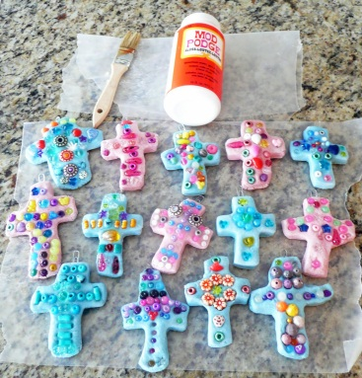
12.50pm | SHARED LUNCH
1.20-1.45pm | THE EUCHARIST AS COMMUNITY GATHERING  - Discuss how a Mass is a gathering of community – friends and family.  - To quiet music, students colour in the reflective colouring sheet while considering the people who they see at Mass. | - Reflective colouring page.
1.45-2.10pm | THE EUCHARIST AS SACRIFICE –  - Introduce the special vessels used at the Liturgy of the Eucharist and what they are for.  - Ask students to quietly write a prayer to God about their First Holy Communion | - Prayer sheet
2.10 – 2.20pm | LITURGY  - Go around the circle and read prayers and finish with the Lord’s Prayer.

Meditation of the Last Supper
0
ByLori Hadorn-Disselkampon May 1, 2015Articles from Our Contributors, Faith Resources
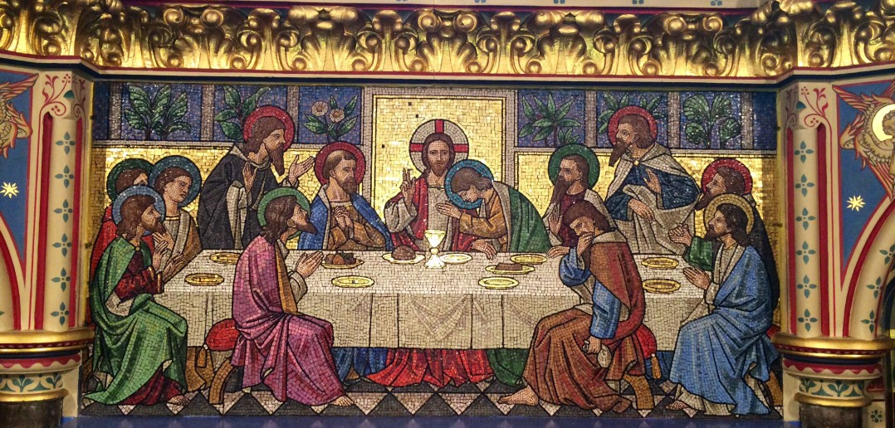
“Depiction of the Last Supper as a glass mosaic reredos within All Saints’ Church, Reading, UK 2014-07-07 23-07” by User:HaloHoney – Own work. Licensed under CC BY-SA 3.0 via Wikimedia Commons.
The following is a meditation I wrote for my students. I lead them in this meditation when we are discussing the sacrament of the Eucharist. I hope that you can relax and picture the Last Supper…
Relax your shoulders; let them sag. Relax your arms, open your hands and lay them in a comfortable position. Tighten your hands into fists and then release them. Relax your legs and make them comfortable. Relax your neck and find a comfortable position for your head. Take a deep breath in then release. Take another deep breath and relax. Be in the silence. Be nowhere but here now. Let your thoughts be released with your next deep breath. Breathe in and release.
You are walking in the heat of the day down a sandy road. You are wearing sandals and can feel the sand under your arch and between your toes but it is smooth and not bothersome. The air is dry and hot but not humid. You are walking through the middle of a town there are people scurrying about packing up their goods on their mules and in baskets trying to get home before the sun sets. You find yourself drawn to an older building. As you make your way in you climb the rickety wooden steps to an upper room. It is a large room, nothing special, very plain but it is occupied. There are several people in the room and you feel strangely drawn to one of the people seated at the table. They are all sitting on the floor around a long table. Normally you would turn around and exit because you were obviously not invited to the small gathering but something in you makes you continue walking more quietly now.
As you approach the table the people continue talking except for the one you feel drawn to. You stop, knowing now that He has sensed your presence. You consider turning around and running back down the stairs, but instead pause for a second, then you turn towards the steps but before you can take a single step in that direction you hear him call you by name. His voice is gentle and inviting. And he says to you come and join us and again he says your name. You turn around and are now face to face with this person. You recognize his face, but don’t know his name. His face is like that of a person you have known and loved all your life. You stand simply staring at him. As he makes his way towards you all of the people who had been talking turn to watch him go to you. He extends his hand and says come and sit with me. As you place your hand in his you feel a rush of energy surge through you and then a calm you have never experienced before. You grasp his hand and he leads you to the table. The people shift their positions and you are seated directly across the table from him. He smiles at you and looks around at his friends he then bows his head for a moment, maybe to pray. Everyone is silence and then…
Then he says, “I have eagerly desired to eat this Passover* with you before I suffer, for, I tell you, I shall not eat it [again]until there is fulfillment in the kingdom of God. “Then he took a cup,* gave thanks, and said, “Take this and share it among yourselves; for I tell you [that]from this time on I shall not drink of the fruit of the vine until the kingdom of God comes.” Then he took the bread, said the blessing, broke it, and gave it you, saying, “This is my body, which will be given for you; do this in memory of me.” And likewise the cup after we had eaten, saying, “This cup is the new covenant in my blood, which will be shed for you.
Taking a piece of the bread you eat it and then as they pass the cup to you, you take a drink. This man, this person that emits peace makes eye contact with you and in his brown gentle eyes you see only love and compassion. It’s as though he is talking to you, like no one else is in the room, he is telling you that he loves you. He gets up from the table walks over to you and you rise to meet him. He embraces you and whispers in your ear, “I have loved you since before you were born, I will love you for all eternity. I must go now to give you eternity. Eat of my flesh and drink of my blood and you shall have everlasting life with me. Never forget this moment, remember it every time you eat and drink of the Eucharist.” He holds you so close that you can feel his heart beating. You long to stay in this moment, to freeze it forever, to never let go.
As he slowly breaks your embrace you watch as he descends the steps and as though in a blur you see the people follow him. You blink and look about you and the entire room is empty except for the table.
You want to follow him, you want to feel that peace again. But you can’t seem to move you feel somewhat paralyzed by this encounter. You close your eyes again wondering if it really happened. You hear people’s voices beneath the floor boards and it startles you. You gather yourself and walk to the steps slowly looking back at the table. As you make your way through the old building you find the door from which you entered. You open the door and your eyes scan the small area and you notice the crowd just down the way, up the road a bit you see that the man is walking ahead of the rest of them. You want to follow but something within you says not too. So you watch as he fades into the distance and you turn the other way and begin to walk down the dark and dusty road, all the while recalling his words and the peace that still lingers in your soul. You know that this was a moment you will cherish forever.
Slowly and quietly take a deep breath in and release it. Take another deep breath and begin to listen to your breathing. Clench your fists and release them, stretch your legs and arms gently. Slowly come back to this place. Open your eyes and just sit in the silence for another moment.
Copyright 2015 Lori Hadorn-Disselkamp
“Depiction of the Last Supper as a glass mosaic reredos within All Saints’ Church, Reading, UK 2014-07-07 23-07” by User:HaloHoney – Own work. Licensed under CC BY-SA 3.0 via Wikimedia Commons.

Bead and Clay Crosses
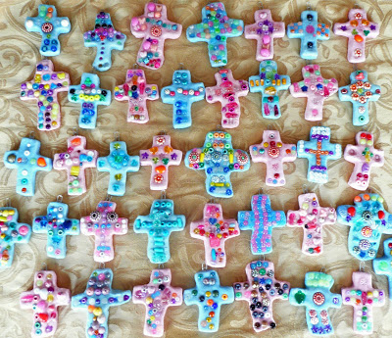
This is a project I do at Easter time with the students. These are done by Grade 1. I also did this with Grade 4 this year using smaller beads and more complicated patterns.
Click on picture to see larger.
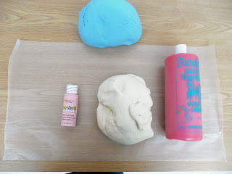
You need to do up a recipe of salt dough clay. ( 1 recipe is enough for 24 crosses using a 3 1/2 inch cutter)
4 cups flour
1 cup salt
2 cups to 2 and 1/2 cups warm water (varies depending on flour and humidity, enough for a soft dough)
Knead into a soft dough
Store in a ziploc bag. If not using right away you can store in the refrigerator for like forever. Just pull it out ahead of time to come to room tempertaure before using.
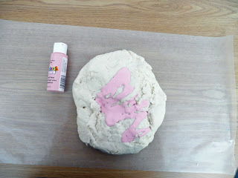
I like to color the dough. Using liquid tempera or acrylic paint squirt some on the dough.
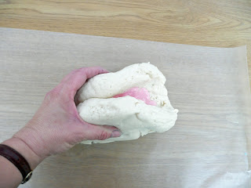
Fold over the dough.
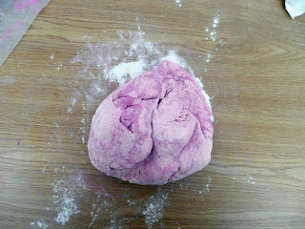
and then knead like crazy....don't worry if it looks marbled like this it just means you have to keep kneading.
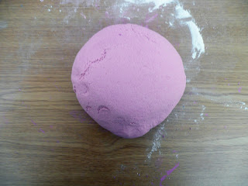
It will eventually look like this. Even color throughout.
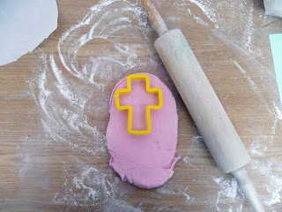
Roll it out and then using a cookie cutter cut out the shape.
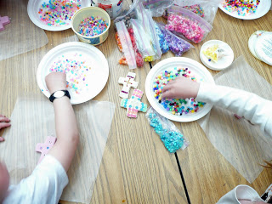
Place a paper clip 1/2 way in at the top for hanging.
I get the kids to put a bit of water on the surface of the cross using their finger and then they can start forming their design with beads. We use pony beads in different sizes as well as wood beads and large decorative beads.
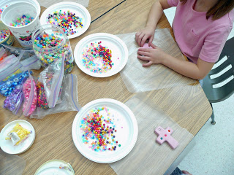
I asked them to try and make a pattern using color or shape.
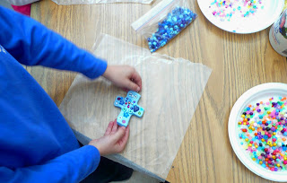
They need to push the beads in fairly firmly.
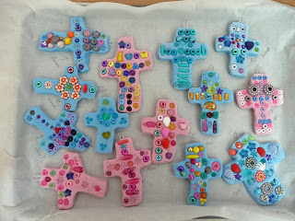
I then place them on a cookie sheet lined with parchment paper. I write the name of the student on the paper in sharpie and then place their creation either on top or next to their name. This allows me to keep them straight until they are baked when I can then write their names on the back in sharpie.
Bake in a 250 - 300 degree oven for about 2 - 3 hours until hard. You don't want to overbake and have them get a brownish tinge.
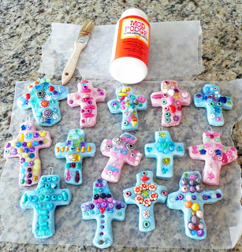
When cool add a coat or 2 of Mod podge. This will help "glue" into place any loose beads as well as add a nice shiny finish.
Keep in mind that salt dough responds to the humidity in the air. It can sometimes feel soft even after baking and sealing. Just let it be and it will dry out again.
That's it. I add a ribbon thru the paper clip at the top and the kids have a great creation to take home for Easter.

