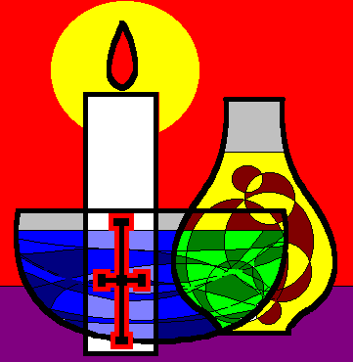
Sacramental Preparation Broome Diocese
School Role
Celebrating a sacrament for the first time is an important step in the life of a Catholic child.

Sacraments are vital expressions of Catholic life. Each time people receive a sacrament there is a deeper response to the call of Jesus to discipleship. Since sacraments are so important they are taken very seriously and there is a need to prepare to receive them thoughtfully and thoroughly. All sacraments are events for the whole Catholic community to celebrate together, this is reflected when parishes prepare and celebrate the sacraments as a community.

Sacraments flow from the life of the Church. Religious education, whether it takes place in a school or parish setting, functions as a support to the sacramental life of the Church.

The Catholic school endeavours to nurture a strong partnership between families and the parish in the sacramental preparation program. Parents are encouraged to take on their central role. The parish and the schools assist parents in this task.
Typically First Reconciliation is in Year 4 and First Eucharist in Year 5.
Schools to liaise with Parish Priest and community to set dates and ensure children are prepared.
In conjunction with the Parish Priest, Schools need to contact the Bishop’s Office to set dates for Confirmation. This needs to be done very early in the year.
For Discussion:
- How does the school in your community support its sacramental life?
- What do the Bishop, priests and parents expect from the school in preparing children for the sacraments?
- What support and guidelines do schools need to help them in their role with parents and parish?

