THE ANGELUS
When telling a story in this way you seat the students around you in a semi-circle and sit on the floor (or at a low table) to tell the story. The wonder questions at the end of the telling are to get students thinking about the meaning and the meaning of the presentation to them, so there are no right or wrong answers.
(all photos are from the storyteller’s perspective. Note too that I have put the words of the parts of the Angelus underneath the objects)
YOU WILL NEED:
- a white or gold rectangular cloth, about 120cm long
- a picture of the Angelus painting by Jean-Francois Millet
- nativity or peg people Mary and angel
- 3 x Hail Mary pictures
- picture of Mary kneeling
- picture of Jesus with people, including children
- picture symbolic of following Jesus
- picture symbolic of us trying to live like Jesus

Children are seated in a semi-circle ready to listen to the story. Have the white or gold cloth rolled up by your side with the stone and the pictures face down next to it
Place the rolled up cloth in front of you.
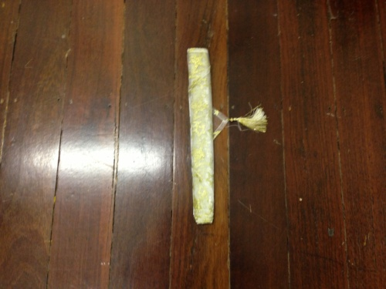

Today we are going to look at a prayer may know, but we are going to learn what the prayer is saying to us. This prayer is a very special prayer and that is why as I tell you about this prayer I am going to place to items on this golden material.
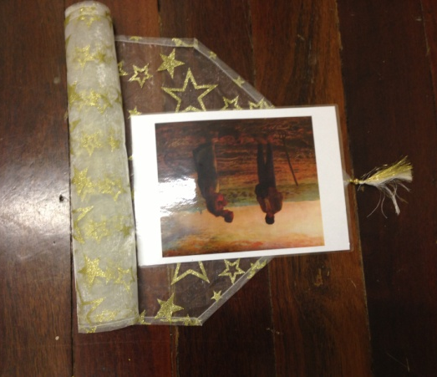
Unroll the cloth enough to place the picture of the Angelus painting on it, facing the students.

The Angelus is a very famous prayer. It is so famous that someone painted a painting about it. Here is the painting. You can see that the people in the field have stopped their farming and are praying. That is because all around the world , just before lunch time people stop what they are doing, just like we do, and pray the Angelus.
Can you imagine the power of a prayer when people in Broome and Mulan and Ringer Soak and America…all stop what they are doing before lunch and pray together?
I wonder how God feels when he has so many people praying the same prayer at the same time around the world?
Pause for thought and some answers, if appropriate.
Unroll some more of the cloth and pick up the Mary figurine.
The Angelus is a prayer where we remember how Jesus was born and how strong Mary was to be his mother.
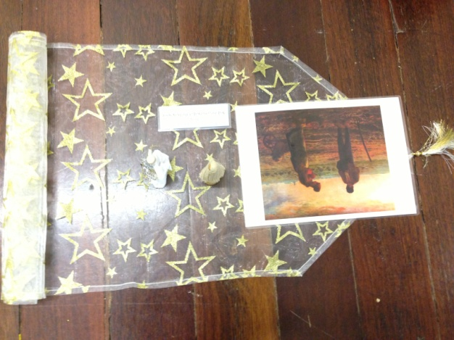
Pick up the angel figurine and place them on the cloth.

In the first part of the prayer we say, “The Angel of the Lord declared unto Mary:
And she conceived of the Holy Spirit.” In this part of the prayer we remember when the angel came to Mary and told her of God’s decision for her to be the mother of Jesus, the Son of God. (Retell the story of the angel appearing to Mary (Luke 1:26-37))

Unroll some more of the cloth and place the card with the Hail Mary pictures on the cloth.

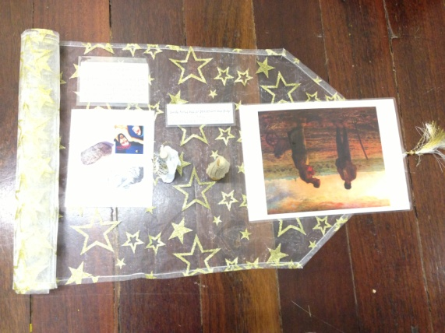

We then say the first of three Hail Marys. We remember the three parts of the prayer (refer to Hail Mary script), when we remember how special Mary was, how she was Jesus’ mum and how we pray to her to help us make the right choices so we can live like Jesus.
Unroll some more of the cloth and place the card with the picture of Mary kneeling on it.
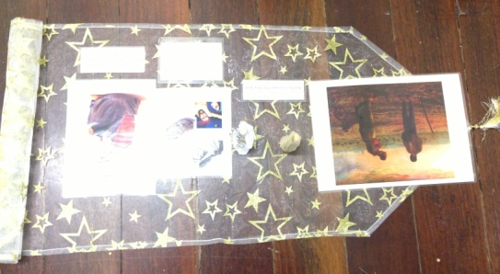

Next we say, “Behold the handmaid of the Lord: Be it done unto me according to Thy word.” This is when we remember that Mary was a servant of God. She did what God wanted her to do and we try to do the same in our own lives.
Unroll some more of the cloth and place the second of the Hail Mary cards on the cloth.
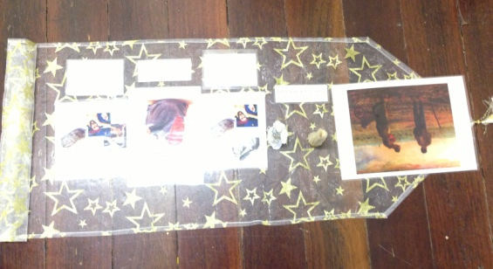

We then say the second of the three Hail Marys that are part of the Angelus.
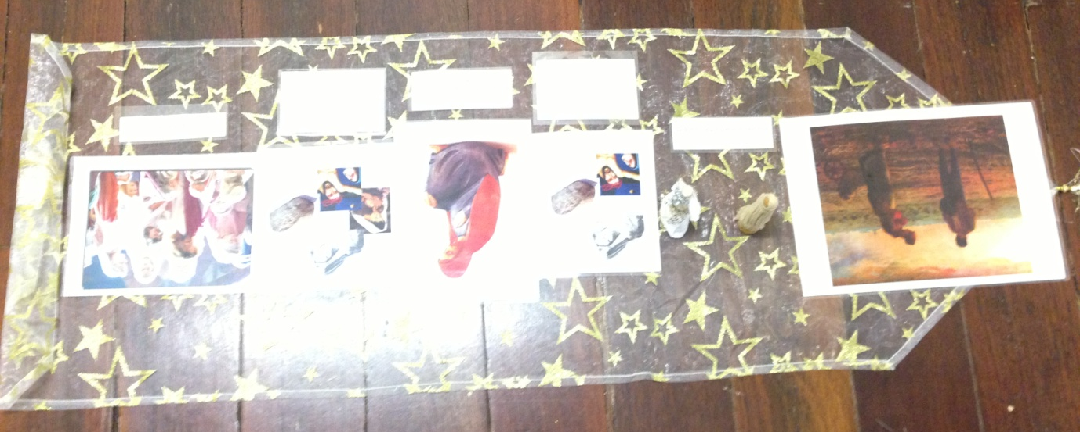
Unroll some more of the cloth and place the picture of Jesus with the people on it.

Next we say, “And the Word was made Flesh: And dwelt among us.” When we say this, we are remembering how Jesus was on earth, living like one of us. How he played, made friends, laughed and cried like we do.
Unroll some more of the cloth and place the third and final Hail Mary card on it.
We then pray the last of the three Hail Marys.
Unroll some more of the cloth and place the picture representing us following Jesus on it.
We then say, “Pray for us, O Holy Mother of God, that we may be made worthy of the promises of Christ.” When we pray this, we are asking Mary to help us to live like her son, Jesus did.
Unroll the last part of the cloth and place the representation of living like Jesus on the cloth.
At the last part of the prayer we say, “Let us pray: Pour forth, we beseech Thee, O Lord, Thy grace into our hearts; that we, to whom the incarnation of Christ, Thy Son, was made known by the message of an angel, may by His Passion and Cross be brought to the glory of His Resurrection, through the same Christ Our Lord.” When we say this we are asking Jesus to help us to live like he did.
Then we finish the prayer with “Amen”, which means we believe in everything we have prayed.
Sit and ponder the prayer for a while.
I wonder which part of the Angelus you like best?
I wonder which part of the Angelus you think is the most important part?

WORD CARDS
The Angel of the Lord declared unto Mary:
And she conceived of the Holy Spirit.

Hail Mary, full of grace, the Lord is with thee; blessed art thou among women and blessed is the fruit of thy womb, Jesus. Holy Mary, Mother of God, pray for us sinners, now and at the hour of
our death. Amen.

Behold the handmaid of the
Lord:
Be it done unto me according to Thy word.

Hail Mary, full of grace, the Lord is with thee; blessed art thou among women and blessed is the fruit of thy womb, Jesus. Holy Mary, Mother of God, pray for us sinners, now and at the hour of
our death. Amen.

And the Word was made Flesh:
And dwelt among us.

Hail Mary, full of grace, the Lord is with thee; blessed art thou among women and blessed is the fruit of thy womb, Jesus. Holy Mary, Mother of God, pray for us sinners, now and at the hour of
our death. Amen.

Pray for us, O Holy Mother of God, that we may be made worthy of the promises of Christ.

Let us pray:
Pour forth, we beseech Thee, O Lord, Thy grace into our hearts; that we, to whom the incarnation of Christ, Thy Son, was made known by the message of an angel, may by His Passion and Cross be brought to the glory of His Resurrection, through the same Christ Our Lord.
Amen.

