THE ASPECTS OF RECONCILIATION AND THEIR IMPORTANCE
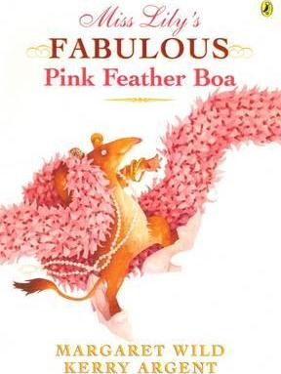
Miss Lilly’s Fabulous Pink Feather Boa
by Margaret Wild and Kerry Argent
Publisher: Viking Penguin Books ISBN: 0-67089-756-6

Miss Lily's fabulous pink feather boa is the most wonderful thing the Last Potoroo has ever seen. When Miss Lily dances the tango, the Last Potoroo can't take her eyes off it. And when she wraps it around herself, she feels, for the first time in her life, that she can do anything - and everything! Something so fabulous just has to be magic...

A delightful book suitable for middle primary classes is Miss Lily's Fabulous Pink Feather Boa by Margaret Wild and illustrated by Kerry Argent. This is a story of the Last Potoroo who comes to stay at Miss Lily's holiday house. She is a shy and timid Potoroo looking for other Potoroos in Australia. Miss Lily owns a pink feather boa which captures the attention of the Last Potoroo until one evening she snips off a piece of the boa. She immediately feels badly but is unable to say anything to Miss Lily. Her holiday comes to an end and when she reluctantly turns away, Miss Lily calls her back and gives the Last Potoroo the fabulous pink feather boa. The Last Potoroo overcome with guilt, admits her theft to which Miss Lily responds: "I know," as she wraps the boa around and around the Potoroo. Such wonderful concepts of forgiveness, acceptance, true friendship and reconciliation are covered in this story making it most apt for reading during Lent. Children could easily identify with the Last Potoroo and certainly would feel relieved to read the happy ending. Miss Lilly can be seen as a metaphor for God in that she knows the wrong choice that the Last Potoroo has made, but forgives her anyway. Each of the aspects of reconciliation can be identified in the story – conversion, confession and celebration.

https://www.youtube.com/watch?v=-d9yaMRdp0k

SUGGESTED USE:
- Read story, using props (eg. A pink feather boa, a postcard with some of the boa stuck to it)
- Using cards made from pictures from the story, ask students to order themselves in the order of the story.
- Ask students to order themselves into order of importance regarding forgiveness in the story. Discuss what the most important part of the story is.
- Discuss what happens with reconciliation in simple English – make amends etc…
- Discuss the ideas of conversion, confession and celebration. Identify where these are happening in the story. Use cards to indicate which picture from the story matches which aspect of reconciliation – these should be close to the most important in the ordering.
- Students create a symbol (using clay, alfoil etc) to represent or draw what they think is the most important part of reconciliation.
- Share with a partner and place around prayer cloth.

