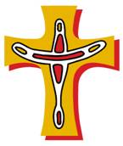

The Kimberley Cross – a symbol of unity.

The upright is a spear-thrower from the North Kimberley
and the boomerang cross-arm is from the South of the Kimberley.

Weapons have become a cross – a sign of the peace of Christ

