Resource Sheet 1

Structure of the Mass

Introductory Rites

Entrance Hymn
Entrance Procession
Greeting
Penitential Rite (or Rite of Blessing and Sprinkling of Holy Water)
Gloria (Sundays only)
Opening Prayer

Liturgy of the Eucharist

Preparation of the Gifts
Prayer over the Gifts
Eucharistic Prayer
Communion Rite
Our Father
Sign of Peace
Breaking of the Bread
Communion
Prayer after Communion

Concluding Rites

Blessing
Dismissal

Liturgy of the Word

First Reading
Responsorial Psalm
Second Reading
Gospel Acclamation (Alleluia)
Gospel
Homily
Profession of Faith (Creed)
General Intercessions (Prayer of the Faithful)

Resource Sheet 2

We Gather for Mass
You will need:
- cloth (colour of the season)
- white felt circle cut into four quadrants: 2 large and 2 small - - see quadrant templates on RE online
- 10 peg figures and 1 priest (white material to represent alb with material
1
2
3
4
the color of the season to represent chasuble and stole)
(Note: The materials above will also be used in the following stories in this unit.)
- Bible
- bread on a plate
- grape juice in chalice/wine goblet
- cards: Introductory Rites; Liturgy of the Word; Liturgy of the Eucharist; Concluding Rite (see below)

Lay seasonal cloth down. Place the quadrants on top of the underlay to form a circle as in illustration above.
Place the peg figures around the circle facing inwards to represent the community gathered. Place the priest at the top of the circle. Trace your finger around the circle as you say:
When we celebrate Mass we come together as the community of God.
Point to each quadrant as you say:
We can look at the Mass as being made up of four parts.
Hold the card ‘Introductory Rites’ as you say:
The first part, called the Introductory Rites, gathers us together into the community that is the Body of Christ.
Place Introductory Rites card in quadrant 1.
Show the card ‘Liturgy of the Word’ as you say:
The second part is called the Liturgy of the Word.
Place Liturgy of the Word card in quadrant 2.
Hold up the Bible as you say:
During the Liturgy of the Word we listen to the Scriptures, the Word of God.
Place the open bible in quadrant 2.
Show the card ‘Liturgy of the Eucharist’ as you say:
The third part is called the Liturgy of the Eucharist.
Place Liturgy of the Eucharist card in quadrant 3.
Hold up the bread and wine as you say:
During the Liturgy of the Eucharist we remember what Jesus said and did during the Last Supper. We give thanks to God and we receive Jesus in Holy Communion.
Place bread and wine in quadrant 3.
Hold the card ‘Concluding Rite’ as you say:
The fourth part is called the Concluding Rites.
Place Concluding Rite card in quadrant 4.
During the Concluding Rites the priest blesses us

Turn the figures out toward the students.
The priest sends us out to take Christ into our world.

Point to each quadrant as you say:
These are the four parts of the Mass: the Introductory Rites, the Liturgy of the Word, the Liturgy of the Eucharist and the Concluding Rites.

Pause for a while before wondering with the students.
I wonder whether you’ve seen any part of this before.
I wonder why the gathered community is called the Body of Christ.
Resource Sheet 3
Introductory Rites
You will need:
1
2
3
4
- cloth (colour of the season)
- white felt circle cut into four quadrants - see quadrant templates on RE online
- 10 peg people, 1 priest (white material to represent alb with material the
color of the season to represent chasuble and stole)
Note: the above materials are the same as used in ‘We Gather for Mass’
- cards: Introductory Rites, Entrance hymn, Entrance procession, Greeting, Penitential Rite, Gloria, Opening Prayer (see below)

Lay seasonal cloth down. Place the quadrants on top of the underlay to form a circle as in illustration above.
Place the peg figures around the circle facing inwards to represent the community gathered. Trace your finger around the circle as you say:
When we celebrate Mass we come together as the community of God.
Point to each quadrant as you say:
We can look at the Mass as being made up of four parts: The Introductory Rites, the Liturgy of the Word, the Liturgy of the Eucharist, and the Concluding Rites.
Hold the card ‘Introductory Rites’ as you say:
The first part, called the Introductory Rites, gathers us together into the community that is the Body of Christ.
Place Introductory Rites card in quadrant 1.
Hold the card ‘Entrance Hymn’ as you say:
At the beginning of the Introductory Rites we sing the Entrance Hymn together.
Place the Entrance Hymn card in quadrant 1 below Introductory Rites card.
Move the priest as if in procession to the edge of the circle as you say:
The priest and servers join the singing as they process from the back of the church to the altar.
Hold the card ‘Entrance Procession’ as you say:
This is called the Entrance Procession.
Place the Entrance Procession card in quadrant 1 below Entrance Hymn card.
Hold the card ‘Greeting’ as you say:
In the Greeting the priest welcomes us saying: “The Lord be with you.” We respond saying, “And also with you.” (Children may join with you in this response.)
Place the Greeting card in quadrant 1 below Entrance Procession card.
Hold the card ‘Penitential Rite’ as you say:
During the Penitential Rite we ask God’s help for a change of heart.

Place the Penitential Rite card in quadrant 1 below Greeting card.

Hold the card ‘Gloria’ card as you say:
We praise and thank God in the prayer called the Gloria.
It begins with the words, “Glory to God in the highest and peace to his people on earth…”

Place the Gloria card in quadrant 1 below Penitential Rite card.
Hold the card ‘Opening Prayer’ as you say:
The Opening Prayer is the last prayer of the Introductory Rites. It completes the gathering of all the people present into a single body. Now those gathered together are ready to hear the word of God.
Place the Opening Prayer card in quadrant 1 below Gloria card.
Point to the Introductory Rites card as you say:
The Introductory Rites gather us together as the community of God through the Entrance Hymn and Procession, the Greeting, Penitential Rite, Gloria and Opening Prayer.
Point to the people, as you say:
In the celebration of the Mass, Jesus is present both in the community gathered
Point to the priest, as you say:
and in the priest.

Pause for a while before wondering with the students.

I wonder what parts of this you’ve heard or seen before.
I wonder which part of this you like the best.
I wonder what it means to say that Jesus is present in the community gathered.
I wonder what it means to say that Jesus is present in the priest.
Resource Sheet 4
Liturgy of the Word
You will need:
1
2
3
4
- cloth (colour of the season)
- white felt circle cut into four quadrants - see quadrant templates on RE online
- 10 peg people, 1 priest (white material to represent alb with material the color
of the season to represent chasuble and stole)
- bible
- cards: Liturgy of the Word, First Reading, Responsorial Psalm, Second Reading, Gospel, Homily, Creed, Prayer of the Faithful (see below)

Lay seasonal cloth down. Place the quadrants on top of the underlay to form a circle as in illustration above.
Place the peg figures, including the priest, around the circle facing inwards to represent the community gathered. Trace your finger around the circle as you say:
When we celebrate Mass we come together as the community of God.
Point to each quadrant as you say:
We can look at the Mass as being made up of four parts: The Introductory Rites, the Liturgy of the Word, the Liturgy of the Eucharist, and the Concluding Rites.
Hold the card ‘Introductory Rites’ as you say:
The first part, called the Introductory Rites, gathers us together into the community that is the body of Christ.
Place ‘Introductory Rites’ card in quadrant 1.
Hold the card ‘Liturgy of the Word’ as you say:
The second part of the Mass is called the Liturgy of the Word.
Place Liturgy of the Word card in quadrant 2.
Hold up the Bible as you say:.
During the Liturgy of the Word we listen to the Scriptures, the Word of God

Place bible beside you.
Hold the card ‘First Reading’ as you say:
During the First Reading we listen to God’s word, which is usually taken from one of the books of the Old Testament.
Place First Reading card in quadrant 2 below Liturgy of the Word card.
Show Old Testament section to the class. Place bible beside you.
Hold card ‘Responsorial Psalm’ as you say:
The First Reading is followed by the Responsorial Psalm.
Place Responsorial Psalm card in quadrant 2 below First Reading card.
Show Book of Psalms in Old Testament to the class as you say:
The Responsorial Psalm usually comes from the Book of Psalms, which is also in the Old Testament.
Place bible beside you.
Hold card ‘Second Reading’ as you say:
Sometimes there is a second reading.
Place Second Reading card in quadrant 2 below Responsorial Psalm card.
Show Acts of the Apostles and Letters in the New Testament as you say:
The Second Reading usually comes from the Acts of the Apostles or from one of the letters in the New Testament.
Place bible beside you.
Hold card ‘Gospel’ as you say:
The priest then reads a story from one of the Gospels.
Place Gospel card in quadrant 2 below Second Reading card.
Show the Gospels in the bible to the class as you say:
The Gospels are the stories about what Jesus said and did when he was on earth. These stories are in the New Testament.
Place the bible near quadrant 2.
Hold card ‘Homily’ as you say:
In the homily the priest helps us to understand God’s word in the readings.
Place Homily card in quadrant 2 below Gospel card.
Hold card ‘Creed’ as you say:
We pray the Creed on Sundays and some feast days. In the Creed we say what we believe, as Catholics.
Place Creed card in quadrant 2 below Homily card.
Hold card ‘Prayer of the Faithful’ as you say:
In the Prayer of the Faithful we pray for the Church, the world and its people.
Place Prayer of the Faithful card in quadrant 2 below Creed card.
Point to the Liturgy of the Word card as you say:
The second part of the Mass is called the Liturgy of the Word.
During the Liturgy of the Word we listen to the Scriptures, the Word of God.
Point to the people, as you say:
In the celebration of the Mass, Jesus is present both in the community gathered,
Point to the priest, as you say:
in the priest.
Point to the Bible, as you say:
and in the Word of God.

Pause for a while before wondering with the students.
I wonder if you know anyone who reads at Mass.
I wonder what your favourite story is from the Old Testament.
I wonder what your favourite story is about Jesus.
I wonder what it means to say Jesus is present in the Word of God
I wonder if you know any of the beliefs we proclaim in the Creed.

Resource Sheet 5

The Last Supper

(Luke 22:7 - 20)
You will need:
- 3.7 ‘The Last Supper’ Visuals (print from RE Online and laminate for use)
1.
2.
- Bible
Students are seated in a semi-circle ready to listen to the story. When the children are settled, get the materials and carry them respectfully to the storytelling place as you would the Bible. Place these beside you and say:

Place class Bible, open at Luke, in front of you with your hand on it.
This story comes from the Gospel according to Luke, which is in the New Testament section of the Bible.

Place Bible beside you. Hold Visual 1 in front of you.
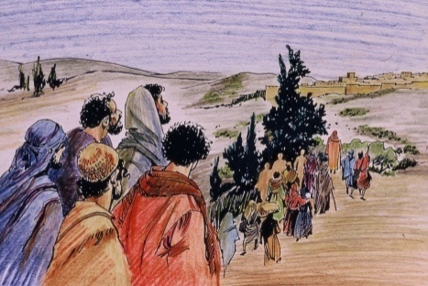

Every year the people of Israel would travel to the great city of Jerusalem to celebrate the Feast of the Passover. Jesus and the disciples would travel from the Galilee area to Jerusalem to celebrate this great feast together.
Place Visual 1 on the floor to your far right facing the children.

Hold Visual 2 in front of you.
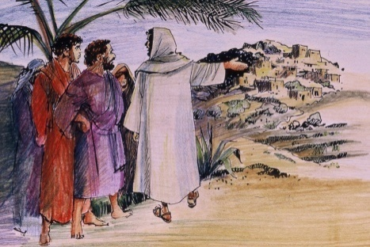
On the day of the Passover Jesus sent Peter and John out, saying “Go and prepare the Passover meal for us.
Place Visual 2 on the left of Visual 1.

Hold Visual 3 in front of you.
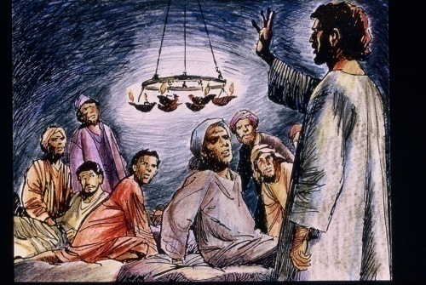

When everything was ready Jesus took his place at the table and his apostles with him. He said, “I have been longing to share this Passover meal with you.”
Place Visual 3 on the left of Visual 2.

Hold Visual 4 in front of you.
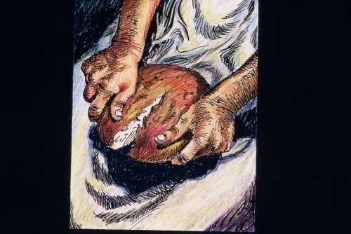

While they were eating Jesus took a loaf of bread, and after giving thanks, he broke it and gave it to them saying, “This is my body, which is given for you. Do this in remembrance of me.”
Place Visual 4 on the left of Visual 3.

Hold Visual 5 in front of you.
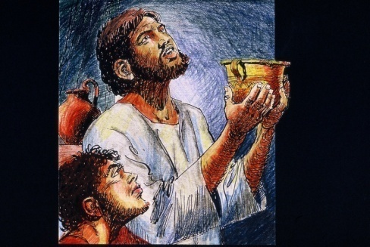

Then Jesus did the same with the cup. He offered thanks and gave the cup to them saying, “This is my blood, which is given for you. Do this in remembrance of me.”
Place Visual 5 on the left of Visual 4.

Pause quietly for a moment, and then begin to wonder together.

Carefully pack story materials into storage box and put on shelf. Ensure that children are watching so they know how to pack the materials away and where to find them.

I Wonder
I wonder what it would have been like to share this meal with Jesus.
I wonder what Jesus meant by the words “This is my body which will be given for you.”
I wonder how Jesus felt as he shared this last meal with his disciples.
I wonder if the disciples understood what Jesus was doing.

Resource Sheet 6
Liturgy of the Eucharist
You will need:
1
2
3
4
- cloth (colour of the season)
- white felt circle cut into four quadrants - see quadrant templates on RE online
- 10 peg people, 1 priest (white material to represent alb with material the color
of the season to represent chasuble and stole)
- bible
- bread on a plate
- grape juice in chalice/wine glass
- cards: Liturgy of the Eucharist, Preparation of the Gifts, Eucharistic Prayer, Our Father, Sign of Peace, Communion, Thanksgiving after Communion (see below)

Lay seasonal cloth down Place the quadrants on top of the underlay to form a circle as in illustration above.
Place the peg figures, including the priest, around the circle facing inwards to represent the community gathered. Trace your finger around the circle as you say:
When we celebrate Mass we come together as the community of God.
Point to each quadrant as you say:
We can look at the Mass as being made up of four parts.

Encourage students to join with you in the following summary of the four parts of the Mass.
Hold the card ‘Introductory Rites’ as you say:
The first part, called the Introductory Rites, gathers us together into the community that is the Body of Christ.
Place Introductory Rites card in quadrant 1.
Show the card ‘Liturgy of the Word’ as you say:
The second part is called the Liturgy of the Word.
Place it in quadrant 2.
Hold up the Bible as you say.
During the Liturgy of the Word we listen to the Scriptures, the Word of God.
Place the open bible in quadrant 2.

Hold the card ‘Liturgy of the Eucharist’ as you say:
The third part of the Mass is called the Liturgy of the Eucharist. During the Liturgy of the Eucharist we remember what Jesus said and did during the Last Supper. We give thanks to God and we receive Jesus in Holy Communion.
Place the Liturgy of the Eucharist card in quadrant 3.

Hold the card ‘Preparation of the Gifts’ as you say:
The Liturgy of the Eucharist begins when the gifts of bread and wine are brought to the altar. We sometimes call this the Offertory Procession.
Place the Preparation of the Gifts card in quadrant 3 below Liturgy of the Eucharist card.
Hold the card ‘Eucharistic Prayer’ as you say:
The priest leads the Eucharistic prayer. In this prayer we give thanks for Jesus and through the work of the Holy Spirit, the bread and wine become the body and blood of Christ.
Place the Eucharistic Prayer card in quadrant 3 below Preparation of the Gifts card.
Hold bread in your hands, showing the children as you say:
The priest takes the bread, blesses it and says the words Jesus used at the Last Supper:
‘Take this, all of you, and eat it. This is my body.’
Place the bread near quadrant 3.

Hold the cup of grape juice as you say:
The priest then takes the wine and blesses it saying the words Jesus used at the Last Supper:
‘Take this all of you and drink from it. This is the cup of my blood.’
Place the cup of grape juice near quadrant 3.
Hold the cards ‘Our Father’ and ‘Sign of Peace’ as you say:
We pray the Our Father and share the Sign of Peace to help us prepare for Communion.
Place the Our Father and Sign of Peace cards in quadrant 3 below Eucharistic Prayer card.
Hold the card ‘Communion’ as you say:
Communion is the great gift that Jesus left us. The priest says, “The Body of Christ.”
We say, ‘Amen’. We are really saying, ‘yes we believe we are receiving the body of Christ’. This strengthens us to become the body of Christ.
Place the Communion card in quadrant 3 below Sign of Peace card.
Hold the card ‘Prayer after Communion’ as you say:
The Liturgy of the Eucharist ends with the priest leading the Prayer after Communion.
Place the Prayer after Communion card in quadrant 3 below Communion card.
Point to the Liturgy of the Eucharist card as you say:
The third part of the Mass is called the Liturgy of the Eucharist. During the Liturgy of the Eucharist we remember what Jesus said and did during the Last Supper. We give thanks to God and we receive Jesus in Holy Communion.
Point to the people, and say
In the celebration of the Mass, Jesus is present in the community gathered,
Point to the priest, and say
in the priest,
Point to the Bible and say
in the Word of God
Point to the bread and wine and say
and in the bread and wine which become the body and blood of Christ.

Pause for a while before wondering with the students.
I wonder why we praise and thank God for Jesus.
I wonder how you feel when the bread and wine become the Body and Blood of Christ.
I wonder what you could say to Jesus after receiving Him in Holy Communion.

Resource Sheet 7
Concluding Rites
You will need:
1
2
3
4
- cloth (colour of the season)
- white felt circle cut into four quadrants
- 10 peg people, 1 priest (white material to represent alb with material the
color of the season to represent chasuble and stole)
- bible
- bread on a plate
- grape juice in chalice/wine glass
- cards: Concluding Rites, Blessing (see below)

Lay seasonal cloth down. Place the quadrants on top of the underlay to form a circle as in illustration above.
Place the peg figures, including the priest, around the circle facing inwards to represent the community gathered.
Trace your finger around the circle as you say:
When we celebrate Mass we come together as the community of God.
Point to each quadrant as you say:
We can look at the Mass as being made up of four parts.
Hold the card ‘Introductory Rites’
The first part, called the Introductory Rites, gathers us together into the community that is the body of Christ.
Place Introductory Rites card in quadrant 1.
Show the card ‘Liturgy of the Word’ as you say:
The second part is called the Liturgy of the Word.
Place Liturgy of the Word card in quadrant 2.
Hold up the Bible as you say:
During the Liturgy of the Word we listen to the Scriptures, the Word of God.
Place the open bible in quadrant 2.
Show the card ‘Liturgy of the Eucharist’ as you say:
The third part is called the Liturgy of the Eucharist. During the Liturgy of the Eucharist we remember what Jesus said and did during the Last Supper. We give thanks to God and we receive Jesus in Holy Communion.
Place Liturgy of the Eucharist card in quadrant 3.
Hold the card ‘Concluding Rites’ as you say:
The Concluding Rites bring the Mass to an end.
Place Concluding Rites card in quadrant 4.
Hold the card ‘Blessing’ in one hand and make the sign of blessing that the priest makes with the right hand as you say:
The priest blesses us in the name of the Father and of the Son and of the Holy Spirit.

Place the Blessing card in quadrant 4 below ‘Concluding Rites’.
Turn the figures out toward the students as you say:
The priest sends us out to take Christ into our world. The priest says, “Go in peace to love and serve the Lord.”

And we say, “Thanks be to God.”

Pause for a while before wondering with the students.
I wonder which part of the Mass you like best.
I wonder in which part/s of the Mass you feel close to Jesus.
I wonder how we can take Christ into our world.
I wonder why the Mass is so important for Catholics.

Introductory Rites
Entrance Procession

Penitential Rite
Opening Prayer
First Reading
Second Reading
Gospel
Responsorial Psalm
Liturgy of the Word
Gloria
Greeting
Entrance Hymn

Homily
Preparation of the Gifts
Our Father
Communion
Liturgy of the Eucharist
Prayer of the Faithful
Prayer after Communion
Concluding Rites
Sign of Peace
Eucharistic Prayer
Creed

