The Walk to Emmaus (Luke 24: 13-33)
Unit 3.3
Luke 24:13-35 The Walk to Emmaus
This is an exquisite story that is full of Lucan ideas – journey, the richness of the word, faith, recognition and meals. This story is only in Luke’s gospel. We are not sure of the location of the village of Emmaus. Two followers of Jesus are travelling there on foot – a distance of about 15 kilometres from Jerusalem. One of them is identified as Cleopas. The other one remains anonymous. It is strange that they do not recognise the risen Jesus who joins them on the journey. Or is it so strange?
Do we always feel that Jesus is with us? Their experience might be much the same as ours. Jesus explains the scriptures to them from the Pentateuch to the prophets. No small feat! This experience later led the two followers to say, “Did not our hearts burn within us as he talked to us on the road and explained the scriptures to us?” (24:32). In light of the scriptures they understood the true meaning of what had happened to Jesus. Their sense of hospitality caused them to insist that the stranger stay with them for a meal. It was in the breaking of the bread that they recognised Jesus. Once they did, he was no longer there with them. Their faith enabled them to perceive Jesus in the Eucharistic ritual. They immediately returned to Jerusalem even though it was late in the day when they set out.

YOU WILL NEED:
* a white or gold ribbon
* a set of visuals made from the PowerPoint: 3.3 The Walk to Emmaus on RE online

Roll out the white/gold ribbon as you say:
At this time of the Church’s year we use white or gold. White is the colour of joy. Easter is the season of joy. This story follows straight on from the one we have just had about the women discovering the empty tomb.

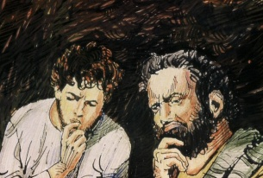
Hold Visual 1 as you say
Two of Jesus’ disciples were travelling from Jerusalem to a village called Emmaus. They were talking with each other about the things that had been happening there, about Jesus their master and friend.

Then Jesus himself joined them but something stopped them from recognizing him.
Place Visual 1 on the ribbon to your far right

Hold Visual 2 as you say
And he said to them, “What are you discussing with each other while you walk along?”
They stood still, looking sad. Then one of them said, “Are you the only person in Jerusalem who doesn’t know the things that have taken place the last few days. They told him all about Jesus of Nazareth, - the things he said, the things he did and how he was crucified; how they hoped he would be their king. They told him how some members of their group had found his tomb empty and had told them that Jesus is alive!
Place Visual 2 on the left of Visual 1

Hold Visual 3 as you say
The stranger then began to explain why Jesus died and how the things that happened to him were written in their Scriptures.
Place Visual 3 on the left of Visual 2

Hold Visual 4 as you say
As they came near the village, the disciples strongly urged him to stay with them.
Place Visual 4 on the left of Visual 3

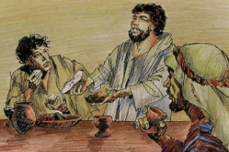
Hold Visual 5 as you say
When he was at table with them he took the bread, blessed it, broke it and gave it to them.
Then their eyes were opened and they recognized him.
The stranger was Jesus. Jesus was risen from the dead!
Then he disappeared from their sight.
Place Visual 5 on the left of Visual 4

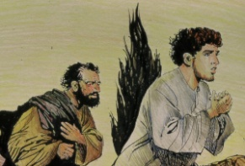
Hold Visual 6 as you say
The friends of Jesus were so happy that Jesus was alive. They got up immediately, and ran as fast as they could back to Jerusalem to tell the disciples.
Place Visual 6 on the left of Visual 5

Hold Visual 7 as you say
They told them what had happened on the road, and how they had recognized Jesus in the breaking of the bread.

Place Visual 7 on the left of Visual 6.

Sit back … Pause for a while before wondering with the students …

I wonder:

- I wonder why the disciples didn’t recognize Jesus.
- I wonder what it was like telling their story of Jesus to a stranger.
- I wonder why the disciples wanted the stranger to stay with them.
- I wonder what it felt like when they recognized that the stranger was really Jesus.
- I wonder why the disciples recognized Jesus at the breaking of the bread.
- I wonder how the disciples changed when they realized that Jesus was risen.

