St Mary’s College
Year 12
Graduation Mass

Tuesday 24th October 2017

Going Beyond

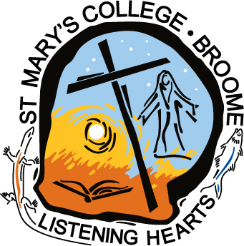

Introduction: Alex Beuke

We warmly welcome you all here this evening to Nulungu Chapel. We gather together in thanksgiving for our many successes as Year 12 graduating students, and pray that as we continue our lives beyond St Mary’s College, we go forth with listening hearts. Our theme for the Mass is Going Beyond, the same theme as our retreat held at the beginning of the year. During this retreat, we explored how God’s Word compels us to move beyond our own immediate needs and reach out to others, to go beyond the limitations we and others put on us, and strive to excel in all we do. Today is a day to acknowledge the times we have stretched ourselves and with faith, gone beyond what we thought was possible, to become the adults God intended us to be. We present our hopes, joys and plans for the future to the Lord. We thank God for all the blessings we have received during our time at St Mary’s College, and ask God to grant us the courage to continue building God’s Kingdom.

Our graduating students will process in with our Mass celebrants Bishop Christopher, Monsignor Paul and Father Marcello. Please stand for the opening song, Here I Am to Worship.

The entrance procession begins with the cross, the Graduating students, followed by Fr Marcello, Monsignor Paul and Bishop Christopher.

Entrance Song: Here I Am to Worship

Light of the world
You stepped down into darkness
Opened my eyes, let me see
Beauty that made this heart adore You
Hope of a life spent with You
Here I am to worship
Here I am to bow down
Here I am to say that You're my God
You're altogether lovely
Altogether worthy
Altogether wonderful to me

King of all days
Oh so highly exalted
Glorious in heaven above
Humbly You came to the earth You created
All for love's sake became poor
Here I am to worship
Here I am to bow down
Here I am to say that You're my God
You're altogether lovely
Altogether worthy
Altogether wonderful to me

Well, I'll never know how much it cost
To see my sin upon that cross
Well, I'll never know how much it cost
To see my sin upon that cross
So, here I am to worship
Here I am to bow down
Here I am to say that You're my God
You're altogether lovely
Altogether worthy
Altogether wonderful to me

Bishop Christopher: In the name of the Father and of the Son and of the Holy Spirit
All: Amen.

Bishop Christopher: The grace of our Lord Jesus Christ and the love of God and the communion of the Holy Spirit be with you all.
All: And with your spirit.

Welcome: Bishop Christopher

Penitential Rite:

Bishop Christopher: Jesus said, “You are the rock on which I build my Church.” As we prepare to go beyond the confines of St Mary’s College as Christ’s presence in the world, let us acknowledge the times when we have not been strong and faithful disciples.

(3 Students to read and put objects onto table at front of altar)

Holding a rock: James Abriol
Lord God, you invite us to grow close to you through prayer and sacrament. We ask forgiveness for the times we have broken or damaged our relationship with you.

Bishop Christopher: Lord have mercy
Response: Lord Have Mercy

Holding a rock: Scartisha Ningella
Lord God, you showed us how to live a life of love. We ask forgiveness for the times we have been hard and lacking in generosity.

Bishop Christopher: Christ have mercy

Response: Christ have Mercy

Holding a rock: JoFrarn Hunter
Lord God, you gift us with the freedom to make wise choices. We ask forgiveness for the times we have chosen to do less than our best, and have not been strong in our service of your world.

Bishop Christopher: Lord have mercy

Response: Lord have mercy

Bishop Christopher: May almighty God have mercy on us, forgive us our sins and bring us to everlasting life

All: Amen.

Opening Prayer:

Bishop Christopher: Let us pray, God our Father, you are the giver of life and love. You invite us to walk in your presence each day and see reflected in others, the face of Christ. As we come to the end of our time together, may all we have achieved through you, continue to flourish, and build your Kingdom. We ask this through Christ our Lord.
All: Amen

First Reading Jeremiah 29:11-15
Sarah Hill

A Reading from the Prophet Jeremiah

The Lord God has this to say to you today: I have loved you with an everlasting love and I am constant in my affection for you. I will build you up and I will protect you in good times and in bad. So be happy and go forth in the dancing of the merrymakers. I have plans in my heart for you: plans for peace, not disaster, plans to give you a future and a reason to hope. And remember, when you call upon me and come and pray to me I will hear you. You will seek me and find me: when you seek me with all your heart, I will be found by you.
The Word of the Lord
All: Thanks be to God
Responsorial Psalm

Psalm 39(40):7-10,17

Here am I, Lord; I come to do your will.
Here am I, Lord; I come to do your will.

You do not ask for sacrifice and offerings,
but an open ear.
You do not ask for holocaust and victim.
Instead, here am I.

Here am I, Lord; I come to do your will.

In the scroll of the book it stands written
that I should do your will.
My God, I delight in your law
in the depth of my heart.

Here am I, Lord; I come to do your will.

Your justice I have proclaimed
in the great assembly.
My lips I have not sealed;
you know it, O Lord.

Here am I, Lord; I come to do your will.

O let there be rejoicing and gladness
for all who seek you.
Let them ever say: ‘The Lord is great’,
who love your saving help.

Here am I, Lord; I come to do your will.

Second Reading: Jack Wilcox

Colossians 3:12-15

You are God’s chosen race, his saints; he loves you, and you should be clothed in sincere compassion, in kindness and humility, gentleness and patience. Bear with one another; forgive each other as soon as a quarrel begins. The Lord has forgiven you; now you must do the same. Over all these clothes, to keep them together and complete them, put on love. And may the peace of Christ reign in your hearts, because it is for this that you were called together as parts of one body. Always be thankful.
The Word of the Lord

All: Thanks be to God

Please stand to welcome the Gospel (Marcus to bring up Gospel)

Gospel Acclamation: (Jack Wilcox)
Alleluia, Alleluia
Come and listen, and I will tell what great things God has done for me.
Alleluia.

Gospel:

Bishop Christopher The Lord be with you

All: And with your spirit

Bishop Christopher A reading from the Holy Gospel according to Matthew

All: Glory to you O Lord

Matthew 28:16-20

Priest:
The eleven disciples went to the hill in Galilee where Jesus had told them to go. When they saw him, they worshipped him, even though some of them doubted. Jesus drew near and said to them, “I have been given all authority in heaven and on earth. Go, then, to all peoples everywhere and make them my disciples: baptise them in the name of the Father, the Son and the Holy Spirit, and teach them to obey everything I have commanded you. And I will be with you always, to the end of the age.

The Gospel of the Lord
All: Praise to you Lord Jesus Christ

Homily: Bishop Christopher

Prayer of the Faithful:

Bishop Christopher:

We are claimed as God's own people, chosen from the beginning. Nourished by God's Word, we turn now to our God in prayer.
Minmae: For the Holy Catholic Church, for Francis our pope, Christopher our bishop, and all priests, that through word and action they bring forth the Kingdom of God. Lord hear Us
Lord Hear Our Prayer
For the leaders of the world, that they are moved by the Spirit to work together to promote the good of all, and enact policies that give us a future filled with hope. Lord hear us
Lord Hear Our Prayer
For the St Mary’s College community, that your Spirit which dwells in Yawaru Country, continues to open the eyes and ears of all to your grace at work in the world, and nurture listening hearts. Lord hear us
Lord Hear Our Prayer
Francis: For all graduating students, that as we go beyond, we will continue to respect and support others, strive for excellence, and carry the love of Christ with us always. Lord hear us
Lord Hear Our Prayer
For all those who have died, especially our loved ones and classmates who have departed from our school community, may they rest in peace. Lord hear us
Lord Hear Our Prayer
Like Mary, we ponder in our hearts our own needs and intentions, [6 second pause]. Lord hear us
Lord Hear Our Prayer
Bishop Christopher: Lord our God, we offer you these prayers, asking your guidance and strength for this graduating class and all your church. We ask this through Christ our Lord.

All: Amen

Offertory Procession: (Dion and Taj)

Offertory Song - instrumental

Liturgy of the Eucharist

Bishop Christopher: Blessed are you, Lord God of all creation,
for through your goodness we have received the bread we offer you:
fruit of the earth and work of human hands,
it will become for us the bread of life.
 | All | Blessed be God for ever.
 | Bishop Christopher | Blessed are you, Lord God of all creation,  for through your goodness we have received  the wine we offer you:  fruit of the vine and work of human hands,  it will become our spiritual drink.
 | All | Blessed be God for ever.
 | Bishop Christopher | Pray, brothers and sisters,  that my sacrifice and yours  may be acceptable to God,  the almighty Father.
 | All | May the Lord accept the sacrifice at your hands  for the praise and glory of his name,  for our good and the good of all his holy Church.
 | All | Amen.
Prayer Over the Gifts:

Grant us, Lord, we pray, a sincere respect for your gifts, that, through the purifying . action of your grace, we may be cleansed by the very mysteries we serve.
Through Christ our Lord.
All: Amen

 | Bishop Christopher | EUCHARISTIC PRAYER II  The Lord be with you.
 | All | And with your spirit.
 | Bishop Christopher | Lift up your hearts.
 | All | We lift them up to the Lord.
 | Bishop Christopher | Let us give thanks to the Lord our God.
 | All | It is right and just.
 | Bishop Christopher | It is truly right and just,  our duty and our salvation,  always and everywhere to give you thanks,  Lord, holy Father, almighty and eternal God,  through Christ our Lord.  For through his Paschal Mystery,  he accomplished the marvellous deed,  by which he has freed us  from the yoke of sin and death,  summoning us to the glory of being now called  a chosen race, a royal priesthood,  a holy nation, a people for your own possession,  to proclaim everywhere your mighty works,  for you have called us out of darkness  into your own wonderful light.  And so, with Angels and Archangels,  with Thrones and Dominions,  and with all the hosts and Powers of heaven,  we sing the hymn of your glory,  as without end we acclaim:
 | All | Holy, Holy, Holy Lord God of hosts.  Heaven and earth are full of your glory.  Hosanna in the highest.  Blessed is he who comes in the name of the Lord.  Hosanna in the highest.
 | Bishop Christopher | You are indeed Holy, O Lord,  the fount of all holiness.  Make holy, therefore, these gifts, we pray,  by sending down your Spirit upon them like the dewfall,  so that they may become for us  the Body and Blood of our Lord Jesus Christ.  At the time he was betrayed  and entered willingly into his Passion,  he took bread and, giving thanks, broke it,  and gave it to his disciples, saying:  take this, all of you, and eat of it,  for this is my body,  which will be given up for you.  In a similar way, when supper was ended,  he took the chalice  and, once more giving thanks,  he gave it to his disciples, saying:  take this, all of you, and drink from it,  for this is the chalice of my blood,  the Blood of the new and eternal covenant,  which will be poured out for you and for many  for the forgiveness of sins.  Do this in memory of me.
 | Bishop Christopher | The mystery of faith.
 | All | When we eat this Bread and drink this Cup,  we proclaim your Death, O Lord,  until you come again.
 | Bishop Christopher | Therefore, as we celebrate  the memorial of his Death and Resurrection,  we offer you, Lord, the Bread of life and the Chalice of salvation,  giving thanks that you have held us worthy  to be in your presence and minister to you.  Humbly we pray  that, partaking of the Body and Blood of Christ,  we may be gathered into one by the Holy Spirit.  Remember, Lord, your Church,  spread throughout the world,  and bring her to the fullness of charity,  together with Francis our Pope, Christopher our Bishop, and all the clergy.  Remember also our brothers and sisters  who have fallen asleep in the hope of the resurrection,  and all who have died in your mercy:  welcome them into the light of your face.  Have mercy on us all, we pray,  that with the Blessed Virgin Mary,  Mother of God, with blessed Joseph her spouse,  with the blessed Apostles,  and all the Saints who have pleased you throughout the ages,  we may merit to be coheirs to eternal life,  and may praise and glorify you  through your Son, Jesus Christ.  Through him, and with him, and in him,  O God, almighty Father,  in the unity of the Holy Spirit,  all glory and honour is yours,  for ever and ever.
 | All | Amen.

COMMUNION RITE

Bishop Christopher: At the Saviour’s command and formed by divine teaching, we dare to sing:

Our Father: ‘Aboriginal Our Father’ (Choir)

You are our Father, you live in Heaven. We talk to you, Father, you are good. (Repeat)

We believe your word Father. We are your children, give us this bread today. (Repeat)

We have done wrong, we are sorry. Teach us Father, all about your word. (Repeat)

Others have done wrong to us, and we are sorry for them, Father today. (Repeat)

Stop us from doing wrong, Father. Save us all from the evil one. (Repeat)

(Clap) You are our Father, you live in Heaven. We talk to you, Father, you are good. (Repeat)

Bishop Christopher:
Deliver us, Lord, we pray, from every evil,
Graciously grant peace in our days
That, by the help of your mercy,
We may be always free from sin
And safe from all distress
As we await the blessed hope
And the coming of our Saviour, Jesus Christ.

All: For the Kingdom the power and the glory are yours now and forever.

Bishop Christopher:
Lord Jesus Christ, who said to your Apostles:
Peace I leave you, my peace I give you,
look not on our sins,
but on the faith of your Church,
and graciously grant her peace and unity
in accordance with your will.
Who live and reign for ever and ever.

All: Amen

Bishop Christopher: The peace of the Lord be with you always.

All: And with your spirit.

Bishop Christopher: Let us offer each other the sign of peace.

The congregation exchange a sign of peace.

LAMB OF GOD

ALL: Lamb of God, you take away the sins of the world, have mercy on us.
Lamb of God, you take away the sins of the world, have mercy on us.
Lamb of God, you take away the sins of the world, grant us peace.

Bishop Christopher:
Behold the Lamb of God,
behold him who takes away the sins of the world.
Blessed are those called to the supper of the Lamb.

All: Lord, I am not worthy
that you should enter under my roof,
but only say the word
and my soul shall be healed.

Holy Communion

Everyone is invited to come forward to receive Holy Communion or a blessing
Michael Pepper, Eucharistic Minister

Communion songs: Hail Mary, Gentle Woman (Joseph and Choir)
This World is Yours – J. Dresden (recording on screen)

Hail Mary, full of grace, the Lord is with you
Blessed are you among women
And blessed is the fruit of your womb, Jesus
Holy Mary, mother of God, pray for us sinners
Now, and at the hour of death, Amen

Gentle Woman, quiet light
Morning Star, so strong and bright
Gentle mother, peaceful dove
Teach us wisdom, teach us love

You were chosen by the Father
You were chosen for the Son
You were chosen from all women
And for woman, shining one
Gentle Woman, quiet light
Morning Star, so strong and bright
Gentle mother, peaceful dove
Teach us wisdom, teach us love
Blessed are you among women
Blessed in turn all women too
Blessed they with peaceful spirits
Blessed they with gentle hearts

Prayer after Communion:
Grant O Lord, we pray, that, benefiting from participating in heavenly things, we may be helped by what you give in this present age and prepared for the gifts that are eternal. Through Christ our Lord
All: Amen

Communion Reflection:

This evening marks for us an ending, but also a new beginning. We tell that story of ending and beginning now using the Easter light, the symbol of Christ, the Alpha and the Omega, the beginning and the end.

Bec Famlonga
Carrie Anne to light candle and hand to Dexter
On behalf of the staff of the school, I offer you the light of Wisdom. As you go beyond, carry this light from this place to a world that stands in need of wisdom; a world that faces decisions and choices never dreamed of in times past. Remember that everything you learned in school was learnt in the company of others. Be open to the learning that is ahead of you. May you be a light of wisdom for others. May you grow in a wisdom that will inspire you to find the good and the true, as you travel the road ahead.

Matt Hill to read
Fran Wilson to light candle and hand to Oliver
On behalf of all families gathered here this evening I offer you the light of love. This is a light we lit for you a long time ago. It is the light you depended on in those early days, the light you ran to when things went wrong. The light that was left on for you because you were afraid of the dark. This is the light that waited up for you if you were late home…and the light that was always there even though sometimes, just sometimes, you wish it wasn’t! As you go beyond, carry this light of love into a world where real love is rare and precious. Use it to light the path of your own search to love and be loved. And when you find that the light is flickering, blown about by the troubles of life, remember that there will always be a light burning for you in that place called home.

Anastasia Bradley
Michael Pepper to light candle and hand to Devony
On behalf of the School Board of St Mary’s College I offer you the light of faith. When you were a baby someone held this light for you and named you as a child of God. Over the years this flame has been fuelled by the example of those around you. Now you must carry that light for yourself. You will not find it an easy task; there may be a price to pay. The flame will flicker, it may even be extinguished for a time. But the most important thing about the flame of faith, is that it is not yours alone. A lone flame cannot pierce the darkness, but many flames together can cast a great light. As you go beyond, we urge you to be part of the Christian community wherever you find it. Be as God called you to be. As the stars in the night, as the sun in the sky. A source of light for all you will meet on the way. Be a light for the world.

Year 7 Student – Charlotte
Joshua Anderson to light candle and hand to Aiden Haynes
On behalf of all remaining St Mary’s College students, I offer you the light of memory. When you are in Year 7 as I am, you Year 12 students seem very old and very big. Five or six years ago seems a very long time. I will leave school in the year 2022. Where will you be then? Days pass by, and for you now, school days are over. Carry the light of those days with you. When you meet, tell again the stories of those years in the classroom and on the playing field. Remember the victories and the disappointments, the lost locker key, the exam success and perhaps the cooling off time outside the Principal’s office. We ask you to remember us who will continue the story of the school to the end of the year 2022 and beyond. Remember us, we will remember you!

Brian Kane: I now invite all remaining Year 12 students to join with your fellow graduates at the front of the altar. It is a tradition at St Mary’s for those who are leaving to be given a special blessing by the College community. I invite Bishop Christopher to lead the congregation in the blessing. Please stand and raise your hands over the St Mary’s College Graduation Class of 2017.

Blessing Song

May the blessing of God be upon you, the blessing of the Father and the Son,
And may the Spirit of God, the Spirit of love, be with you all your days.

May God the Father,
From whom every family takes its name,
Give you the power through His Spirit
For your hidden self to grow strong.
And may Jesus, the Son, live in your heart
Through faith and then, planted in love
And built on love,
May you be filled with the fullness of God.

May the blessing of God be upon you, the blessing of the Father and the Son,
And may the Spirit of God, the Spirit of love, be with you all your days.

Concluding Rite

Bishop Christopher: The Lord be with you.
All: And with your spirit.

Bishop Christopher: May Almighty God bless you, in the name of the Father, the Son and the Holy Spirit.
All: Amen

Bishop Christopher: Go in peace glorifying the Lord by your life.
All: Thanks be to God.

Final song: Hearts on Fire
(Students proceed out behind the Cross)

We come from Ancient Dreamtime,
From the bush or by the sea,
We come from a thousand city streets.
We are the rich & lowly,
We are the poor and strong
We come to share this moment,
Gathering here, singing one song.

With our hearts on fire with the love of Jesus,
Hearts on fire, let’s spread the Word.
Hearts on fire, feel the Spirit blazing.
Hearts on fire,
Called to live the Good News in this land,
Setting hearts on fire, with our hearts on fire,
Setting hearts on fire.
We long to live in freedom, we yearn for unity.
We dream of justice, joy and peace
Spirit, fill us with your power.
Jesus, help us live your call.
O Creator, give us wisdom,
So we will be Good News for all.

With our hearts on fire with the love of Jesus,
Hearts on fire, let’s spread the Word.
Hearts on fire, feel the Spirit blazing.
Hearts on fire,
Called to live the Good News in this land,
Setting hearts on fire, with our hearts on fire,
Setting hearts on fire.

We are the voice of Jesus,
We are his heart & hands,
We are his body in our land.
Stand up, live the story,
To all the world proclaim,
Go out to all creation,
Lighting the fire, fanning the flames.

With our hearts on fire with the love of Jesus,
Hearts on fire, let’s spread the Word.
Hearts on fire, feel the Spirit blazing.
Hearts on fire,
Called to live the Good News in this land,
Setting hearts on fire, with our hearts on fire,
Setting hearts on fire.
Graduating Class of 2017

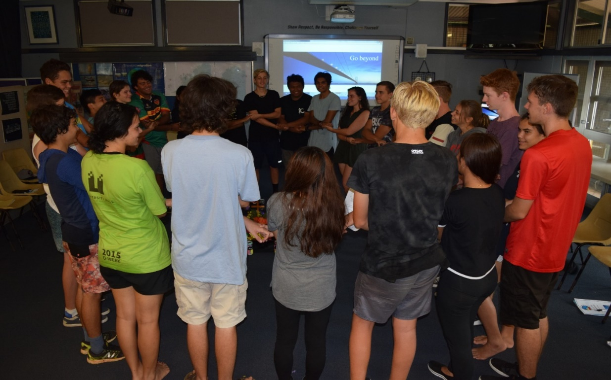

Alex Beuke Jenaiyah Bin Omar
Peter Burton Megan Campbell
Jofrarn Hunter Oliver Wilson
Abier Hamaguchi Sarah Hill
Charm Johnson Devony Lance
Dexter Lance Marcus Scholtes
Francis McNally James Abriol
Scartisha Ningella Jamie Paton
Minmae Pineda Leilani Ozies
Aiden Haynes Taj Jamieson
Dion Parriman Jack Wilcox

