Advent and Christmas Overview
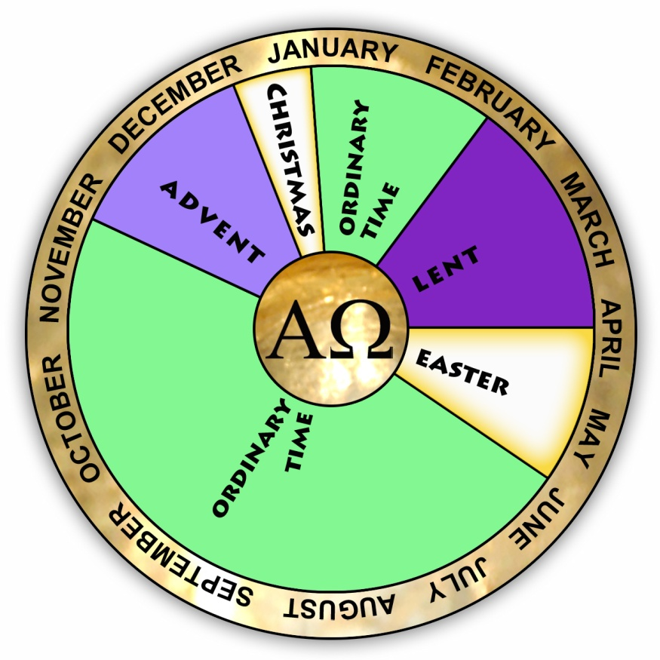
The early Christians had only one feast ‘the day of Kyrios Christ, the weekly and annual Pasch’ - in other words, Sunday and Easter. Christmas, the feast of the Nativity, was not celebrated widely in the church until the fourth century. Nonetheless, today the church holds that ‘next to the yearly celebrations of the paschal mystery, the Church considers nothing more important than the memorial of Christʼs birth and early manifestations.’

Feast of the Incarnation
Christmas celebrates the Incarnation, that is, Jesus Christ becoming human and living among us. This is one aspect of the paschal mystery. All the other aspects of this mystery are celebrated within the cycle of the church year. From the beginning of the year, at Advent, the church ‘unfolds the whole mystery of Christ, from the incarnation and birth until the ascension, the day of Pentecost, and the expectation of blessed hope and of the coming of the Lord’ at the end of time.
At the centre and source of the church year is Christ. So it is entirely appropriate to have the Alpha and Omega symbol at the centre of a liturgical calendar. Alpha and Omega are the first and last letters of the Greek alphabet. These letters have been used since the early days of the church to represent Christ - the beginning and the end – the totality.

The Advent Season – preparing for Christmas
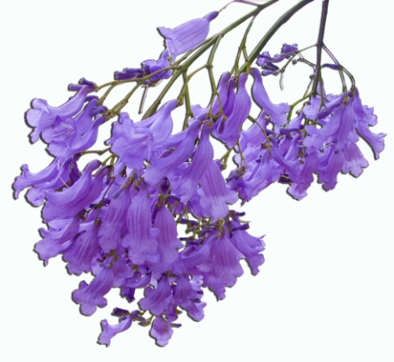
Advent is a time of preparation for Christmas. Advent is not a separate season and cannot be understood outside the Christmas context. The word advent comes from the Latin adventus meaning coming: we wait and watch for the arrival of Christ.
Advent begins on the Sunday nearest to November 30 and lasts four weeks. The first Sunday of Advent is the beginning of the Church year.

Ambience: hopeful expectation
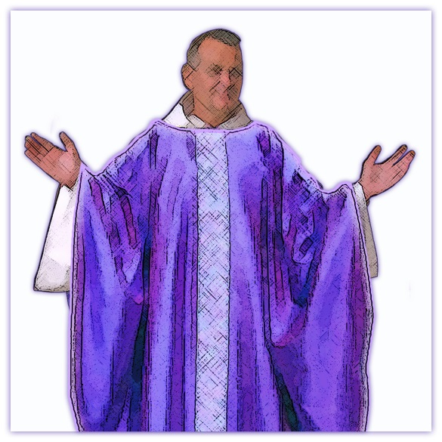
Today Advent is not a penitential season, as it was in the past. An atmosphere of hopeful expectation permeates the readings and the prayers of the liturgies. This is a solemn, but not a sombre time.

Colour: violet
The official colour of the vestments for this season is the same as Lent, that is, violet, but many parishes use a less penitential purple for Advent. Since the Jacaranda is blooming at this time of year around Brisbane, parishes sometimes use blue/mauve as their Advent colour to reflect a sense of hopeful expectation.

Liturgical themes: past, present & future
During Advent we watch and wait for the coming of Christ. The readings and prayers for the season focus on the two advents of Christ: first, the birth of the Messiah, Jesus, in Bethlehem (past); and the second coming of Christ at the end times (future). The second coming is why we live in hopeful expectation, which means that we watch and wait for the end times when: God’s Kingdom will become a reality; all God’s promises will be fulfilled; all creation will be completed and renewed; there will be no more poverty, sickness or unhappiness; and we will see God face to face. However, those days are not all in the future. Jesus lived, died, rose from the dead and sent us his Spirit, so that we could start living the Kingdom reality here and now (present).
The readings and prayers for the season often tell how the Holy Spirit supports us in our daily efforts to live a Kingdom lifestyle: by sharing the good news about God’s Kingdom and being helpful and kind to others, especially the poor. This was how Jesus lived his life and this was the example that he left for us.

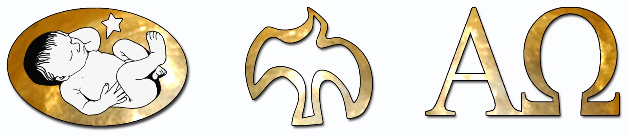

The Christmas Season
Christmas is the great feast of the Incarnation. The Christmas season starts on Christmas Eve and concludes with the feast of the Baptism of the Lord, which marks the beginning of Ordinary Time.
The Feast of Christmas has a vigil mass on Christmas eve and three traditional Masses on Christmas day: at midnight, at dawn and during the day. The custom of celebrating these three masses stems from ancient liturgical practices in the Holy Land. The masses were celebrated in three different locations (or stations), which were within walking distance of Jerusalem and which were associated with the life of Christ. One of the earliest references to these stational masses was written by a woman, called Egeria, who made a pilgrimage to the Holy Land probably in the early fifth century.
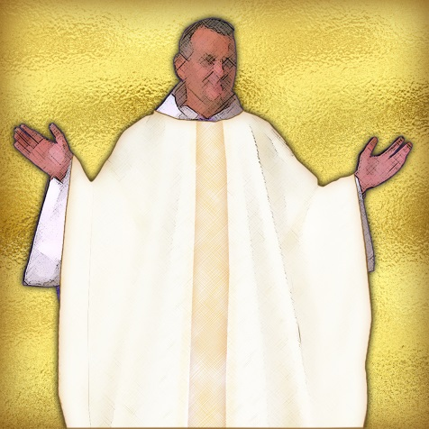
The true birth date of Christ is unknown, but by the fourth century, most Christians celebrated the feast of the Nativity on December 25, which is close to the winter solstice in the Northern Hemisphere.

Colour: white
The colour for the Christmas season is white. Traditionally, this colour is a symbol of purity. Also, when white cloth comes into contact with bright light it appears to glow. These qualities make it an appropriate colour for Christmas vestments.

Themes: from darkness to light
December 25 is close to the date of the winter solstice in the Northern Hemisphere. This is the moment when the sun has reached its furthest distance from the earth and begins its return, bringing summer warmth and life-giving light to the world. There are many references to the natural season in the liturgies of Christmas and these draw the seasonal changes into alignment with the theology of the Incarnation: Christ is the ‘true light.’ The first reading for the Christmas midnight mass proclaims ‘the people that walked in darkness has seen a great light; on those who live in a land of deep shadow a light has shone . . . for there is a child born for us, a son given to us . . .’ (Is 9:2,6)
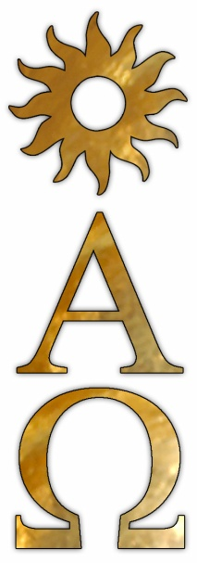
Here are some examples of references to Christ as the ‘true light’ in the prayers of the three traditional Christmas masses:
- Collect for the Christmas midnight mass:
O God, who have made this most sacred night radiant with the splendour of the true light, grant, we pray, that we, who have known the mysteries of his light on earth, may also delight in his gladness in heaven.
- Entrance antiphon for the mass at dawn:
Today a light will shine upon us, for the Lord is born for us . . .
- Gospel acclamation for the mass during the day:
Alleluia, alleluia!
A holy day has dawned upon us.
Come, you nations and adore the Lord.
Today a great light has come upon the earth.
Alleluia!
The Christmas cycle also includes the feasts of the Holy Family, Mary Mother of God, Epiphany and the Baptism of the Lord, after which Ordinary Time begins.

Advent Prayer Space

Imaging the two advents of Christ: the Crib and the Chi-Roh
The use of the crib at Christmas has a long history in the church as you can see from the overview below; but the nativity scene itself refers to only part of the story. When you make a prayer space in the classroom for the last week of school (the first week of Advent), try to make references to the whole paschal mystery, especially the two advents of Christ. One suggestion is to use a crib and a Chi-Roh image together:
- The crib refers to the first advent of Jesus when he was born in Bethlehem
- The Chi-Roh symbol contains the alpha and omega, which are the first and last letters of the Greek alphabet. These letters have been used since the early days of the church to represent Christ – the beginning and the end – the totality. This is an appropriate image to represent the second coming of Christ on the last day.
The cross shape in the Chi-Roh image makes a reference to the passion and death of Christ. So placing the Chi-Roh, the Alpha and Omega and the Crib images together, is one way to represent the entire paschal mystery.

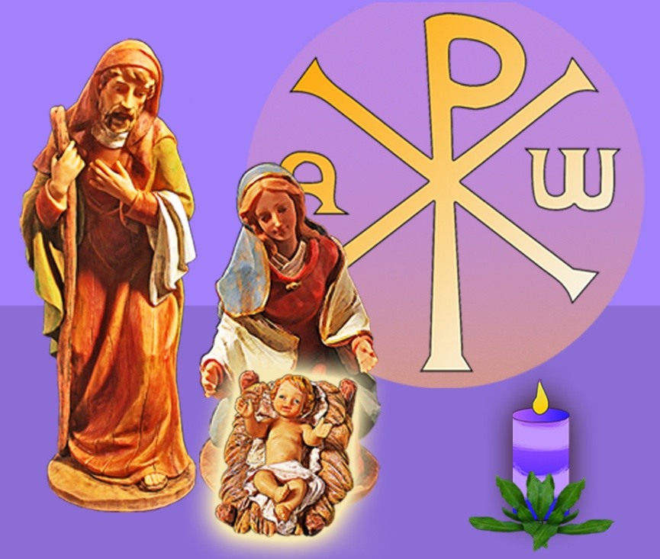
Chi-Roh symbol
The Chi-Roh is one of the earliest symbols representing Christ. It is formed by combining the first two letters of the Greek work for Christ chi (X) and roh (P). Later the Alpha and Omega were placed on either side of the Chi-Roh and this symbol is commonly used today as, among other uses, a visual motif on paschal candles.

Christmas Crib
The use of the Christmas nativity scene – often called crib, crèche or manger – has a long history in the church’s celebration of Christmas. As early as the 5th century, the Basilica of Saint Mary Major in Rome had a small chapel built in the shape of a cave to imitate the birth place of Jesus in Bethlehem. An early name for the church was St Mary at the Crib. The earliest images of the nativity scene, however, can be seen in the relief sculptures on Roman Christian tombs of the 4th century. These sarcophagal sculptures already show the ox and the ass, for example on the Sarcophagus of Marcus Claudianus.
It was St Francis of Assisi who made the Christmas devotion to the crib popular in the 13th century. As a young man, Francis had made a pilgrimage to the Holy Land, where he saw the manger at Bethlehem and it made a great impression on him. In 1223, when he was in the Italian hill town of Greccio for Christmas, Francis decided to make the Christmas celebrations special for the local people. The parish church was not big enough for the Christmas crowd, so Francis set up for the Christmas mass on the hillside next to a cave in which he recreated the nativity tableau – complete with ox and ass – which he had seen in Bethlehem.
In Franciscan spirituality the Christmas and the Easter story are drawn closely together. Jesus is the Incarnate Word whose characteristics are poverty, humility and compassion. Cross and crib are key characteristics of Jesus, who authentically experienced the full vulnerabilities of humanity – from his birth as a helpless infant in Bethlehem to his shameful and painful death on the Cross. Franciscan spirituality, then, places a great emphasis on the humanity of Christ. The role of Mary is prominent also and her role is understood to be central to the whole Paschal mystery. For more information on this topic read St Francis and the Crib by Leonard Foley, O.F.M. and St. Francis and the Christmas Creche by Fr William Saunders.

Advent Wreath
An Advent Wreath is a useful symbol of the season. The progressive lighting of the candles over the four weeks of Advent is a way to mark the passing of the time while we watch and wait for the advent of Christ at Christmas. This symbol comes from the Northern Hemisphere where Advent is celebrated during winter. In the dead of winter, the nights are long and the sun is too far away to give warmth to the earth. So it is appropriate to use candle light as a symbol of hope.
The use of light also reflects what Luke’s gospel says about the advent of Christ: ‘By the tender mercy of our God, the dawn from on high will break upon us, to give light to those who sit in darkness and in the shadow of death, to guide our feet into the way of peace.’ (Luke 1:78-79)
This focus on winter imagery can be a problem for those of us who live in the Southern Hemisphere. The way to overcome the difficulty is to infuse a little local colour into the mix. Try making a wreath with Australian greenery.
The colour of the wreath candles does not matter too much. The custom of using three purple and one pink candle reflects the old notion of Advent as a penitential season. Nowadays Advent is the season of hopeful expectation, so white candles are a good choice; but there are no rules about this. Be creative, but remember, the focus is not on the candles, but on Christ our light.
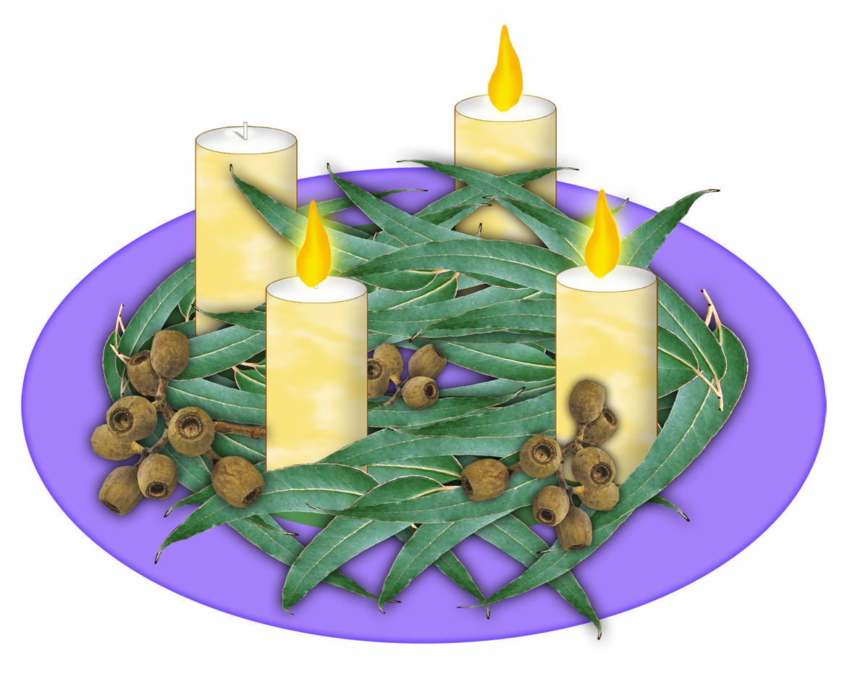

Bibliography
Jounel, Pierre. “The Christmas Season.” In The Church at Prayer. Edited by Aimé Georges Martimort, 4:77-96. Collegeville, Minnesota: The Liturgical Press, 1986.
McKenzie, John. Dictionary of the Bible. New York: Touchstone, 1995.
National Conference of Catholic Bishops (USA), Committee on the Liturgy. Lectionary for Masses with Children. New York: Catholic Book Publishing, 1993.
O'Shea, W. J., and S. K. Roll. "Advent." New Catholic Encyclopedia. 2nd ed. Vol. 1. Detroit: Gale, 2003. 133-135. Gale Virtual Reference Library. Accessed October 18, 2011, http://go.galegroup.com.ezproxy1.acu.edu.au/ps/i.do?&id=GALE%7CCX3407700169&v=2.1&u=acuni&it=r&p=GVRL&sw=w
Roll, S. K. "Christmas and its Cycle." New Catholic Encyclopedia. 2nd ed. Vol. 3. Detroit: Gale, 2003. 551-557. Gale Virtual Reference Library. Accessed October 13, 2011, http://go.galegroup.com.ezproxy1.acu.edu.au/ps/i.do?&id=GALE%7CCX3407702399&v=2.1&u=acuni&it=r&p=GVRL&sw=w
The Liturgical Commission. Daily Mass Book 2012. Brisbane: Liturgical Commission, 2011.
Ordo 2012: The Celebration of Eucharist and the Liturgy of the Hours in Australia and New Zealand. Brisbane: Liturgical Commission, 2011.
Break Open the Word: the Book for Readers Year B – 2012. Brisbane: Liturgical Commission, 2011.

Documents
General Norms for the Liturgical Year and the Calendar.
http://www.liturgyoffice.org.uk/Calendar/Info/GNLY.pdf
Directory of Popular Piety and the Liturgy Principles and Guidelines.
http://www.vatican.va/roman_curia/congregations/ccdds/documents/rc_con_ccdds_doc_20020513_vers-direttorio_en.html
Sacrosanctum Concilium, Constitution on the Sacred Liturgy. http://www.vatican.va/archive/hist_councils/ii_vatican_council/documents/vat-ii_const_19631204_sacrosanctum-concilium_en.html
Dies Domini. Day of the Lord. http://www.vatican.va/holy_father/john_paul_ii/apost_letters/documents/hf_jp-ii_apl_05071998_dies-domini_en.html
Tertio Millennio Adveniente. Comes the third Millennium. http://www.vatican.va/holy_father/john_paul_ii/apost_letters/documents/hf_jp-ii_apl_10111994_tertio-millennio-adveniente_en.html

Websites
“Bethlemen.” BiblePlaces.com. Accessed October 30, 2013. http://www.bibleplaces.com/bethlehem.htm
Foley, Leonard, O.F.M. “St Francis and the Crib.” AmericanCatholic.org. Accessed October 30, 2013. http://www.americancatholic.org/Features/Christmas/Crib.asp
Saunders, William. “St. Francis and the Christmas Creche.“ Catholic Education Resource Centre. Accessed October 30, 2013. http://www.catholiceducation.org/articles/religion/re0238.html
Stracke, J. Richard. “The Sarcophagus of Marcus Claudianus.” Georgia Regents University. Accessed October 30, 2013. http://www.aug.edu/augusta/iconography/palazzoMassimo/mcSarcophagus.Nativity.html
VHOAGLAND. Saint Mary Major, Rome, Italy. (Video file). Accessed October 30, 2013. http://www.youtube.com/watch?v=BeDaWytbbbE

Links to Children's Liturgy Resources

- We Pray as One - daily liturgical prayer for the school classroom and parish meetings published by Liturgy Brisbane.
- Guidelines for Children’s Liturgy of the Word produced by Brisbane Catholic Education and Liturgy Brisbane.
- Mountjoy Enterprises - a number of Advent and Christmas liturgy sources books and CD-ROMS by Rina Wintour: http://www.liturgycreations.com/ Phone 0400 332 120
- Faith & Life: a vicariate of the Roman Catholic Archdiocese of Brisbane.
- Liturgy Office of England and Wales – resources to support Liturgy of the Word with Children.
- Resources for Catholic Educators – links to many useful Advent resources.
- RESource an online teaching and learning initiative of the Catholic Education Office, Melbourne

Advent and Christmas Overview
was produced by ResourceLink @ Brisbane Catholic Education in 2010.
Text, graphics & layout: Dr Jenny Close

This resource is licensed under a Creative Commons Attribution-Noncommercial 3.0 Unported License.
To view a copy of this license, visit http://creativecommons.org/licenses/by-nc/3.0/.

You are free to share, to copy, to distribute and transmit the work, to remix or adapt the work - under the following conditions: (1) attribution — you must attribute the work in the manner specified by the author or licensor (but not in any way that suggests that they endorse you or your use of the work); (2) noncommercial — you may not use this work for commercial purposes.

Pierre Jounel, “The Christmas Season” in The Church at Prayer, ed. Aimé Georges Martimort (Collegeville, Minnesota: The Liturgical Press, 1986), 4:78.
Congregation for Divine Worship and the Discipline of the Sacraments, General Norms for the Liturgical Year and the Calendar, accessed 23 March, 2011, http://www.liturgyoffice.org.uk/Calendar/Info/GNLY.pdf, 32.
The ‘paschal mystery’ was the title that the Church gave – millennia ago - to the saving events of Jesus’ life, death and resurrection.
Vatican II Council, Sacrosanctum Concilium, Constitution on the Sacred Liturgy. The Holy See, accessed October 20, 2011, http://www.vatican.va/archive/hist_councils/ii_vatican_council/documents/vatii_const_19631204_sacrosanctum-concilium_en.html, 102.

